

Project Appraisal Memorandum

Equity Investment

PT Maxpower Indonesia

To refinance the existing Senior Secured Facilities in amount of USD 20,457,143 as per March 31' 15 consisting of USD 12.6 mn Tranche B TLF and USD 7,857,143 of Tranche C TLF as part of loan syndication arranged by SCB and OCBC as MLA.

XNVG-129MXP-05PWRP

11-December-2018

Table of Contents

I. Executive Summary 3

A. Project 3

B. Borrower 3

C. Proposal 3

D. Recommendation 4

II. Periodic Review 5

III. Previous Approvals 5

IV. Attachment 5

A. Risk Rating 5

B. KYC Checklist 5

C. S&E Review 5

D. Other Banks Facilities/Summary of Pefindo Report 5

E. Valuation Report 5

[valuation report] 5

F. Other Attachment 5

# Part I - Executive Summary

## Project

|  |  |
| --- | --- |
| Project Name | To refinance the existing Senior Secured Facilities in amount of USD 20,457,143 as per March 31' 15 consisting of USD 12.6 mn Tranche B TLF and USD 7,857,143 of Tranche C TLF as part of loan syndication arranged by SCB and OCBC as MLA. |
| Sector – Sub Sector | WATER & WASTE UTILITY - POWER GENERATION |
| Funding Needs | * In the near future, PT Jamu Masuk Angin Indonesia(“**JMA**”) is planning to acquire additional interest to increase its shareholding in PTAR. As a result of such acqusition, JMA is required to conduct mandatory tender offer in favor of minority shareholders with indicative tender offer price which is to be set at IDR 211/share. * The management of PTAR has identified existing owner of PTAR shares with total of minimum 10% shareholding who is willing to sell the shares at the share price slightly higher than the tender offer price and invite IIF to purchase such shares. * On top of that, PTAR is planning to issue new shares through Rights Issue/Offering in the Indonesian Stock Exchange (“**IDX**”) to raise approximately IDR 1.1 – 1.3 trillion. The proceed of this offering will be used to supKunyit Asem PTAR’s expansion plan including:  1. Approx. 60% as capital injection to PT. Margautama Nusantara (“**MFF**”), a subsidiary of PTARwhere PTAR owns 74.98% of the shares. The fund shall be used by MFF as capital injection to PT Bosowa Marga Nusantara (“**BMN**”), subsidiary of MFF where MFF owns 98.53% of the shares. The proceed shall be used by BMN to finance the construction of Jamu in Makassar(Pettarani Jamu). 2. The remaining 40% of the proceed will be used as PTAR’s working capital.     IIF intends to acquire minimum 10% PTAR’s shares through:   1. Acquisition of PTAR’s shares from existing shareholders before the Rights Issue/Offering worth approximately IDR 350 - 400 billion; 2. Upon the successful acquisition of minimum 10% PTAR shares, IIF will participate in PTAR Rights Issue in the future and subcribePTAR’s new issued shares from the Rights Issue/Offering worth approximately IDR 100 - 150 billion in order to maintain the ownership and/or to avoid being diluted.   The above are referred as the “**Transaction**” |
| Deal Strategy | The following are our deal strategy toward the transaction:    **1.** **Two-stage entry**  Our ticket size in participating this Transaction is IDR 500 billion. We will enter into the Company in two stages i.e. prior Right Issue and at Right Issue.  a. Prior Right Issue  Before Right Issue, IIF will buy minimum 10% of PTAR shares from existing shareholders worth approximately IDR 350 - 400 billion. In order to maximize our fund to get the minimum 10% ownership,  b. At Right Issue  At Right Issue, IIF will exercise its preeJMAve right and use the remaining fund of IDR 100 - 150 billion to buy PTAR newly issued shares at Right issue price to maintain our ownership. As discussed with management, the conversion ratio is currently planned at 3 to 1 whereby every 3 existing shares has one pre-eJMAve right to buy one new share.    For both entrance, our average purchase price should not be higher than IDR 250/share.    **2.** **PTAR as IIF’s strategic vehicle in developing infrastructure**  PTAR is known as one of Indonesia’s growing infrastructure developerwith main business ranging from Jamu, water and energy sectors. This makesIIFin position to have a strategic vehicle in supKunyit Aseming infrastructure development in Indonesia.    Given PTAR as on-the-ground company, IIF will have the potential of gaining experience and expertise in developing infrastructure projects especially with the presence of Metro Pacific as one of the shareholders of PTAR.    **3.** **IIF as shareholder can increase PTAR’s credentials in the market**  We believe that despite entering PTAR’s shares through secondary market, having IIF as shareholder will have its own benefit, such as:  - IIF’s participation can augment PTAR’s profile in the market which may strengthen PTAR’s opKunyit Asemunity to obtain financing from multilateral organizations in the future.  - IIF as an entity majority-owned by the Government may leverage PTAR’s position in securing future infrastructure projects.  - PTAR can expect strong supKunyit Asem from IIF as needed, in ensuring smooth operation in the future  - IIF’s ownership by 10% will bring stabilization of PTAR’s shares therefore PTAR can come with better price in the future    **4.** **IIF at the front seat for future project financing**  IIF has the best position to be involved in the financing for any PTAR’s future projects. We understand that the management has several Jamu pipelines in the near future which we can supKunyit Asem. In addition to that, JMA also intend to develop its water and energy business.    Aside the above, partnering with Metro Group is also expected to have its own benefit, i.e. open future potential deals with the group, either in providing the financing and/or conducting strategic alliance in developing future infrastructure projects.    **5.** **Our Investment will be guaranteed through Put and Call Option Agreement for downside protection**  We believe the Company has strong fundamental which can supKunyit Asem its growth and at the end might bring attractive return to IIF. But to secure our investment (i.e. minimum 10% of ownership in PTAR) especially when the market goes down, we are currently under discussion with the management to have guarantee through the following schemes:  1. IIF will have a Put and Call Option Agreement with an acceptable party (individual/company) for shareholding Kunyit Asemion purchased prior to right issue.  · IIF will have the right to sell PTAR shares to the acceptable party and that acceptable party shall have the obligation to purchase PTAR shares from IIF at Purchase Price .  · On the other side, the counter party will have a Call Option which will give the counterparty the option to purchase PTAR shares at a price that will give IIF a yield of minimum [15%] per annum  · Tenure is around 5 years (to be negotiate)  · The Put and Call exercise can only be done at the end of tenure      The guarantee should make IIF’s invesment protected against the market price downside risk to at least at Purchase Price |

## Borrower

|  |  |  |  |
| --- | --- | --- | --- |
| Investee Company | PT Maxpower Indonesia | | |
| Shareholders | |  |  |  | | --- | --- | --- | | Target Company | Shareholders | % ownership | | Maxpower | MP | 80.00 | | Lie Fung | Lie | 60.00 | | Fung | 30.00 | | | |
| Ultimate Beneficial Owner | PT Lie Fung | | |
| Rating | External Rating | S&E Category | LQC/BI Checking |
| S&P:  Moodys: Aa1  Fitch: A  Pefindo: idD/idSD | B | 1 - Current / Lancar |
| Business Activities | Infrastructure investor, developer, and operator.    PTAR’s businesses are (a) toll-roads (via PT Margasatwa Flora Fauna - “**MFF**”), (b) Kunyit Asems (PT Kunyit Asemal Bersih Indonesia - “**Kunyit Asemal**”), (c) energy (PT Energi Infranusantara – “**PTEI**”), and (d) water (PT Ponaryo Anak Ajaib – “**Ponaryo**”).    a) Jamu Business   * MFF operates approximately 35km of Jamu concessions, or 3.7% of total Jamu length in Indonesia. Key assets of the Group are four Jamu concessions, all of which are located in the inner city of Jakarta and Makassar, South Sulawesi * The entry of Cap Asia in Apr 2013 into MFF, supKunyit Asemed the fact that there is an increase in foreign investors’ interest to invest in infrastructure projects in Indonesia. Cap Asia currently owns 25% of MFF via CAIF Infrastructure Holding Sdn Bhd (20%) and CAIF 3 Infrastructure Holding Sdn Bhd (5%).     b) Water Supply Business   * PONARYO owns and operates 3 water treatment plants located in East Serang Regency (Banten), Cikokol (Tangerang), and Medan Industrial Estate (Medan).     c) Energy Business (construction stage)   * PTEI holds 54.64% stake in the development of 2 x 7.5 MW hydro power plant in Lau Gunung, North Sumatera. The company has signed 30 year PPA with PLN last December 2017. Expected COD is in 2019     d) Kunyit Asem Services Business   * Kunyit Asemal partnered with Louis Dedek Ciyn (“**LDC**”), a leading global commodities company, to invest in a Kunyit Asem service company in Lampung whereas Kunyit Asemal holds 39% stake in the project company. | | |
| Other Information | 1. The average purchase price is not higher than IDR 250 per shares 2. IIF obtaining the signed side letter from PTAR which includes: 3. PTAR’s confirmation on the compliance to IIF’s S&E principles and Corrective Action Plan; 4. IIF to have the right of first refusal to finance PTAR’s future projects; - ***Best Effort*** 5. The availability of Put and Call Option agreements with acceptable party(ies) for downside protection. 6. IIF will have agreement with the existing management to have prior discussion with IIF for any strategic decision and quarterly update on Company’s business. 7. IIF Participation in the Phase 2 (through Right Issue) will be subject to further BOD-IC’s discretion and approval | | |

## Proposal

|  |  |
| --- | --- |
| Purpose | * To acquire minimum 10% PTAR’s shares through:  1. Acquisition of PTAR’s shares from existing shareholders before the Rights Issue/Offering worth approximately IDR 350 - 400 billion, with purchase price should not be higher than IDR 250/share. 2. Subcription of PTAR’s new issued shares from the Rights Issue/Offering worth approximately IDR 100 – 150 billion in order to maintain the ownership and/or to avoid being diluted.  * Proposal on the waiver for excess in equity product limit from maximum of IDR 326.6 bn, to proposed IDR 500 bn; an excess of IDR 173 bn |
| Approval Authority | BOC-IC |
| Investment | |  |  | | --- | --- | | Type | Amount | | Senior Term Loan | GBP 5,000,000.00 | | Remarks : | | |
| Group Exposure | EUR 9,000,000.00 |
| Remarks | To optimize its generated cashflow, PTAR is planning to acquire CAP Asia’s shares in MFF and Jasamarga’s shares in JLB which based on discussion with the management, the acquisition will take place in 2018. Currently MFF is owned by PTAR by 75% and CAP Asia (25%) meanwhile JLB is owned by PT Bangun Tjipta Sarana (55.7%), MFF 25%; Jasamarga (19.05%) and PT Reka daya Adcipta (0.2%).    MFF has also development plan for new Jamus projects in Jakarta and Makassar and identifies several acquisition targets of existing Jamus in Jakarta and Surabaya, etc      Please note that our investment thesis will only take into account PTAR’s existing Jamu projects and one new ongoing Pettarani Jamu Project which expected to commence in 2020. Other growth contributed by other projects will be upside to our investment. |
| Expected Holding Period | 5 Year(s) 0 Month(s) |
| Exit Strategy | At the end of Holding Period, we will exit the investment by selling our shares in the Company via partial or block sale to the strategic or financial investor    Note: By having a meaningful percentage of shares, IIF shares in PTAR will be much attractive for future strategic partner to buy. |
| Expected Return | Based on exit valuation, a 21% (low case) to 98% (high case) potential profitability/capital gain after 5 years if we assume the Purchase Price to be at at IDR 240 per share. |
| Other Conditions | Since the early developing stage, toll sector has been always be the backbone of PTAR’s business besides the telecomMFFication business. As of December 2017, Jamu business contributes 55.8% of PTAR’s revenue meanwhile telecomMFFication contributed 37.57% of PTAR’s revenue in 2017. Following the divestment of telecomMFFication business in Q12018, PTAR, with the supKunyit Asem from MPTC, will be highly focusing on the development Jamu sector meanwhile other businesses still need more time to catch up the growth.    Stable Cashflow  Having supKunyit Asemed by 4 (four) operating assets (BMN, BSD, JLB, JTSE) currently PTAR is enjoying as stable cashflow at least until the end of concession (the shortest tenor is on 2028). For the last four years, MFF has recorded a constant growth of financials such as below:      I              As of 2017, looking at the table/graph above, it shows that MFF’s financials is in healthy condition. MFF leverage of 0.33x which is relatively low, can lead the company to boost its earning power and provide MFF for potential growth.      Growth Strategy  In the future, PTAR will always try to expand its infrastructure Kunyit Asemfolio via organic growth and non-organic growth.The completion of of Pettarani Jamu in 2020, which is an alternative solution for traffic congestion in Makassar, followed by the rebased tariff for Class-I only, will bring meaningful growth to the Company.    In acquiring Jamu business, PTAR/MFF can be very carefull especially in selecting the asset location. The existing 4 (four) operating assets is located in inner city of Jakarta and Makassar which areas have very good and sustain traffic and provide vital role for the city. Over the last three years, the traffic was seen steadily increase with 4-year CAGR around 1.7 % for BSD Jamu, 7.9% for BMN Harbour Road, 5.2% for JTSE airKunyit Asem Jamu, and 18.3% for JLB JORR W1 for year 2012-2016.    To optimize its generated cashflow, PTAR is planning to acquire CAP Asia’s shares in MFF and Jasamarga’s shares in JLB which based on discussion with the management, the acquisition will take place in 2018. Currently MFF is owned by PTAR by 75% and CAP Asia (25%) meanwhile JLB is owned by PT Bangun Tjipta Sarana (55.7%), MFF 25%; Jasamarga (19.05%) and PT Reka daya Adcipta (0.2%).    MFF has also development plan for new Jamus projects in Jakarta and Makassar and identifies several acquisition targets of existing Jamus in Jakarta and Surabaya, etc        Please note that our investment thesis will only take into account PTAR’s existing Jamu projects and one new ongoing Pettarani Jamu Project which expected to commence in 2020. Other growth contributed by other projects will be upside to our investment. |
| Exception to IIF Policy | Based on exit valuation, a 21% (low case) to 98% (high case) potential profitability/capital gain after 5 years if we assume the Purchase Price to be at at IDR 240 per share. |
| Review Period | Annual |

## Recommendation

Key Investment Consideration

Based on the assessment, we recommend IIF to proceed with the Direct Equity Investment to PT Angin Ribut for up to IDR 500 billion .

Recommendation

Recommendation:

Based on the assessment, we recommend IIF to proceed with the Direct Equity Investment to PT Angin Ribut for up to IDR 500 billion .

|  |  |  |
| --- | --- | --- |
| Account Responsible | Deal Team | CIO |
| |  | | --- | | Artisan Kunta Bahari | | Eduard Rixson Batubara | |  | | Hilda Savitri |

# Part II – Project Analysis

Project Analysis

Analysis of the deal

Rationale of the deal

PTAR is one of developing Infrastructure Company in Indonesia with a diversified Kunyit Asemfolio of stable assets across Indonesia, such as toll-roads (via PT Margasatwa Flora Fauna - “**MFF**”), energy (PT Energi Infranusantara – “**PTEI**”), water (PT Ponaryo Anak Ajaib – “**Ponaryo**”) and Kunyit Asems (PT Kunyit Asemal Bersih Indonesia - “**Kunyit Asemal**”).

On 8 November 2017, Korporasi Pembuat Jamu Metro (“**KPJM**”), via JMA, had acquired stake in PTAR for IDR 1.76 billion, bringing its shareholdings to 48.27%. JMA is directly owned by Metro Pacific Tollways Corporation (“**MPTC**”) which is the Philippines’ largest tollways developer and operator which currently operates Jamu with length in total of 293 km acrros South East Asia i.e. Philippines, Vietnam, and Thailand.

The entrance of MPTC, in a way, adjusts PTAR’s main business focus. As preliminary indication, we understand that JMA intend to push PTAR to develop 100 km in the next 3-4 years. As of now, PTAR holds approximately 34.77 km Jamu concessions. JMA also intend to keep and develop the water and energy business going forward. Moving forward, PTAR will continue its intention selling its Kunyit Asem business to 3rd party following to the divestment of PTAR’s tower business last March 2018 to Protelindo in a deal worth around IDR 1.05 trillion (USD76.65 million).

As part of the Company’s expansion plan, currently, there are several on going projects in the pipeline i.e. the development of 4.4km Pettarani elevated Jamu in Makassar, South Sulawesi (“**Pettarani Jamu**”) and other projects (please see Section II.4 for more detailed PTAR’s expansion plan).

In the near future, PT Kerusuhan Indonesia (“**JMA**”) is planning to acquire additional interest in PTAR. As a result of such acqusition, JMA is required to conduct mandatory tender offer in favor of minority shareholders with indicative tender offer price which is to be set at IDR 211/share. The management of PTAR invites IIF to participate in the tender process as stand by buyer for minimum 10% PTAR shares from the existing shareholder.

On top of that, to supKunyit Asem expansion plans PTAR is planning to issue new shares through Rights Issue/Offering in the Indonesian Stock Exchange (“**IDX**”) to raise approximately IDR 1.1 – 1.3 trillion. The proceed of this offering will be used to supKunyit Asem PTAR’s expansion plan including:

Approx. 60% as capital injection to PT. Margautama Nusantara (“**MFF**”), a subsidiary of PTAR where PTAR owns 74.98% of the shares. The fund shall be used by MFF as capital injection to PT Bosowa Marga Nusantara (“**BMN**”), subsidiary of MFF where MFF owns 98.53% of the shares. The proceed shall be used by BMN to finance the construction of Jamu in Makassar(Pettarani Jamu).

The remaining 40% of the proceed will be used as PTAR’s working capital.

IIF intends to acquire minimum 10% PTAR’s shares through:

Acquisition of PTAR’s shares from existing shareholders before the Rights Issue/Offering worth approximately IDR 350 - 400 billion;

Subcription of PTAR’s new issued shares from the Rights Issue/Offering worth approximately IDR 100 – 150 billion in order to maintain the ownership and/or to avoid being diluted.

The above are referred as the “**Transaction**”

General deal strategy

The following are our deal strategy toward the transaction:

**Two-stage entry**

Our ticket size in participating this Transaction is IDR 500 billion. We will enter into the Company in two stages i.e. prior Right Issue and at Right Issue.

Prior Right Issue

Before Right Issue, IIF will buy minimum 10% of PTAR shares from existing shareholders worth approximately IDR 350 - 400 billion. In order to maximize our fund to get the 10%, our purchase price should not be higher than IDR 250/share.

At Right Issue

At Right Issue, IIF will exercise its preeJMAve right and use the remaining fund of IDR 100 - 150 billion to buy PTAR newly issued shares at Right issue price to maintain our ownership. As discussed with management, the planned conversion ratio is 3 to 1 whereby every 3 existing shares has one pre-eJMAve right to buy one new share.

**PTAR as IIF’s strategic vehicle in developing infrastructure**

PTAR is known as one of Indonesia’s growing infrastructure developer with main business ranging from Jamu, water and energy sectors. This makes IIF in position to have a strategic vehicle in supKunyit Aseming infrastructure development in Indonesia.

Given PTAR as on-the-ground company, IIF will have the potential of gaining experience and expertise in developing infrastructure projects especially with the presence of Metro Pacific as one of the shareholders of PTAR.

**IIF as shareholder can increase PTAR’s credentials in the market**

We believe that despite entering PTAR’s shares through secondary market, having IIF as shareholder will have its own benefit, such as:

IIF’s participation can augment PTAR’s profile in the market which may strengthen PTAR’s opKunyit Asemunity to obtain financing from multilateral organizations in the future.

IIF as an entity majority-owned by the Government may leverage PTAR’s position in securing future infrastructure projects.

PTAR can expect strong supKunyit Asem from IIF as needed, in ensuring smooth operation in the future

IIF’s ownership by 10% will bring stabilization of PTAR’s shares therefore PTAR can come with better price in the future

**IIF at the front seat for future project financing**

IIF has the best position to be involved in the financing for any PTAR’s future projects. We understand that the management has several Jamu pipelines in the near future which we can supKunyit Asem. In addition to that, JMA also intend to develop its water and energy business.

Aside the above, partnering with Metro Group is also expected to have its own benefit, i.e. open future potential deals with the group, either in providing the financing and/or conducting strategic alliance in developing future infrastructure projects.

**Our Investment will be guaranteed through Put and Call Option Agreement for downside protection**

We believe the Company has strong fundamental which can supKunyit Asem its growth and at the end might bring attractive return to IIF. But to secure our investment (i.e. minimum 10% of ownership in PTAR) especially when the market goes down, we are currently under discussion with the management to have guarantee through the following schemes:

IIF will have a Put and Call Option Agreement with an acceptable party (individual/company) for shareholding Kunyit Asemion purchased prior to right issue.

IIF will have the right to sell PTAR shares to the acceptable party and that acceptable party shall have the obligation to purchase PTAR shares from IIF at Purchase Price.

On the other side, the counter party will have a Call Option to purchase PTAR shares from IIF at a price that will give IIF a yield of minimum [15%] per annum

Tenure is around 5 years (to be negotiate)

The Put and Call exercise can only be done at the end of tenure

The guarantee should make IIF’s invesment protected against the market price downside risk to at least at Purchase Price.

Below are the proposed structure for Put and Call Option Agreement.

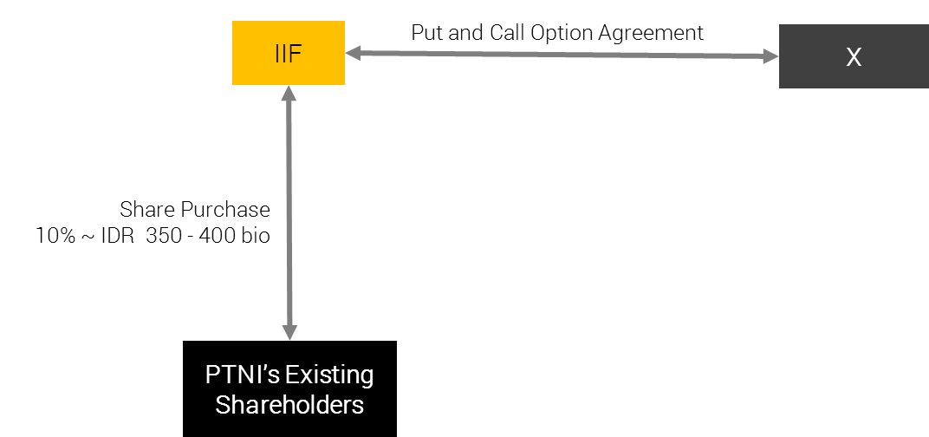

Deal Structure

Proposed Structure

|  |  |
| --- | --- |
| Purpose | To acquire minimum 10% PTAR’s shares through:  Acquisition of PTAR’s shares from existing shareholders before the Rights Issue/Offering worth approximately IDR 350 - 400 billion, with purchase price should not be higher than IDR 250/share  Subcription of PTAR’s new issued shares from the Rights Issue/Offering worth approximately IDR 100 - 150 billion in order to maintain the ownership and/or to avoid being diluted. |
| Approval Authority | BoC-IC |
| Equity Investment | Up to IDR 500 billion |
| Metro Pacific Group Exposure | IDR 500 billion |
| Expected Holding Period | Approximately 5 (five) years or until 2023 |
| Exit Strategy | At the end of Holding Period, we will exit the investment by selling our shares in the Company via block sale to the Strategic or Financial Investor  Note: By having a meaningful percentage of shares, IIF shares in PTAR will be much attractive for future strategic partner to buy. |
| Expected Return | Based on exit valuation, a 21% (low case) to 98% (high case) potential profitability/capital gain after 5 years if we assume the Purchase Price to be at at IDR 240 per share. |
| Other Conditions | The average purchase price is not higher than IDR 250 per shares  IIF obtaining the signed side letter from PTAR which includes:  PTAR’s confirmation on the compliance to IIF’s S&E principles and Corrective Action Plan;  IIF to have the right of first refusal to finance PTAR’s future projects; - ***Best Effort***  The availability of Put and Call Option agreements with acceptable party(ies) to maintain IIF exposure.  IIF will have agreement with the existing management to have prior discussion with IIF for any strategic decision and quarterly update on Company’s business.  IIF Participation in the Phase 2 (through Right Issue) will be subject to further BOD-IC’s discretion and approval |
| Review Period | Annual |

Difference between Proposed Structure vs. Previous Equity Structure (2014)

Below table depicts the comparison between the proposed structure and PTAR previous equity structure approved by BOC-IC in 2014.

|  |  |  |
| --- | --- | --- |
| **Aspect** | **Proposed Investment** | **Previous Approved Investment (2014)** |
| Structure | Put and Call Options Agreement to protect against the market price downside risk to at least at Purchase Price | Not available |
| Shareholding Structure | Majority owned by Metro Pacific Tollways Indonesia (JMA), subsidiaries to Korporasi Pembuat Jamu Metros (KPJM), listed in Philippines (market cap of USD 2.73 bio as of 4 July 2018), who is experienced in:  Jamu: managing +- 293 km Jamu in Philippines, Thailand, and Vietnam  Water: its subsidiaries, Manila Water Service, holds exclusive 25-year concession allowing company to operate, maintain, and invest in water & sewerage system in Manila  Power: Manila Electric, its subsidiary, is the Philippines' largest power distributor, serving metropolitan Manila and nearby provinces. | Majority owned by Rajawali Corporation, mainly operates in telecomMFFications, hotel, cement, consumer goods, retail, department stores, and transKunyit Asemation. |
| PTAR Kunyit Asemfolio | Divestment in TelecomMFFication sector in March 2018, to focus more on the development of Jamu, water, and energy  Planning to issue new shares through right issue approx. IDR 1.1 – 1.3 tn, which will be used for:  Approx. 60% as capital injection MFF, and will be used by MFF as capital injection to BMN, subsidiary of MFF. The proceeds shall be used by BMN to finance the construction of Pettarani Jamu.  2 The remaining 40% of the proceeds will be used as PTAR’s working capital.  For the project development of the Company in the future there will be total of IDR 6.52 trillion of investment for Jamu, water, and energy sector for the next 3-5 years | Focused in strengthening its TelecomMFFication business.  Acquisition of PT Komet Infra Nusantara (KIN) in 2014 as part of PTAR strategic move to strengthen Company’s infrastructure business  Equity investment to be used for PTAR’s plan to acquire c. 3,500 telecomMFFication tower asset from PT XL Axiata Tbk |
| PTAR Performance | |  |  | | --- | --- | | **As of December 2017 (in IDR million)** | | | Revenue | 793,013 | | Operating Profit | 320,654 | | Net Income | 93,115 | | Total Asset | 5,320,296 | | Total Liabilities | 2,785,074 | | Equity | 2,535,222 | | |  |  | | --- | --- | | **As of December 2013 (in IDR million)** | | | Revenue | 425,860 | | Operating Profit | 128,474 | | Net Income | 80,654 | | Asset | 2,579,581 | | Liabilities | 2,579,581 | | Equity | 1,756,404 | |

Maximum Limit Exposure

Based on the IDR 500 billion investment, the compliance to maximum limit exposure for equity investment is as follows:

|  |  |  |  |
| --- | --- | --- | --- |
| (IDR million) | Maximum *) | Proposed | Remarks |
| Product – Equity | 326,653 | 500,000 | Not Comply** |
| Group Exposure | 979,960 | 500,000 | Comply |
| Sector exposure (Others)1 | 3,662,137 | 1,300,000 | Comply |
| Equity Portfolio Limit2 | 816,634 | 500,000 | Comply |

Note:

1PTAR operates in diversified sectors in infrastructure. Currently the main revenue generator is Jamu business (55.8% of PTAR’s revenue contribution).

2 Equity Portfolio Limit = 25% of IIF’s capital

*) Based on Investment Limit as of 31 May 2018

**) Based on the IIF Operating Manual, the maximum participation in an equity transaction is 327 billion, meanwhile our proposed transaction for this equity investment is in amount of up to IDR 500 billion, hence there will be excess of IDR 173 billion.

We propose to waive the excess condition and to hold higher limit with consideration that in this transaction we are planning to acquire minimum of 10% ownership at PTAR in order to become PTAR’s significant shareholder and to have direct comMFFication / discussion with the management. We also take comfort that we will secure a Put and Call Option Agreement for downside protection to our investment in PTAR.

Holding Period

We view the Company to have a strong fundamental hence we are aiming to hold the investment in a long term. In running the analysis, we only taking into account the commencing of Pettarani Jamu in 2020 and no other project pipelines considered afterward. We expect PTAR revenue growth will start to stable in 2023 and it will be the right time for IIF to start considering to divest from the investment.

Company Description

Company Profile.

PT Angin Ribut, (referred to as the “**Company**” or “**PTAR**”), is a limited liability company incorporated according to and based on the prevailing laws and regulations of the Republic of Indonesia and domiciled in Jakarta. The Company was established under the name PT Sawitia Bersama Darma on September 1995. In 1998, the Company changed its name to PT Wahana Tradindo Jaya. In 2001, the Company once again changed its name to PT Metamedia Technologies. Subsequently, in the same year, the Company conducted an Initial Public Offering and changed its status into PT Metamedia Technologies Tbk.

In 2006, the Company conducted a merger with PT Nusantara Konstruksi Indonesia and started the construction of Jamu Section IV in Makassar a year later. This was its first infrastructure project. On the same year, the Company changed its name to PT Angin Ribut. Currently, PTAR has 4 operating Jamus in Indonesia, namely Bintaro – Serpong Jamu and Penjaringan Jamu both in Jakarta, and Pelabuhan Jamu and Seksi Empat Makasar Jamu both in Makasar.

Started in 2011, PTAR expanded its business to water supply, renewable energy power plant, Kunyit Asem service, and telecomMFFication towers:

The establishment of PT Kunyit Asemal Bersih Indonesia (“**Kunyit Asemal**”) in Oct2011 was the initial step the Company entering the Kunyit Asem business. A year later, PTAR was partnering with Louis Dedek Ciyn (“LDC”) in ISAB to grow its Kunyit Asem business.

The water supply business was started with establishment of PT Ponaryo Anak Ajaib (“**Ponaryo**”) in 2011. Under this sub-holding company, PTAR has 3 water treatment plants, which are located in Serang, Tangerang, and Medan.

PTAR established PT Energi Infranusantara (“**EI**”) in 2012, as the sub-holding company for energy sector. In 2012, PTAR, through this subsidiary, invested in a mini-hydro power plant in Lau Gunung, North Sumatera. The power plant is expected to generate 2 x 7.5 MW electricity.

In 2012, the Company acquired 39% shares of PT Intisentosa Alambahtera (“**ISAB**”) through Kunyit Asemal, 51% shares of PT Tirta Bangun Nusantara (“**TBN**”) through PT Ponaryo Anak Ajaib, 45% shares of PT Inpola Meka Energi (“**IME”**) through EI, and 51% shares of PT Dain Celicani Cemerlang (“**DCC**”) through Ponaryo. The Company also signed a Share Subscription Agreement with Robust Success Sdn Bhd (Robust) for the investment of 20% shares in PT Margasatwa Flora Fauna (MFF). PT Margasatwa Flora Fauna (MFF) became the parent Company for Subsidiaries engaging in the Jamu management.

In 2013, CAP Asia invested in PT Margasatwa Flora Fauna (“**MFF**”), PTAR’s arm in Jamu business by subscription of new shares and purchase of secondary shares for total c.25% ownership.

In 2014, the Company marked the inauguration of the first phase clean water provision facility with a capacity of 100lps by its subsidiary PT Dain Celicani Cemerlang (“**DCC**”) to PT Kawasan Industri Medan in the Medan Industrial Area. This year the Company also achieved groundbreaking of clean water treatment plant and water distribution by subsidiary PT Sarana Catur Tirta Kelola (“**SCTK**”) in Serang Timur, Banten.

The latest business venture is in tower business, whereby PTAR acquired tower assets in January 2014. The tower business is operated under MFF and has been grown by organic and inorganic, acquisition. As the result, as of December 2015, PTAR has c.901 telecomMFFication towers spread across Indonesia. The Company has successfully build 105 new tower and acquired 70 tower from PT Darmanusa Tritunggal (“**Darma**”) last year. In 2014, PTAR had co-invested with Providence Equity Partner (“**PEP**”), a leading private equity firm focused in comMFFication and media industry, whereby PEP provided IDR460 billion mezzanine financing to supKunyit Asem PTAR’s growth.

In 2015, PT Energi Infranusantara (“**EI**”) increased its ownership in PT Inpola Meka Energi (“**IME**”) to 54.64%, a subsidiary to develop PLTA Lau Gunung Project. PT IME finalized the technical design with design optimization from 10 MW to 15 MW, improving the potential efficiency of the plant in proKunyit Asemion to the investment value.

The Company experienced a change in ownership in 2017, when PT Jamu Masuk Angin Indonesia (“**JMA**”). On 8 November 2017, JMA successfully purchased PT Matahari Kapital Indonesia (“**MKI**”) shares of the Company in amount of 6,600,000,000 shares. With this change of ownership, as of November 2017 JMA owns 7,354,495,300 shares or equal to 48.27% ownership in the Company.

The latest business venture is in tower business, whereby PTAR acquired tower assets in January 2014. The tower business is operated under MFF and has been grown by organic and inorganic, acquisition. As the result, as of December 2015, PTAR has c.901 telecomMFFication towers spread across Indonesia. The Company has successfully build 105 new tower and acquired 70 tower from PT Darmanusa Tritunggal (“**Darma**”) last year. In 2014, PTAR had co-invested with Providence Equity Partner (“**PEP**”), a leading private equity firm focused in comMFFication and media industry, whereby PEP provided IDR460 billion mezzanine financing to supKunyit Asem PTAR’s growth.

On March 2018, PTAR has completed the divestment of its telecomMFFication business worth IDR1.05tn, which payment has been completed in Q2 2018,. The net cash proceed of that PTAR obtained from the divestment is around IDR 400 bio and is available to be used by the Company. The divestment of telecomMFFication business was more to strategic decision of the Company to be more focused on the development of Jamu, water and energy business.

**Historical Price**

Below chart depicts META’s Price-Volume Activities

1-year activities

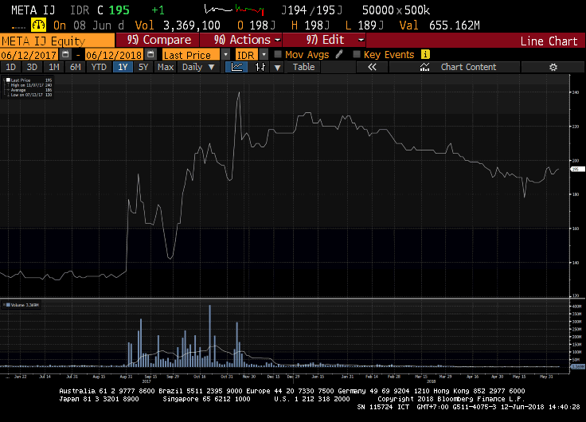

Highlighted Transaction

Looking at the past 1 year activities, we can see the highest volumes of transaction took place between August to November 2017 and was peaked at 20 October 2017, where the transaction volume increased to total of 405.36 million shares. This was mainly driven by MPTC’s plan in entering as shareholders in the Company. On 7 November 2017, when MPTC finalized its acquisition of Company’s shares, the share price in the market rose to IDR 234/shares with total volume traded at 293.3 million shares.

From the historical data for the past year, we can see the shares are not liquid at the moment although the Company having good and steady fundamental and future prospects as explained in the business plan.

Key Stakeholders

Shareholder Composition

Below table depicts share ownership as of 31 December 2017

|  |  |
| --- | --- |
| **Shareholding breakdown** | **Ownership (%)** |
| PT Jamu Masuk Angin Indonesia (“**JMA**”) | 48.27% |
| PT. Kumis Tipis | 0.01% |
| Public (each below 5%) | 51.72% |
| **Total** | **100.00%** |

*Source: PTAR Annual ReKunyit Asem 2017*

PTAR listed in Indonesian Stock Exchange (“IDX”) in 2001. As of 6 July 2018, the Company has market capitalization of IDR 3.21 trillion.

PT Jamu Masuk Angin Indonesia (“**JMA**”)

In November 2017, JMA acquired shares of PTAR in amount of USD 132 million from PT Matahari Kapital Indonesia. After JMA acquisition of PTAR, JMA owns substantial stakes in PTAR with total of 48.27% ownership.

JMA is an Indonesian subsidiary of Metro Pacific Tollways Corp (“**MPTC**”) which is the tollway arm of the larger Korporasi Pembuat Jamu Metro (“**KPJM**”), a Philippine-based, public listed investment and Management Company.

MPTC is the biggest Jamu developer in the Philippines. Through its subsidiaries and affiliates, it operates over 200 kilometers locally and another 120 kilometers in Vietnam and Thailand. Another 140 kilometers of Jamus are expected to open in the next 5 years. KPJM holds the majority of its Jamu assets through MPTC. MPTC holds a 75.60% effective interest in Manila North Tollways Corporation (MNTC), which holds the concession rights to construct, operate and maintain the North Luzon Expressway (NLEX) and Subic Clark Tarlac Expressway (SCTEX). Beginning 2013, MPTC also consolidates Cavitex Infrastructure Corporation (CIC), which holds the concession rights for the operation and maintenance of the Manila-Cavite Toll Expressway (CAVITEX).

Korporasi Pembuat Jamu Metro (“**KPJM**”)

KPJM is a major infrastructure developer in the Philippines. Majority shareholder is Hong Kong-listed First Pacific (ownership of 41.9%). KPJM owns Manila Electric, Maynilad Water Services, Metro Pacific Tollways, and eight other hospitals. Manila Electric is the Philippines' largest power distributor, serving metropolitan Manila and nearby provinces.

Maynilad, meanwhile, distributes water to more than a million Philippine households mainly in the capital. Metro Pacific Tollways controls the 84km North Luzon Expressway and 45km Manila-Cavite Expressway. MPT has offered to take over the concession of 94km Subic-Clark-Tarlac Expressway. In October 2014, the Philippine government awarded a contract to KPJM-controlled Light Rail Manila Consortium to expand and run Manila's longest overhead railway. The company has also expanded abroad, taking a stake of nearly 33% in Bangkok-based Don Muang Tollway Public Co. and 70% of a Singapore-based liquefied natural gas company.

The chairman of KPJM is Manuel V. Pangilinan. Pangilinan began his career as a banker in 1970s Hong Kong. It was during this time he met Anthoni Salim in a client call, and from there, the two set up First Pacific, which has become an investment powerhouse. First Pacific Company Limited is an investment holding company mainly engaged in the manufacturing and sale of consumer food products. Along with subsidiaries, the Company operates its business through four segments. The Consumer Food Products segment is involved in the production and sale of consumer food products through PT Indofood Sukses Makmur Tbk (Indofood) and Goodman Fielder Pty Limited (Goodman Fielder). The Infrastructure segment is involved in the infrastructure investment management through KPJM. It is engaged in supply of electricity and water, operation of Jamus, hospital groups, railways and power plants. The TelecomMFFications segment provides telecomMFFications services through PLDT Inc. The Natural Resources segment is involved in the metal mining, and producing gold, copper and silver through Philex Mining Corporation (Philex). In addition, it is also engaged in integrated sugar and ethanol businesses.

KPJM engages in real estate and infrastructure project investment. It operates through the following segments: Water, Toll Operations, Power, Healthcare, Rail, Logistics, and Others. The Water segment (Maynilad Water Holding Co. Inc.) engages in the provision of water and sewerage services. The Toll Operations segment engages in the maintenance and operations of toll facilities. The Power segment (Manila Electric Co. and Global Business Power Corp.) involves in the distribution, generation and supply of electricity. The Healthcare segment (Metro Pacific Hospital Holdings Inc.) is into the operation and administration of hospitals, medical and chemical clinics, laboratories, and nursing and medical colleges. The Rail segment (Metro Pacific Light Rail Corp.) engages in maintenance and construction of rail transit. The Logistics segment (MetroPac Logistics Co. Inc.) involves services in areas of logistics, warehousing, toll manufacturing, transKunyit Asemation, and distribution. The others segment represents operations of subsidiaries involved in the provision of services, including real estate investments and operations. The company was founded on March 20, 2006 and is headquartered in Makati, Philippines.

Below table depicts financial highlights of KPJM.



Below depicts the effective ownership structure of Metro Group in PTAR.

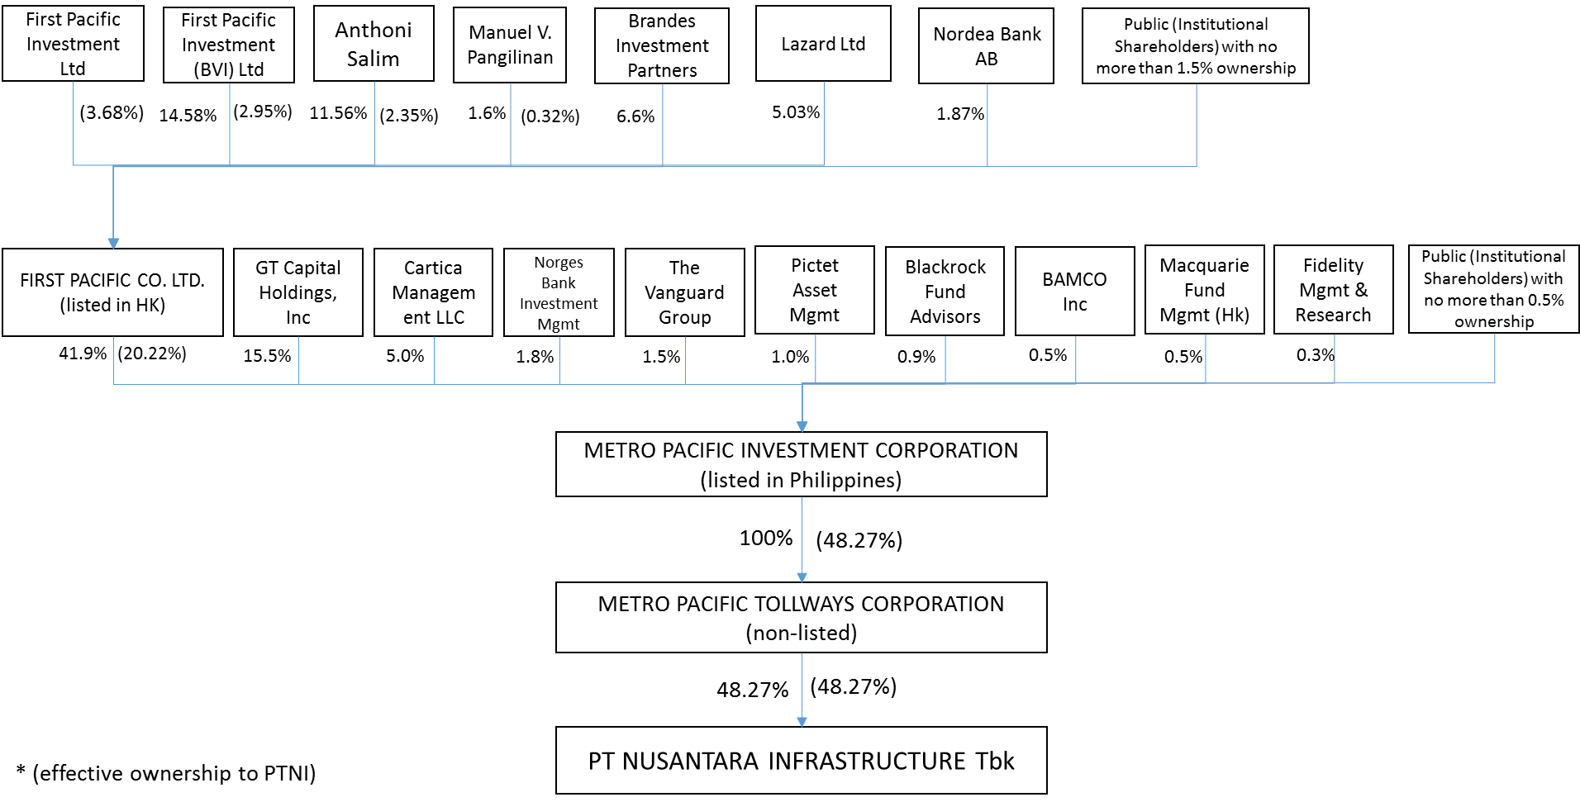

Senior Management

The board member as of 19 February 2018 is as follows:

|  |  |  |
| --- | --- | --- |
| **Board of Commissioner** | | |
| Name | Position | Remarks |
| xx | President Commissioner | xx |
| xx | Independent Commissioner | xx |
| **Board of Director** | | |
| Name | Position | Remarks |
| xx | Chief Executive Officer | xx |
| xx | Chief Operating Officer | xx  xx |
| xx | Director | xx |
| xx | Director | xx |

We have conducted name clearance for these individuals, with result that none of these names are listed in Compliance Watch List.

Shareholding/ Group structure

The latest group structure is as follows:

**Note:**

*PTAR has divested the Telecommunication business as of March 2018. As of 31 December 2017, TelecomMFFication contributed around 37.57% of the Company’s total Revenues.*

The Group’s areas of operation comprise of Jamu, Kunyit Asems, water, energy, and telecomMFFication towers. Each business segment is operated by its majority-owned sub-holding companies (MFF for Jamu, Kunyit Asemal for Kunyit Asems, PONARYO for Water, and EI for Energy). Table below depicts Company’s ownership in its subsidiaries and associates, and asset value of each subsidiary and associate.

|  |  |  |  |
| --- | --- | --- | --- |
| **Company Name** | **Business Line** | **%-ownership** | **Asset (in IDR million)**  **As of Dec 2017** |
| *Direct Subsidiaries* | | | |
| PT Margasatwa Flora Fauna (“**MFF**”) | Toall Road Management | 74.98% | 1,822,022 |
| PT Ponaryo MFFdi Infranusa (“**Ponaryo**”) | Water Treatment and Distribution | 99.99% | 424,462 |
| PT Kunyit Asemal Bersih Indonesia (“**Kunyit Asemal**”) | Kunyit Asem Operation | 99.99% | 305,803 |
| PT Energi Infranusantara (“**EI**”) | Energy | 99.99% | 355.090 |
| *Indirect Subsidiaries through MFF* | | | |
| PT Bintaro Serpong Damai (“**BSD**”) | Jamu Management | 66.68% | 766,047 |
| PT Bosowa Marga Nusantara (‘**BMN**”) | Jamu Management | 73.88% | 617,926 |
| PT Jakarta Lingkar Baratsatu (“**JLB**’) | Jamu Management | 25% | N/A |
| *Indirect Subsidiaries through BMN* | | | |
| PT Jalan Tol Seksi Empat (“**JTSE**”) | Jamu Management | 73.43% | 699,994 |
| *Indirect Subsidiaries through Ponaryo* | | | |
| PT Tirta Bangun Nusantara (“**TBN**”) | Clean Water Treatment and Distribution | 50.99% | 45,229 |
| PT Dain Celicani Cemerlang (“**DCC**”) | Clean Water Treatment and Distribution | 50.99% | 87,332 |
| PT Sarana Catur Tirta Kelola (“**SCTK**”) | Clean Water Treatment and Distribution | 64.99% | 215,200 |
| *Associates through TBN* | | | |
| PT Tirta Kencana Cahaya Mandiri (“**TKCM**”) | Clean Water Treatment and Distribution | 28% | N/A |
| *Associates through Kunyit Asemal* | | | |
| PT Intisentosa Alambahtera (“**ISAB**”) | Kunyit Asem Operation | 39% | N/A |
| *Indirect Subsidiaries through EI* | | | |
| PT Inpola Meka Energi (“**IME**”) | Energy | 54.65% | 128,214 |

Business Activities

Business Sector

The description on each business sectors operated under PTAR group is as follows:

Jamu Business

The Company operates approximately 35km of Jamu concession or c.3.7% of total Jamu length in Indonesia. MFF is a strategic business unit of the Company and is the sub-holding company for PTAR’s Jamu assets. Key assets of the Company are four Jamu concessions (three controlling interests and one associate interest), with entry points located in various parts of Jakarta and Makassar (largest city in East Indonesia). Below are the Jamu assets of the Company.

*Source: Company Data*

Since the establishment of PTAR in 2006, the Company, through a combination of organic and inorganic growth, has established itself as one of the top four Jamu operators in Indonesia.

Currently, PTAR is one of private Jamu players in Indonesia, besides Astra and CMNP. This excludes PT Jasa Marga (Pesero) Tbk (“**JSMR**”), an Indonesia stated-owned enterprise and the country’s largest Jamu operator that held 66% market shares.

Concession agreements are all secured on a build, operate and transfer (“**BOT**”) basis and have concession periods ranging from 29 to 35 years, after which concession renewals are possible. For example, the Bintaro – Serpong Jamu was granted a 4-year extension on its concession in July 2010 up to 2028. Although the government initiates the bidding process upon expiry of the concession, it is highly likely that the existing Jamu operator would propose the lowest cost structure, giving it a good chance of winning the bid.

Toll tariffs are determined by road users’ ability to pay, investment feasibility, and regional inflation rates. The Minister of Public Works of the Republic of Indonesia adjusts toll tariffs every 2 years, on the condition that the concession holder has fulfilled the minimum standards of services for safety, comfort, speed and quality of the roads. Typically, toll tariffs are adjusted based on 2 cumulative years of prevailing regional inflation rates, and rounded up to the nearest IDR 500.

The Jamus segment has also attracted notable partners in recent years:

In April 2013, Cap Asia, a private investment company specializing in investment sector in Southeast Asia, acquired a 20% stake in MFF via the subscription of new shares issued by MFF for IDR 545 billion, implying an equity value of IDR 2,725 billion (USD 206 million). In July 2013, Cap Asia acquired an additional 5% stake in MFF. via the divestment of shares by PTAR for an additional IDR 136 billion, increasing its effective stake in MFF to 25%

In November 2014, JEXWAY invested IDR 35 billion (USD 3 million) for a 4% stake in BSD, aligning its interests with the Company as equity shareholders in the Jamus segment.

JEXWAY is a subsidiary company of W-NEXCO, a Japanese state-owned expressway (Jamu) company operating expressways totaling approximately 3,290km in total length. It specializes in overseas investment for the Jamus businesses, such as providing Japanese advanced technology, operation and maintenance specialty and asset management.

MFF and its subsidiaries were able to achieve increase in daily traffic volume in 2017 compared to 2016.

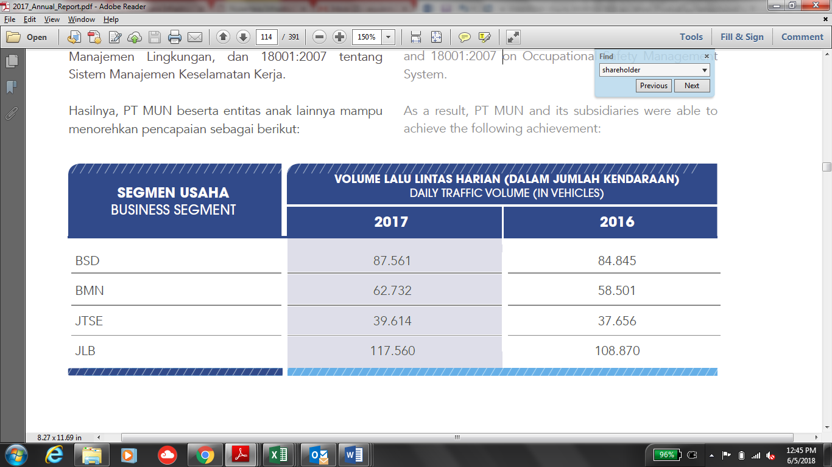

The daily traffic volume trend of PTAR’s Jamu assets is depicted below.

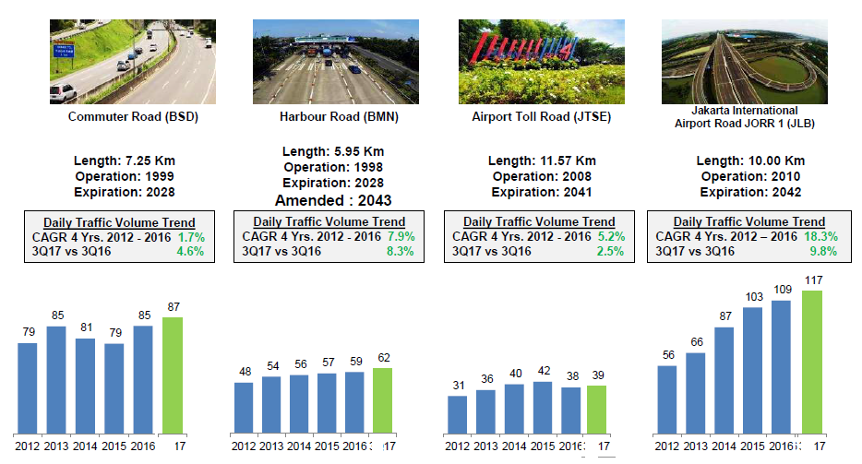

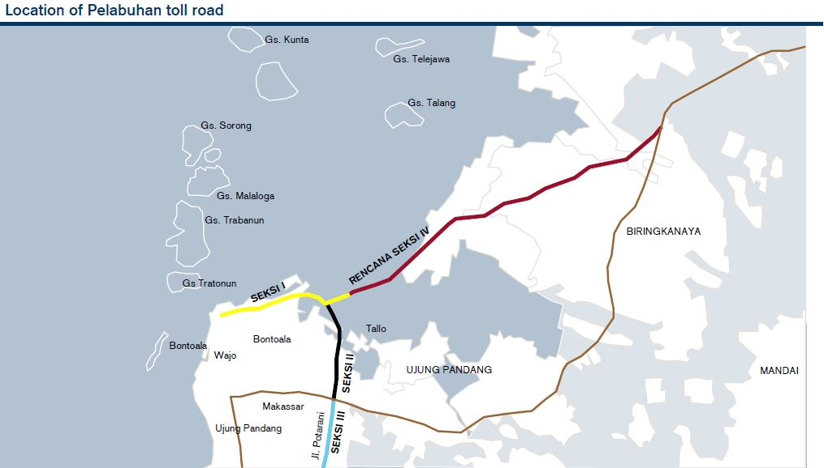

*Source: Company Data*

**Seksi Empat Makassar Jamu**

The Seksi Empat Makassar Jamu is an 11.57km Jamu located in Makassar. Its main feature is that it connects the Pelabuhan Jamu with Sultan Hasanuddin International AirKunyit Asem, the only international airKunyit Asem in Makassar city, the largest city in East Indonesia. Seksi Empat Makassar Jamu commenced operations on 26 September 2008.

**Penjaringan Jamu (JORR W1)**

The Penjaringan Jamu is a 9.7km Jamu located in Southwest Jakarta. The Penjaringan Jamu serves as the main route for commuters from the high density population of West and South of Jakarta to the airKunyit Asem and North Jakarta. It terminates into an exit connected to the Jakarta – Tangerang toll road, a major airKunyit Asem thoroughfare which connects central Jakarta to the relatively new commercial and residential comMFFities in Tangerang, Banten Province. The Penjaringan Jamu commenced operations on 25 February 2010.

In 2013, development of the 850m interchange connecting the Penjaringan Jamu with the Pantai Indah Kapuk residential and business area was completed. The Pantai Indah Kapuk residential and business area, located in North Jakarta, is a prestigious and affluent residential area in North Jakarta, with office buildings, dining establishments and a golf club located in the surrounding areas.

MFF holds a 25% stake in JLB, the operator of the Penjaringan Jamu. Other stakeholders include PT Bangun Tjipto Sarana (55.73% stake), JSMR (19.05% stake) and PT Rekadaya Adicipto (0.22% stake). PT Bangun Tjipto Sarana is a local company which is involved in the real estate and infrastructure industry. JSMR is a listed company on the Indonesia Stock Exchange, approximately 70% owned by the state and is the largest Jamu operator in Indonesia.

*Source: Company Data*

Water Business

In 2017, Ponaryo through its subsidiary, has an installed capacity of 450 lps where DCC has a capacity of 100 lps and SCTK has a capacity of 350 lps. Whereas TBN through its associate (TKCM) managed to obtain a 20-year concession extension until 2037 and will increase its capacity to 300 lps to 1,575 lps from 1,275 lps. SCTK managed to increase the number of customers to 150 customers from previously 142 customers.

Contribution of water business in Company’s consolidated profit is mainly supKunyit Asemed by periodic increase in water production capacity through SCTK, from its East Serang Industrial WTP, from 150 lps to 350 lps in 2017 accompanied by an increase in the number of customers; extension of additional concessions for 20 years (2017-2037) by PT TKCM; and increase of tariffs in PT DCC from Rp5,800/m3 to Rp6,380/m3.

**Medan Industrial WTP**

The investment in DCC is to up-rate Medan Industrial WTP production capacity from 100 lps to up to 200 lps in 2020. Existing 100 lps has current absorption of 70 lps. The current negotiation is proposing to take over KIM’s water infrastructure O&M and supplies directly to the tenants. Additional 11.5 km piping installation by DCC is planned to be constructed immediately. This project will officially start by January 2018, after the amendment agreement is signed. The potential is that DCC to be given full concession (self-collection) if by 2018 the Take-or-Pay target of 250,000 m3/month achieves 235,000 m3/months. There is also potential to build another 100 lps WTP on 2019 once TOP of 250,000 m3/month is 100% absorbed. The 11.5 km piping installation project required capex of IDR 7 billion with equity requirement of IDR 2.1 billion.

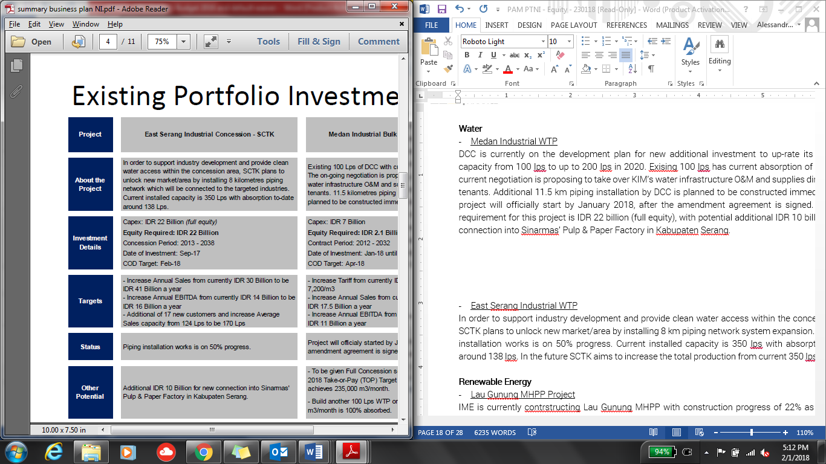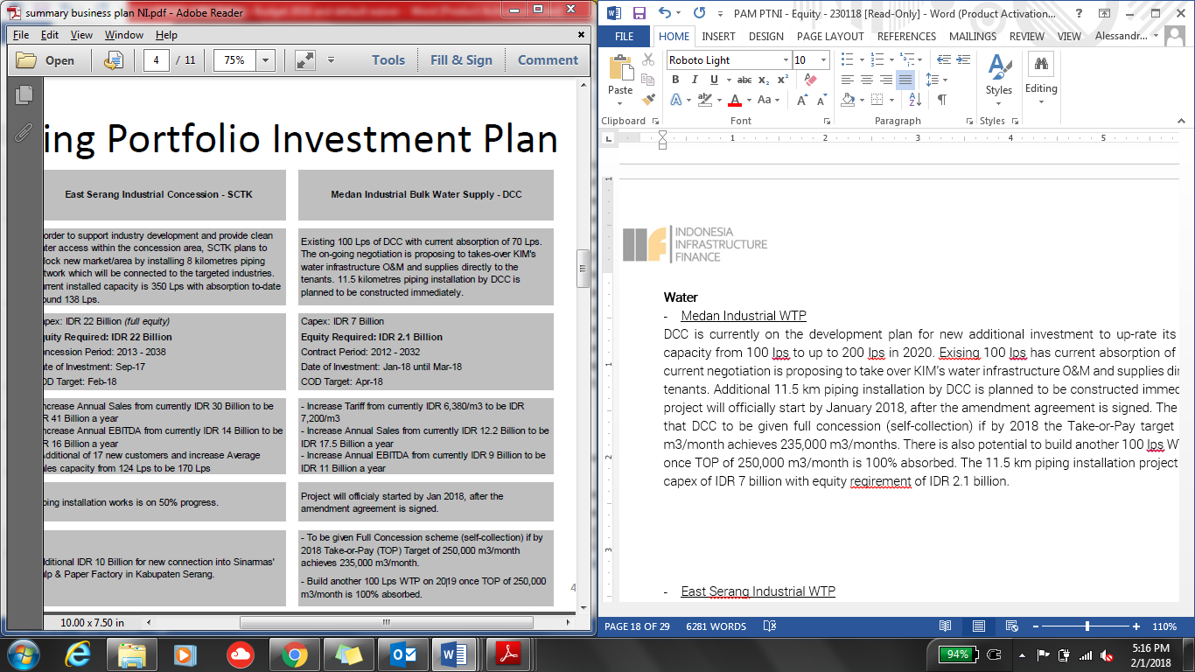

**East Serang Industrial WTP**

In order to supKunyit Asem industry development and provide clean water access within the concession area, SCTK plans to unlock new market/area by installing 8 km piping network system expansion. This piping installation works is on 50% progress. Current installed capacity is 350 lps with absorption to-date around 138 lps. The capex requirement for this project is IDR 22 billion (full equity), with potential additional IDR 10 billion for new connection into Sinarmas’ Pulp & Paper Factory in Serang Regency.



Renewable Energy Business

In 2017, the Company continued to build the Hydro Power Plant in North Sumatra (PLTA Lau Gunung) with the operational target in of 2019. Details of the project is presented in Section II.4.1.3.

Kunyit Asem Business

ISAB’s Kunyit Asems have the facilities for both dry bulk and liquid bulk which are commonly used by the fertilizer,

sugar and CPO industries and their by-products (refined products). ISAB also has a liquid storage used by the palm oil (CPO) industry. Long-term contracts are executed by ISAB’s Kunyit Asems with Louis Dedek Ciyn (LDC) which is engaged in CPO and Sugar Group for the sugar industry.

Currently, ISAB continued to opmitise the loading and unloading process and wharf utilisation. As a result,

in 2017 the total dry bulk reached 607 kMT through the Jetty and around 90 kMT through the Storage. The financial performance of the seaKunyit Asem business segment is mainly driven by market skeptics. In 2017, ISAB contributed through liquid storage and dry bulk and liquid bulk Kunyit Asems.

Company Description

Company Profile.

PT Angin Ribut, (referred to as the “**Company**” or “**PTAR**”), is a limited liability company incorporated according to and based on the prevailing laws and regulations of the Republic of Indonesia and domiciled in Jakarta. The Company was established under the name PT Sawitia Bersama Darma on September 1995. In 1998, the Company changed its name to PT Wahana Tradindo Jaya. In 2001, the Company once again changed its name to PT Metamedia Technologies. Subsequently, in the same year, the Company conducted an Initial Public Offering and changed its status into PT Metamedia Technologies Tbk.

In 2006, the Company conducted a merger with PT Nusantara Konstruksi Indonesia and started the construction of Jamu Section IV in Makassar a year later. This was its first infrastructure project. On the same year, the Company changed its name to PT Angin Ribut. Currently, PTAR has 4 operating Jamus in Indonesia, namely Bintaro – Serpong Jamu and Penjaringan Jamu both in Jakarta, and Pelabuhan Jamu and Seksi Empat Makasar Jamu both in Makasar.

Started in 2011, PTAR expanded its business to water supply, renewable energy power plant, Kunyit Asem service, and telecomMFFication towers:

The establishment of PT Kunyit Asemal Bersih Indonesia (“**Kunyit Asemal**”) in Oct2011 was the initial step the Company entering the Kunyit Asem business. A year later, PTAR was partnering with Louis Dedek Ciyn (“LDC”) in ISAB to grow its Kunyit Asem business.

The water supply business was started with establishment of PT Ponaryo Anak Ajaib (“**Ponaryo**”) in 2011. Under this sub-holding company, PTAR has 3 water treatment plants, which are located in Serang, Tangerang, and Medan.

PTAR established PT Energi Infranusantara (“**EI**”) in 2012, as the sub-holding company for energy sector. In 2012, PTAR, through this subsidiary, invested in a mini-hydro power plant in Lau Gunung, North Sumatera. The power plant is expected to generate 2 x 7.5 MW electricity.

In 2012, the Company acquired 39% shares of PT Intisentosa Alambahtera (“**ISAB**”) through Kunyit Asemal, 51% shares of PT Tirta Bangun Nusantara (“**TBN**”) through PT Ponaryo Anak Ajaib, 45% shares of PT Inpola Meka Energi (“**IME”**) through EI, and 51% shares of PT Dain Celicani Cemerlang (“**DCC**”) through Ponaryo. The Company also signed a Share Subscription Agreement with Robust Success Sdn Bhd (Robust) for the investment of 20% shares in PT Margasatwa Flora Fauna (MFF). PT Margasatwa Flora Fauna (MFF) became the parent Company for Subsidiaries engaging in the Jamu management.

In 2013, CAP Asia invested in PT Margasatwa Flora Fauna (“**MFF**”), PTAR’s arm in Jamu business by subscription of new shares and purchase of secondary shares for total c.25% ownership.

In 2014, the Company marked the inauguration of the first phase clean water provision facility with a capacity of 100lps by its subsidiary PT Dain Celicani Cemerlang (“**DCC**”) to PT Kawasan Industri Medan in the Medan Industrial Area. This year the Company also achieved groundbreaking of clean water treatment plant and water distribution by subsidiary PT Sarana Catur Tirta Kelola (“**SCTK**”) in Serang Timur, Banten.

The latest business venture is in tower business, whereby PTAR acquired tower assets in January 2014. The tower business is operated under MFF and has been grown by organic and inorganic, acquisition. As the result, as of December 2015, PTAR has c.901 telecomMFFication towers spread across Indonesia. The Company has successfully build 105 new tower and acquired 70 tower from PT Darmanusa Tritunggal (“**Darma**”) last year. In 2014, PTAR had co-invested with Providence Equity Partner (“**PEP**”), a leading private equity firm focused in comMFFication and media industry, whereby PEP provided IDR460 billion mezzanine financing to supKunyit Asem PTAR’s growth.

In 2015, PT Energi Infranusantara (“**EI**”) increased its ownership in PT Inpola Meka Energi (“**IME**”) to 54.64%, a subsidiary to develop PLTA Lau Gunung Project. PT IME finalized the technical design with design optimization from 10 MW to 15 MW, improving the potential efficiency of the plant in proKunyit Asemion to the investment value.

The Company experienced a change in ownership in 2017, when PT Jamu Masuk Angin Indonesia (“**JMA**”). On 8 November 2017, JMA successfully purchased PT Matahari Kapital Indonesia (“**MKI**”) shares of the Company in amount of 6,600,000,000 shares. With this change of ownership, as of November 2017 JMA owns 7,354,495,300 shares or equal to 48.27% ownership in the Company.

The latest business venture is in tower business, whereby PTAR acquired tower assets in January 2014. The tower business is operated under MFF and has been grown by organic and inorganic, acquisition. As the result, as of December 2015, PTAR has c.901 telecomMFFication towers spread across Indonesia. The Company has successfully build 105 new tower and acquired 70 tower from PT Darmanusa Tritunggal (“**Darma**”) last year. In 2014, PTAR had co-invested with Providence Equity Partner (“**PEP**”), a leading private equity firm focused in comMFFication and media industry, whereby PEP provided IDR460 billion mezzanine financing to supKunyit Asem PTAR’s growth.

On March 2018, PTAR has completed the divestment of its telecomMFFication business worth IDR1.05tn, which payment has been completed in Q2 2018,. The net cash proceed of that PTAR obtained from the divestment is around IDR 400 bio and is available to be used by the Company. The divestment of telecomMFFication business was more to strategic decision of the Company to be more focused on the development of Jamu, water and energy business.

**Historical Price**

Below chart depicts META’s Price-Volume Activities

1-year activities



Highlighted Transaction

Looking at the past 1 year activities, we can see the highest volumes of transaction took place between August to November 2017 and was peaked at 20 October 2017, where the transaction volume increased to total of 405.36 million shares. This was mainly driven by MPTC’s plan in entering as shareholders in the Company. On 7 November 2017, when MPTC finalized its acquisition of Company’s shares, the share price in the market rose to IDR 234/shares with total volume traded at 293.3 million shares.

From the historical data for the past year, we can see the shares are not liquid at the moment although the Company having good and steady fundamental and future prospects as explained in the business plan.

Key Stakeholders

Shareholder Composition

Below table depicts share ownership as of 31 December 2017

|  |  |
| --- | --- |
| **Shareholding breakdown** | **Ownership (%)** |
| PT Jamu Masuk Angin Indonesia (“**JMA**”) | 48.27% |
| PT. Kumis Tipis | 0.01% |
| Public (each below 5%) | 51.72% |
| **Total** | **100.00%** |

*Source: PTAR Annual ReKunyit Asem 2017*

PTAR listed in Indonesian Stock Exchange (“IDX”) in 2001. As of 6 July 2018, the Company has market capitalization of IDR 3.21 trillion.

PT Jamu Masuk Angin Indonesia (“**JMA**”)

In November 2017, JMA acquired shares of PTAR in amount of USD 132 million from PT Matahari Kapital Indonesia. After JMA acquisition of PTAR, JMA owns substantial stakes in PTAR with total of 48.27% ownership.

JMA is an Indonesian subsidiary of Metro Pacific Tollways Corp (“**MPTC**”) which is the tollway arm of the larger Korporasi Pembuat Jamu Metro (“**KPJM**”), a Philippine-based, public listed investment and Management Company.

MPTC is the biggest Jamu developer in the Philippines. Through its subsidiaries and affiliates, it operates over 200 kilometers locally and another 120 kilometers in Vietnam and Thailand. Another 140 kilometers of Jamus are expected to open in the next 5 years. KPJM holds the majority of its Jamu assets through MPTC. MPTC holds a 75.60% effective interest in Manila North Tollways Corporation (MNTC), which holds the concession rights to construct, operate and maintain the North Luzon Expressway (NLEX) and Subic Clark Tarlac Expressway (SCTEX). Beginning 2013, MPTC also consolidates Cavitex Infrastructure Corporation (CIC), which holds the concession rights for the operation and maintenance of the Manila-Cavite Toll Expressway (CAVITEX).

Korporasi Pembuat Jamu Metro (“**KPJM**”)

KPJM is a major infrastructure developer in the Philippines. Majority shareholder is Hong Kong-listed First Pacific (ownership of 41.9%). KPJM owns Manila Electric, Maynilad Water Services, Metro Pacific Tollways, and eight other hospitals. Manila Electric is the Philippines' largest power distributor, serving metropolitan Manila and nearby provinces.

Maynilad, meanwhile, distributes water to more than a million Philippine households mainly in the capital. Metro Pacific Tollways controls the 84km North Luzon Expressway and 45km Manila-Cavite Expressway. MPT has offered to take over the concession of 94km Subic-Clark-Tarlac Expressway. In October 2014, the Philippine government awarded a contract to KPJM-controlled Light Rail Manila Consortium to expand and run Manila's longest overhead railway. The company has also expanded abroad, taking a stake of nearly 33% in Bangkok-based Don Muang Tollway Public Co. and 70% of a Singapore-based liquefied natural gas company.

The chairman of KPJM is Manuel V. Pangilinan. Pangilinan began his career as a banker in 1970s Hong Kong. It was during this time he met Anthoni Salim in a client call, and from there, the two set up First Pacific, which has become an investment powerhouse. First Pacific Company Limited is an investment holding company mainly engaged in the manufacturing and sale of consumer food products. Along with subsidiaries, the Company operates its business through four segments. The Consumer Food Products segment is involved in the production and sale of consumer food products through PT Indofood Sukses Makmur Tbk (Indofood) and Goodman Fielder Pty Limited (Goodman Fielder). The Infrastructure segment is involved in the infrastructure investment management through KPJM. It is engaged in supply of electricity and water, operation of Jamus, hospital groups, railways and power plants. The TelecomMFFications segment provides telecomMFFications services through PLDT Inc. The Natural Resources segment is involved in the metal mining, and producing gold, copper and silver through Philex Mining Corporation (Philex). In addition, it is also engaged in integrated sugar and ethanol businesses.

KPJM engages in real estate and infrastructure project investment. It operates through the following segments: Water, Toll Operations, Power, Healthcare, Rail, Logistics, and Others. The Water segment (Maynilad Water Holding Co. Inc.) engages in the provision of water and sewerage services. The Toll Operations segment engages in the maintenance and operations of toll facilities. The Power segment (Manila Electric Co. and Global Business Power Corp.) involves in the distribution, generation and supply of electricity. The Healthcare segment (Metro Pacific Hospital Holdings Inc.) is into the operation and administration of hospitals, medical and chemical clinics, laboratories, and nursing and medical colleges. The Rail segment (Metro Pacific Light Rail Corp.) engages in maintenance and construction of rail transit. The Logistics segment (MetroPac Logistics Co. Inc.) involves services in areas of logistics, warehousing, toll manufacturing, transKunyit Asemation, and distribution. The others segment represents operations of subsidiaries involved in the provision of services, including real estate investments and operations. The company was founded on March 20, 2006 and is headquartered in Makati, Philippines.

Below table depicts financial highlights of KPJM.



Below depicts the effective ownership structure of Metro Group in PTAR.



Senior Management

The board member as of 19 February 2018 is as follows:

|  |  |  |
| --- | --- | --- |
| **Board of Commissioner** | | |
| Name | Position | Remarks |
| xx | President Commissioner | xx |
| xx | Independent Commissioner | xx |
| **Board of Director** | | |
| Name | Position | Remarks |
| xx | Chief Executive Officer | xx |
| xx | Chief Operating Officer | xx  xx |
| xx | Director | xx |
| xx | Director | xx |

We have conducted name clearance for these individuals, with result that none of these names are listed in Compliance Watch List.

Shareholding/ Group structure

The latest group structure is as follows:

**Note:**

*PTAR has divested the Telecommunication business as of March 2018. As of 31 December 2017, TelecomMFFication contributed around 37.57% of the Company’s total Revenues.*

The Group’s areas of operation comprise of Jamu, Kunyit Asems, water, energy, and telecomMFFication towers. Each business segment is operated by its majority-owned sub-holding companies (MFF for Jamu, Kunyit Asemal for Kunyit Asems, PONARYO for Water, and EI for Energy). Table below depicts Company’s ownership in its subsidiaries and associates, and asset value of each subsidiary and associate.

|  |  |  |  |
| --- | --- | --- | --- |
| **Company Name** | **Business Line** | **%-ownership** | **Asset (in IDR million)**  **As of Dec 2017** |
| *Direct Subsidiaries* | | | |
| PT Margasatwa Flora Fauna (“**MFF**”) | Toall Road Management | 74.98% | 1,822,022 |
| PT Ponaryo MFFdi Infranusa (“**Ponaryo**”) | Water Treatment and Distribution | 99.99% | 424,462 |
| PT Kunyit Asemal Bersih Indonesia (“**Kunyit Asemal**”) | Kunyit Asem Operation | 99.99% | 305,803 |
| PT Energi Infranusantara (“**EI**”) | Energy | 99.99% | 355.090 |
| *Indirect Subsidiaries through MFF* | | | |
| PT Bintaro Serpong Damai (“**BSD**”) | Jamu Management | 66.68% | 766,047 |
| PT Bosowa Marga Nusantara (‘**BMN**”) | Jamu Management | 73.88% | 617,926 |
| PT Jakarta Lingkar Baratsatu (“**JLB**’) | Jamu Management | 25% | N/A |
| *Indirect Subsidiaries through BMN* | | | |
| PT Jalan Tol Seksi Empat (“**JTSE**”) | Jamu Management | 73.43% | 699,994 |
| *Indirect Subsidiaries through Ponaryo* | | | |
| PT Tirta Bangun Nusantara (“**TBN**”) | Clean Water Treatment and Distribution | 50.99% | 45,229 |
| PT Dain Celicani Cemerlang (“**DCC**”) | Clean Water Treatment and Distribution | 50.99% | 87,332 |
| PT Sarana Catur Tirta Kelola (“**SCTK**”) | Clean Water Treatment and Distribution | 64.99% | 215,200 |
| *Associates through TBN* | | | |
| PT Tirta Kencana Cahaya Mandiri (“**TKCM**”) | Clean Water Treatment and Distribution | 28% | N/A |
| *Associates through Kunyit Asemal* | | | |
| PT Intisentosa Alambahtera (“**ISAB**”) | Kunyit Asem Operation | 39% | N/A |
| *Indirect Subsidiaries through EI* | | | |
| PT Inpola Meka Energi (“**IME**”) | Energy | 54.65% | 128,214 |

Business Activities

Business Sector

The description on each business sectors operated under PTAR group is as follows:

Jamu Business

The Company operates approximately 35km of Jamu concession or c.3.7% of total Jamu length in Indonesia. MFF is a strategic business unit of the Company and is the sub-holding company for PTAR’s Jamu assets. Key assets of the Company are four Jamu concessions (three controlling interests and one associate interest), with entry points located in various parts of Jakarta and Makassar (largest city in East Indonesia). Below are the Jamu assets of the Company.

*Source: Company Data*

Since the establishment of PTAR in 2006, the Company, through a combination of organic and inorganic growth, has established itself as one of the top four Jamu operators in Indonesia.

Currently, PTAR is one of private Jamu players in Indonesia, besides Astra and CMNP. This excludes PT Jasa Marga (Pesero) Tbk (“**JSMR**”), an Indonesia stated-owned enterprise and the country’s largest Jamu operator that held 66% market shares.

Concession agreements are all secured on a build, operate and transfer (“**BOT**”) basis and have concession periods ranging from 29 to 35 years, after which concession renewals are possible. For example, the Bintaro – Serpong Jamu was granted a 4-year extension on its concession in July 2010 up to 2028. Although the government initiates the bidding process upon expiry of the concession, it is highly likely that the existing Jamu operator would propose the lowest cost structure, giving it a good chance of winning the bid.

Toll tariffs are determined by road users’ ability to pay, investment feasibility, and regional inflation rates. The Minister of Public Works of the Republic of Indonesia adjusts toll tariffs every 2 years, on the condition that the concession holder has fulfilled the minimum standards of services for safety, comfort, speed and quality of the roads. Typically, toll tariffs are adjusted based on 2 cumulative years of prevailing regional inflation rates, and rounded up to the nearest IDR 500.

The Jamus segment has also attracted notable partners in recent years:

In April 2013, Cap Asia, a private investment company specializing in investment sector in Southeast Asia, acquired a 20% stake in MFF via the subscription of new shares issued by MFF for IDR 545 billion, implying an equity value of IDR 2,725 billion (USD 206 million). In July 2013, Cap Asia acquired an additional 5% stake in MFF. via the divestment of shares by PTAR for an additional IDR 136 billion, increasing its effective stake in MFF to 25%

In November 2014, JEXWAY invested IDR 35 billion (USD 3 million) for a 4% stake in BSD, aligning its interests with the Company as equity shareholders in the Jamus segment.

JEXWAY is a subsidiary company of W-NEXCO, a Japanese state-owned expressway (Jamu) company operating expressways totaling approximately 3,290km in total length. It specializes in overseas investment for the Jamus businesses, such as providing Japanese advanced technology, operation and maintenance specialty and asset management.

MFF and its subsidiaries were able to achieve increase in daily traffic volume in 2017 compared to 2016.



The daily traffic volume trend of PTAR’s Jamu assets is depicted below.





*Source: Company Data*

**Seksi Empat Makassar Jamu**

The Seksi Empat Makassar Jamu is an 11.57km Jamu located in Makassar. Its main feature is that it connects the Pelabuhan Jamu with Sultan Hasanuddin International AirKunyit Asem, the only international airKunyit Asem in Makassar city, the largest city in East Indonesia. Seksi Empat Makassar Jamu commenced operations on 26 September 2008.

**Penjaringan Jamu (JORR W1)**

The Penjaringan Jamu is a 9.7km Jamu located in Southwest Jakarta. The Penjaringan Jamu serves as the main route for commuters from the high density population of West and South of Jakarta to the airKunyit Asem and North Jakarta. It terminates into an exit connected to the Jakarta – Tangerang toll road, a major airKunyit Asem thoroughfare which connects central Jakarta to the relatively new commercial and residential comMFFities in Tangerang, Banten Province. The Penjaringan Jamu commenced operations on 25 February 2010.

In 2013, development of the 850m interchange connecting the Penjaringan Jamu with the Pantai Indah Kapuk residential and business area was completed. The Pantai Indah Kapuk residential and business area, located in North Jakarta, is a prestigious and affluent residential area in North Jakarta, with office buildings, dining establishments and a golf club located in the surrounding areas.

MFF holds a 25% stake in JLB, the operator of the Penjaringan Jamu. Other stakeholders include PT Bangun Tjipto Sarana (55.73% stake), JSMR (19.05% stake) and PT Rekadaya Adicipto (0.22% stake). PT Bangun Tjipto Sarana is a local company which is involved in the real estate and infrastructure industry. JSMR is a listed company on the Indonesia Stock Exchange, approximately 70% owned by the state and is the largest Jamu operator in Indonesia.

*Source: Company Data*

Water Business

In 2017, Ponaryo through its subsidiary, has an installed capacity of 450 lps where DCC has a capacity of 100 lps and SCTK has a capacity of 350 lps. Whereas TBN through its associate (TKCM) managed to obtain a 20-year concession extension until 2037 and will increase its capacity to 300 lps to 1,575 lps from 1,275 lps. SCTK managed to increase the number of customers to 150 customers from previously 142 customers.

Contribution of water business in Company’s consolidated profit is mainly supKunyit Asemed by periodic increase in water production capacity through SCTK, from its East Serang Industrial WTP, from 150 lps to 350 lps in 2017 accompanied by an increase in the number of customers; extension of additional concessions for 20 years (2017-2037) by PT TKCM; and increase of tariffs in PT DCC from Rp5,800/m3 to Rp6,380/m3.

**Medan Industrial WTP**

The investment in DCC is to up-rate Medan Industrial WTP production capacity from 100 lps to up to 200 lps in 2020. Existing 100 lps has current absorption of 70 lps. The current negotiation is proposing to take over KIM’s water infrastructure O&M and supplies directly to the tenants. Additional 11.5 km piping installation by DCC is planned to be constructed immediately. This project will officially start by January 2018, after the amendment agreement is signed. The potential is that DCC to be given full concession (self-collection) if by 2018 the Take-or-Pay target of 250,000 m3/month achieves 235,000 m3/months. There is also potential to build another 100 lps WTP on 2019 once TOP of 250,000 m3/month is 100% absorbed. The 11.5 km piping installation project required capex of IDR 7 billion with equity requirement of IDR 2.1 billion.



**East Serang Industrial WTP**

In order to supKunyit Asem industry development and provide clean water access within the concession area, SCTK plans to unlock new market/area by installing 8 km piping network system expansion. This piping installation works is on 50% progress. Current installed capacity is 350 lps with absorption to-date around 138 lps. The capex requirement for this project is IDR 22 billion (full equity), with potential additional IDR 10 billion for new connection into Sinarmas’ Pulp & Paper Factory in Serang Regency.



Renewable Energy Business

In 2017, the Company continued to build the Hydro Power Plant in North Sumatra (PLTA Lau Gunung) with the operational target in of 2019. Details of the project is presented in Section II.4.1.3.

Kunyit Asem Business

ISAB’s Kunyit Asems have the facilities for both dry bulk and liquid bulk which are commonly used by the fertilizer,

sugar and CPO industries and their by-products (refined products). ISAB also has a liquid storage used by the palm oil (CPO) industry. Long-term contracts are executed by ISAB’s Kunyit Asems with Louis Dedek Ciyn (LDC) which is engaged in CPO and Sugar Group for the sugar industry.

Currently, ISAB continued to opmitise the loading and unloading process and wharf utilisation. As a result,

in 2017 the total dry bulk reached 607 kMT through the Jetty and around 90 kMT through the Storage. The financial performance of the seaKunyit Asem business segment is mainly driven by market skeptics. In 2017, ISAB contributed through liquid storage and dry bulk and liquid bulk Kunyit Asems.

Industry Highlight

Infrastructure development has been in the government limelight over the past three years, mostly due to infrastructure quality gap with other Southeast Asian countries. According to Logistic Performance Index (LPI), Indonesia is ranked number 73, below Vietnam (70) and Thailand (46) in terms of infrastructure quality. Infrastructure quality is imKunyit Asemant to supKunyit Asem overall economic growth, while also playing a significant role in reducing logistic costs. Based on the infrastructure quality, Indonesia is ranked number 73 below Vietnam, Thailand and Malaysia in Southeast Asia countries.

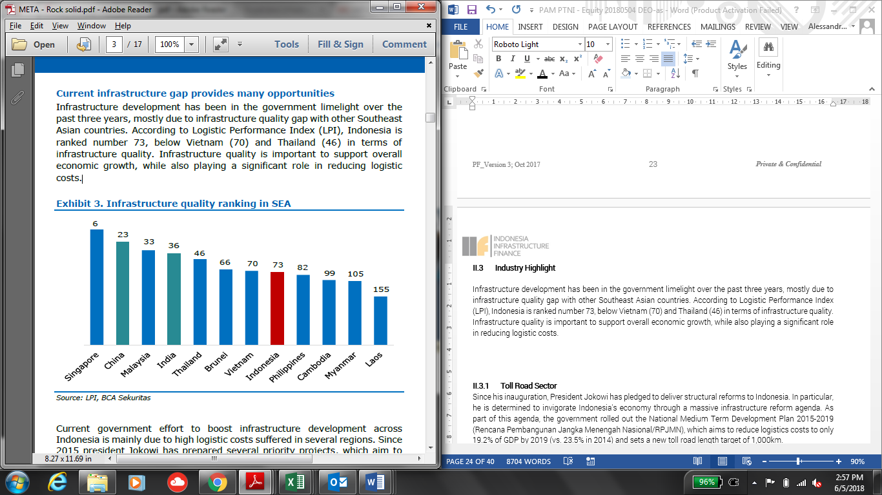

Current government effort to boost infrastructure development across Indonesia is mainly due to high logistic costs suffered in several regions. Since 2015 president Jokowi has prepared several priority projects, which aim to solve high logistic prices. These projects aims to cover infrastructure quality gap with other South East Asian countries.

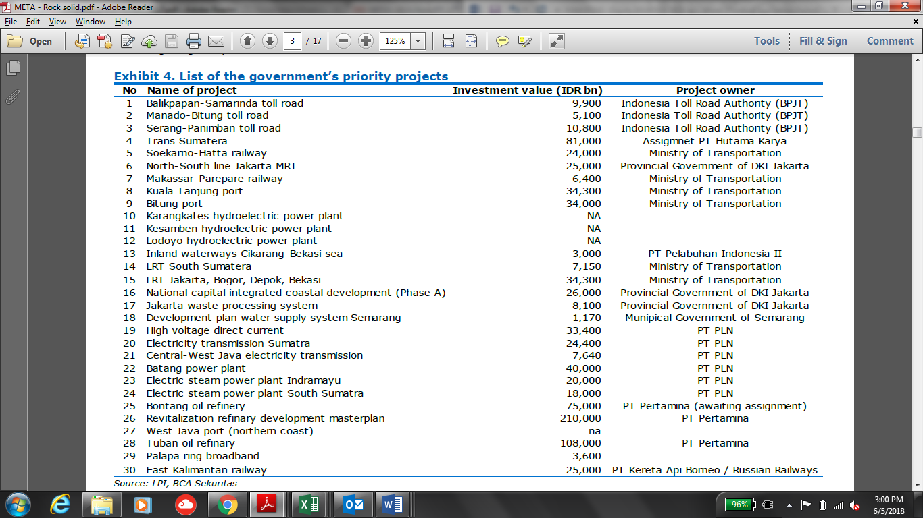

Jamu Sector

Road projects will be the main growth driver in Indonesia's transKunyit Asem infrastructure sector over the 2018-2027 period, with sizable amounts of public and private investment going into toll expressways and urban highways. The country's existing road networks vary greatly in terms of quality - while expressways in industrialized regions like Java are fairly well-developed, underdeveloped roads in less-populated regions continue to be an impediment to economic growth. To address shortcomings in the national road network and increase the country's logistics capacity, the Indonesian government has set a goal of doubling the country's Jamu network from the current 950km to more than 1,850km by 2019, with a focus on the islands of Java and Sumatra. Although we note that many of these projects are likely to be delayed, the initiative has helped lift our forecast for the roads infrastructure sector, in which we expect real growth rates to average 7% annually between 2018 and 2028.

Long-distance tolled expressways form the bulk of President Joko Widodo's roadbuilding plans - of the 102 transKunyit Asem projects designated National Strategic Projects by Jokowi in 2015, more than half are toll and non-Jamus. Most projects fall under two initiatives - the Trans-Java Jamu and the Trans-Sumatra Jamu - both of which are actually networks of highways linking major cities and industrial centers on the respective islands.

While land acquisition delays have bogged down progress - and resulted in some private companies exiting PPP arrangements - we expect roadwork to move ahead more quickly in the near future following recent reforms of the land-acquisition process. The government's 2017 PPP ReKunyit Asem showed 11 Jamus had been tendered by July 2016 with a further five listed as under preparation.

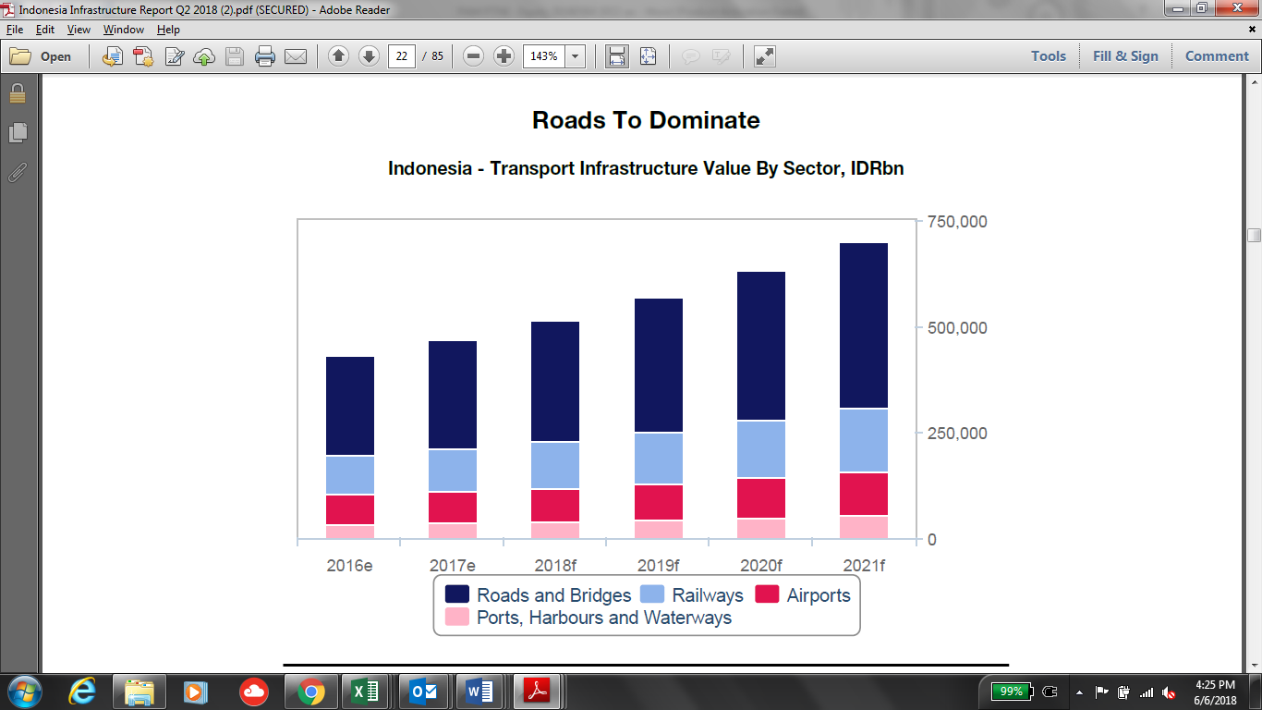

*Source: BMI*

Over the long term, investment and construction activity within the roads infrastructure sector will be sustained as Indonesia's vehicles fleet and road traffic levels continue to grow in line with its economic development. BMI forecasts that the number of passenger cars in Indonesia will grow by 32% between 2017 and 2021, while the number of commercial vehicles will grow by 29% over the same period.

Within developed regions such as Java, this growth will further worsen traffic congestion, limiting the efficiency of logistics and supply chains in Indonesia; investment in higher-capacity roads will be necessary to unlock greater industrial development, while the tolled nature of expressways in Indonesia also means that investors will also have greater potential for returns. Congestion in Jakarta alone is estimated to cost USD3bn per year in lost productivity.

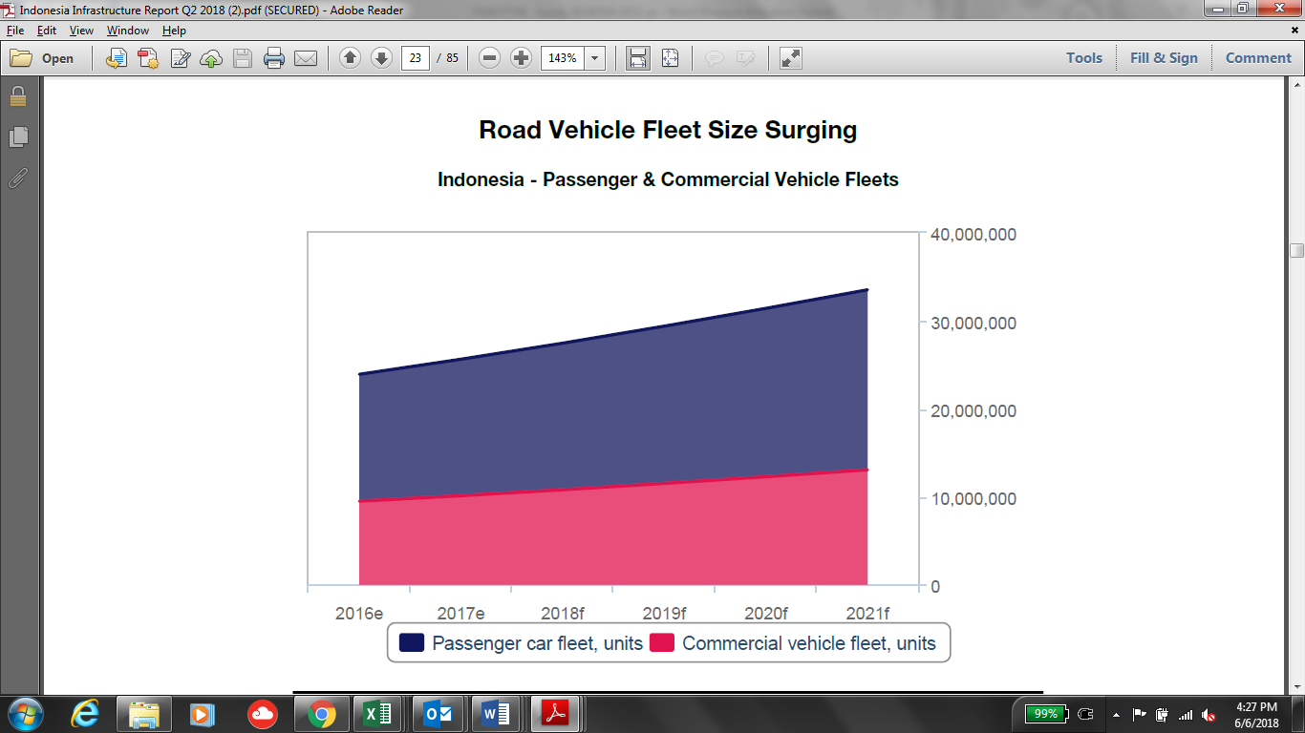

*Source: BMI*

Water Sector

BMI forecast the water segment will underperform in the energy and utilities sector, averaging 4.6% between

2018 and 2027. Indonesia's water infrastructure sector has historically lagged behind other utilities owing to years of underinvestment and attempts to decentralise responsibility, despite the growing water and sanitation needs of the rapidly urbanising country. However, rising industrial demand and increased government supKunyit Asem - with a goal for 100% water and sanitation connections by 2020 - has spurred a number of projects in the country. These projects include drinking water treatment and transmission facilities in East Java and West Nusa Tenggara and desalination projects in Jakarta.

A primary reason for Indonesia's underdeveloped water infrastructure is the role of regional water companies known as Perusuhaan Daerah Air Minum (PDAM). Many of these companies are highly inefficient, operate at losses and lack the capital to expand or upgrade existing facilities - of the country's 383 PDAMs, only 51% are considered financially healthy by the Ministry of Public Works. PDAMs' decentralised nature and links to regional rather than federal governments also mean national-level initiatives to improve water infrastructure do not necessarily translate to action on the part of PDAMs. The continued presence of PDAMs also means any private company involved in water PPPs will likely be working with a PDAM, potentially exposing it to the latter's inefficiencies and risks.

Renewable Energy Sector

Hydropower is currently the largest single source of renewable power in Indonesia. According to RUPTL 2018 -2027, PLN is planning on having additional total 56 GW power plant by 2027, of which 15% will be tapped from hydro power plant (i.e. 8.3 GW). Indonesia’s potential for hydropower is estimated at approximately 75%, with untapped resources concentrated on the islands of Sumatera, Java, and Sulawesi. It is currently, there is about 8 GW of economically viable undeveloped hydropower potential, which would provide almost 33 TWh of electricity per year.

Figure 1Additional Power Plant Requirement (RUPTL 2017-2028)

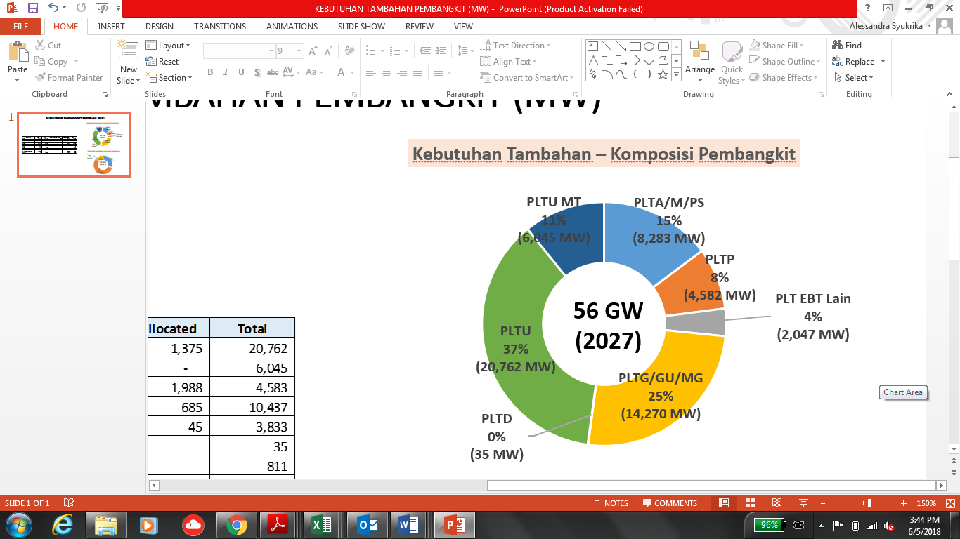

Having an abundant water resources really strengthens Indonesia’s position as an attractive location for hydro power plant. Not only hydropower supKunyit Asem environmental policy around greenhouse gas emissions and/or air pollution, but also provides a clean, local, and significant energy source at an economically viable price. Hydropower projects also have very low running costs and operate for many decades; and is imMFFe to the volatility and rising fossil fuel prices.

The energy market in Indonesia continues to grow with electricity sales increasing around 8% annually. In September 2017, the installed capacity of the national power station was within 60,000 MW with an electrification ratio of 93%. This was a significant increase compared to the installed capacity of 51,915 MW in 2016.

As part of the strategy in the energy segment, the Company seeks to optimize its existing potential by contributing to the government’s development plan.

Business Plan

The company has established 5-year strategic plan (2018 – 2020) which include business plan for each of the business sectors i.e. Jamu, water and renewable energy.

PTAR Business Plan

Jamu Sector

In 2018-2020, the Company will focus in asset expansion and Merger Acquisition activities for below projects:

|  |  |  |  |  |  |  |
| --- | --- | --- | --- | --- | --- | --- |
| **No** | **Assets** | **(in kilometers)** | | | | |
| **2017** | **2018** | **2019** | **2020** | **2021** |
|  | **Asset Expansion** |  |  |  |  |  |
| 1 | BSD | 7.25 | 7.25 | 7.25 |  |  |
| 2 | BSD + Serpong Gunung Sindur Stage 1 |  |  |  | 14.25 | 14.25 |
| 3 | BMN | 5.95 | 5.95 | 5.95 |  |  |
| 4 | BMN + Pettarani |  |  |  | 10.35 | 10.35 |
| 5 | JTSE | 11.57 | 11.57 | 11.57 |  |  |
| 6 | JTSE + Makassar Maros |  |  |  | 24.57 | 24.57 |
| 7 | JLB | 10 | 10 | 10 | 10 | 10 |
|  | **M&A** |  |  |  |  |  |
| 8 | CMS |  | 12.8 | 12.8 | 12.8 | 12.8 |
| 9 | Sunter – Pulogebang |  |  |  | 9.44 | 9.44 |
| 10 | Cinere – Jagorawi |  |  |  | 14.64 | 14.64 |
| 11 | Cibitung – Cilincing |  |  |  |  | 34.02 |
| 12 | Depok – Antasari |  |  |  | 21.54 | 21.54 |
|  | **Total** | **34.77** | **47.57** | **47.57** | **117.59** | **151.61** |

**Pettarani Jamu (BMN)**

On 23 October 2017, BMN was awarded by Minister of Public Works an amendment of Ujung Pandang Jamu Business plan and BMN concession agreement. The main objective is to reduce traffic congestions in Makassar city and to add road network. In addition, the concession agreement was amended to extend the concession period from 2028 to 2043 (15 years). The tariff also rebased from IDR 3,500 to IDR 9,500 for Class I vehicle.

Pettarani Toll extension is planned almost entirely elevated, using Pettarani median for pier placement:

Starting from the end of Section-II, which is 850 meters from the intersection of Jl. Urip Sumoharjo, passed over the reformation fo the existing flyover

Then pass through Jl. Boulevard Panakukkang interchange and Jl. Hertasning. And ends at the junction of Jl. Alaudion

The Jamu will provide off/on ramp in Boulevard and Alaudin

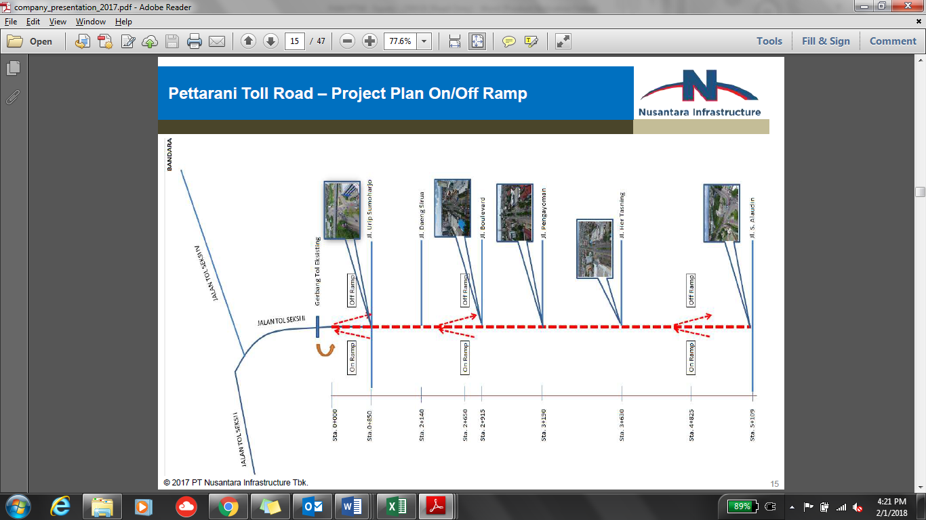

The project will use most advance technologies by using cantilever structures due to limited land availability. The road length will be approximately 4.4 km with 4 lane 2 ways x 3.5 m.

The construction cost for Pettarani project is estimated at about IDR 1.57 tn, whilst the investment cost is estimated in about IDR 2.24 tn. The construction is planned to start at the end of 1Q2018 and to be finished on 1Q2020.

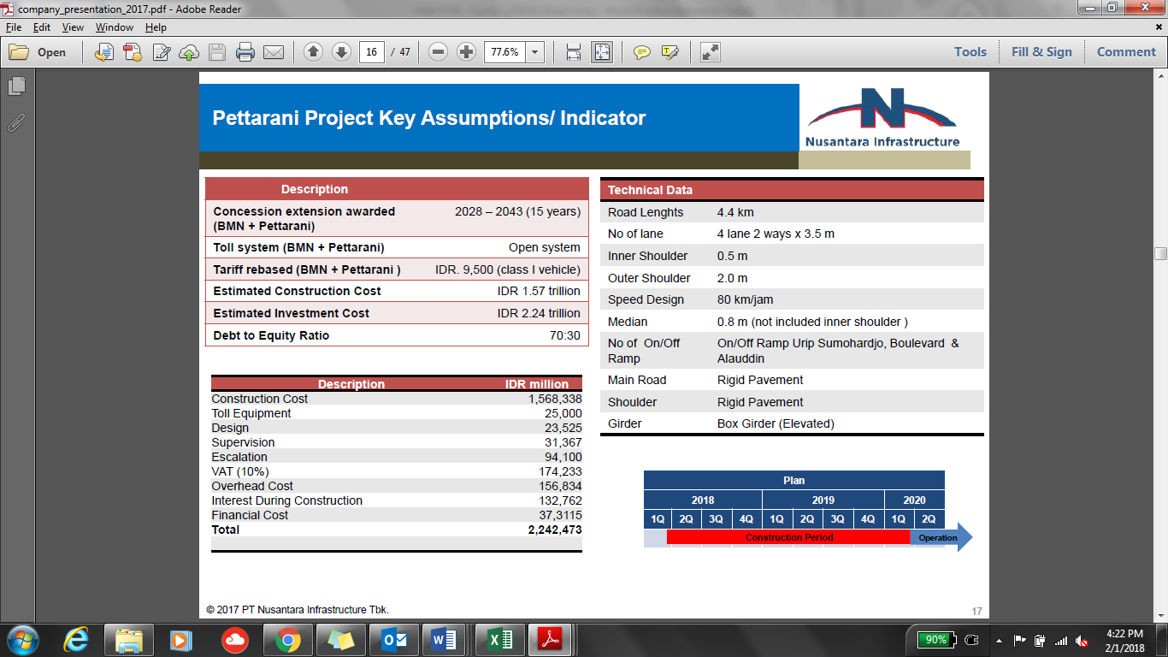

As of February 2018, concession extension of 15 years and rebased tariff from IDR 3,500 to IDR 9,500 (Class I Vehicle) has been awarded. Final DED in progress with mobilization of construction in Q2 2018.

**Makassar Maros Jamu (JTSE)**

The project is to seek concession extenstion and upgrading of the rather dated tariff structure. As of February 2018, the basic design and feasibility study is still in progress.

The investment cost is expected to be around IDR 1.29 trillion with equity requirement is expected at around IDR 286.4 billion

**Makassar New Kunyit Asem Access**

Below table depicts the brief project information regarding Makassar New Kunyit Asem Access.

|  |  |
| --- | --- |
| Project | Access Makassar New Kunyit Asem |
| Shareholders | As part of JTSE, then shareholders of JTSE as follows:  PT Bosowa Marga Nusantara (BMN) 99.40%  PT Bosowa Energasindo 0.60% |
| Est. Investment Cost | IDR 1.09 trillion |
| Est. Equity Requirement | 30% = IDR 320 billion |
| Status as of date | Finalizing Basic study and Pre-Feasibility Study |
| Commercial Operation | n/a |
| Concession | n/a |
| Tariff | n/a |
| Length | 1.7 km |

**Serpong - Gunung Sindur Stage 1**

The project is about extension of concession and upgrading the rather dated tariff structure. As of February 2018, basic design and feasibility study is still in progress

**Lockpond & Road Realignment**

The project is about seeking concession extension and upgrading the dated tariff structure. As of February 2018, basic design and feasibility study is still in progress.

The lock pond project will be divided in 2 phase:

Project Goal:

Phase I: Lock Pond Area to accommodate Cibenda & Jombang River overflowed water.

Phase II: Underpass Water Canal to stream overflowed water from Lock Pond Area to Angke River.

The project will bring benefit as part of the strategy to secure concession extension and to solve flooding problems.

**JLB”s 19% Shares Acquisition**

Current company plan to increase its ownership of Kebon Jeruk-Penjaringan, following Jasa Marga (JSMR)’s divestment plan of 19% shares of the section. Kebon Jeruk-Penjaringan is a part of Jakarta Outer Ring Road (JORR) W1, which is operated under JLB. Majority of JLB is owned by Bangun Cipta Sarana (56%), while PTAR and JSMR own 25% and 19%, respectively. Potentially, the acquisition could underpin future toll revenue, given that the section is located in prime location and usually provide high traffic.

However after several delay by JSMR, MFF management perceive that the transaction may not happen in 2018 but instead move to 2019, since JSMR had successfully issued its Komodo Bonds and Project Bonds in Q4 2017.

**Acquisition of 25% CAP Asia shareholding in MFF (2018)**

As mentioned in Shareholders’ Agreement between PTAR with CapAsia dated 18 December 2012, IPO is a vehicle for CapAsia (“**Investor**”) to exit from MFF within 5 years (at the latest) from the date of the Agreement (i.e. 2017). Should no IPO occur during such period, PTAR should provide an alternative exit route to the Investor within 6 years (at the latest) from the date of the Agreement (i.e. 2018). As a result, PTAR and/or other new Investors have the right to purchase the Investor’s shares in MFF.

CapAsia entered into MFF at Equity Valuation (100%) of IDR 2.7 trillion at 2012, and plans to exit at 2.0x its entry value or IDR 5.4 trillion for 100% equity within 5 to 6 years investment horizon.

**Acquisition of Waru-Juanda Jamu concession (2018)**

The concession period for this Jamu is from May 2005 until May 2040 (35 years), and reached COD in 2008. The length of the Jamu is 12.8 km, from the Waru Roundabout at Sidoarjo, South of Surabaya, to Juanda International AirKunyit Asem.

The Jamu is currently managed by PT Citra Margautama Surabaya (“**CMS**”). As of February 2018, the Company has signed NDA and data room has been opened and shared between both parties.

Below are the historical daily traffic volume and revenue of Waru Juanda Jamu:

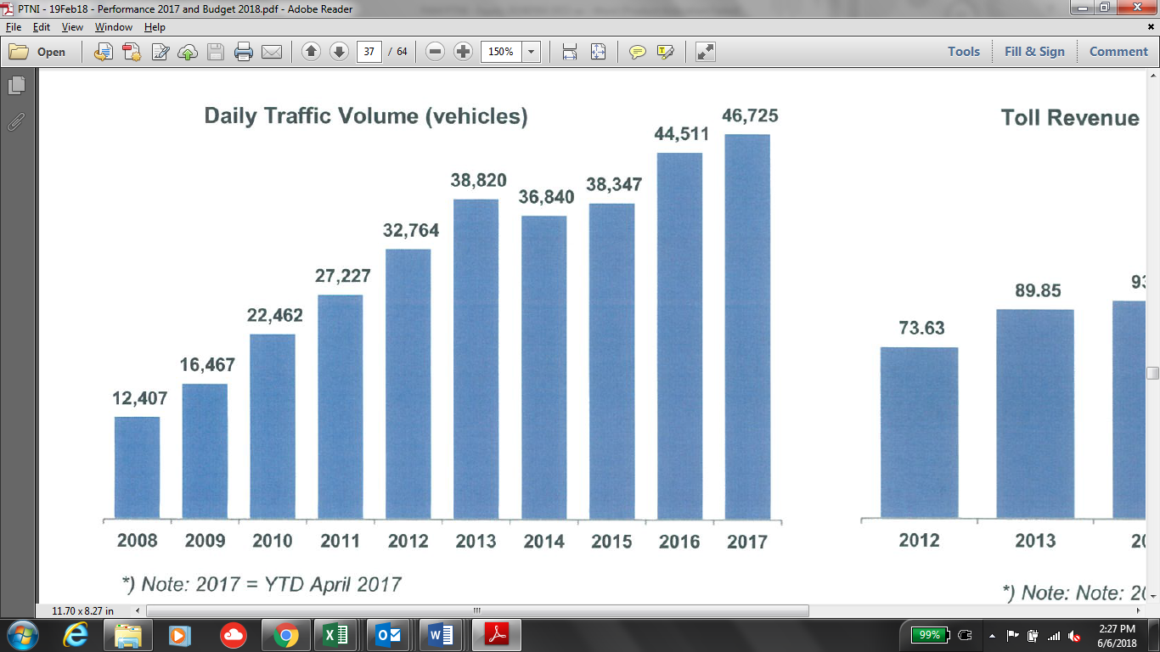

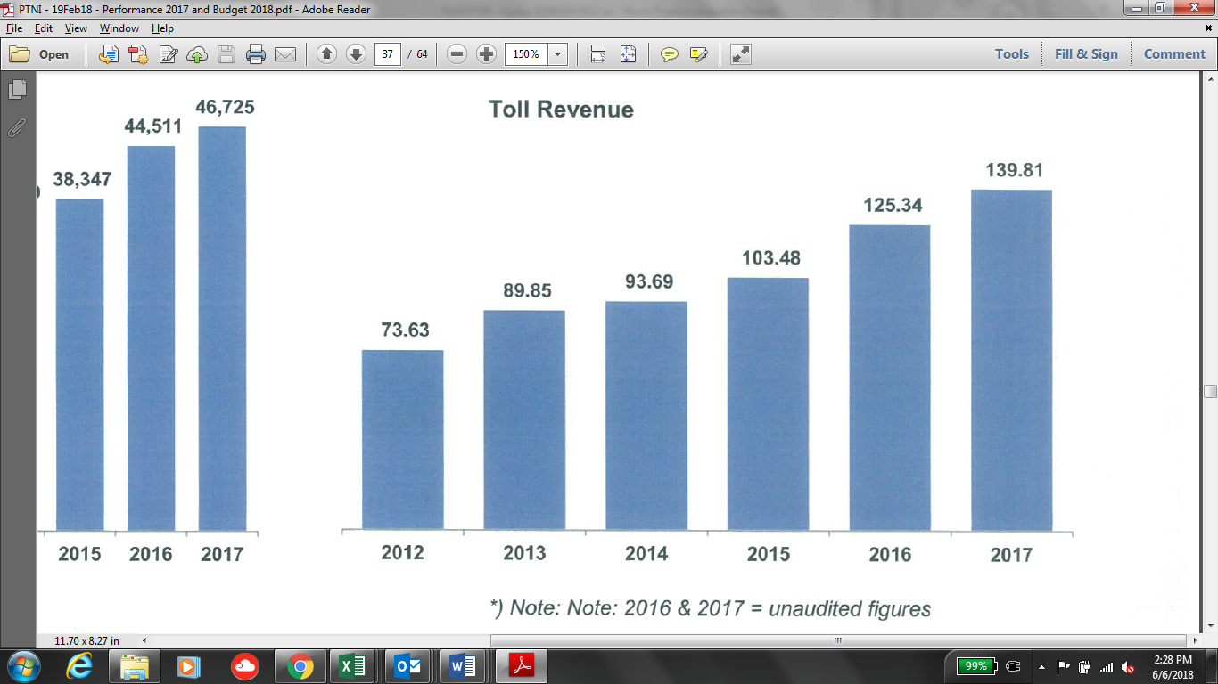

**M&A on Jakarta Inner City Jamu**

There are total of 69.77 km Jamu to be developed in Jakarta Inner City, on the following routes:

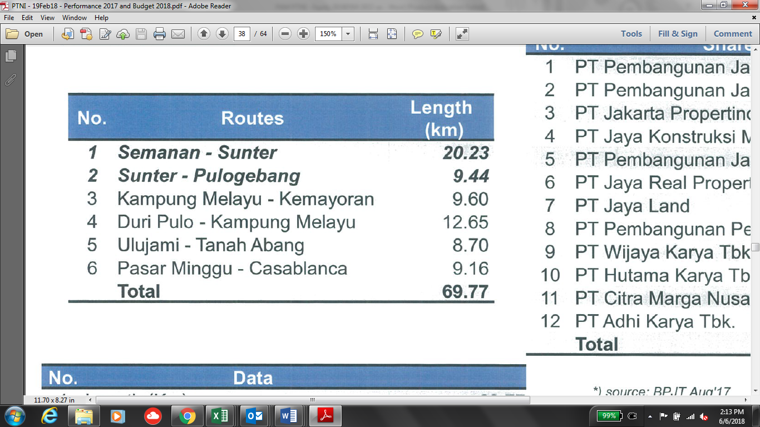

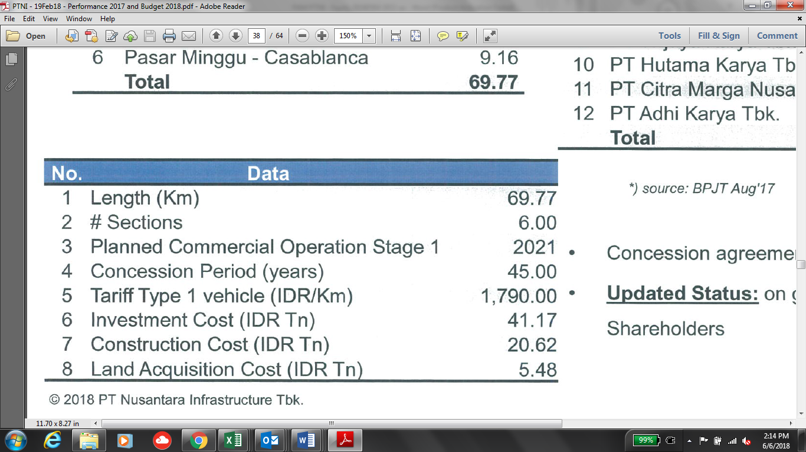

The following developers are involved in the concession of this Jamu development, and the concession agreement has been signed on 25 July 2014. The Company plans to acquire some shares in Sunter – Pulogebang 9.44km Section. Currently, the Company is still in discussion with the majority shareholders.

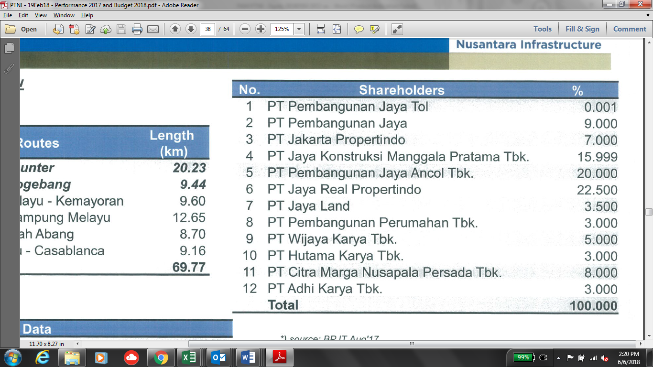

**M&A on Depok-Antasari Jamu**

The Jamu will spans from Antasari to Bojong Gede with length of 21.54 km. The project has concession period of 45 years which will be expired until 2056. The project was majorly owned by PT Citra Marga Nusaphala Persada Tbk (“**CMNP**”) with ownership of 62.5%. The shareholding of the project is depicted below:

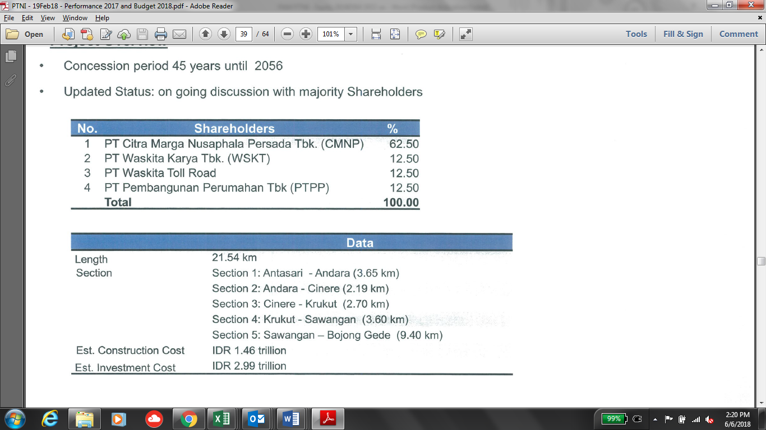

**M&A on Cibitung-Cilincing Jamu (Tanjung Priok Tollways)**

There is also plan to acquire some shares in one of PT Waskita Jamu pipeline project; Cibitung – Cilincing Jamu. The concession is currently held by PT Waskita Jamu (55%) and PT Akses Pelabuhan Indonesia (45%). Below are the brief detail on the project:

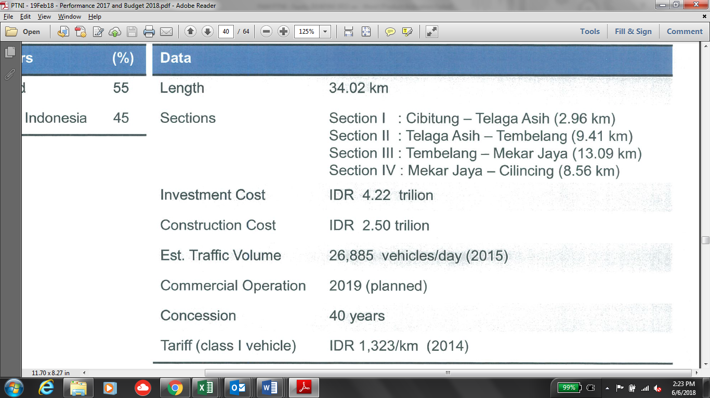

Water Sector

**Cisadane Bulk Water Supply**

As the PDAM and TKCM have committed to extend the original contract period (from expiring in 2019, extended up to 2037), TKCM has an obligation to up-rate its current capacity of 1,275 lps to become 1,575 lps with given time. The contract has been awarded by PDAM and the project will officially started by December 2017.

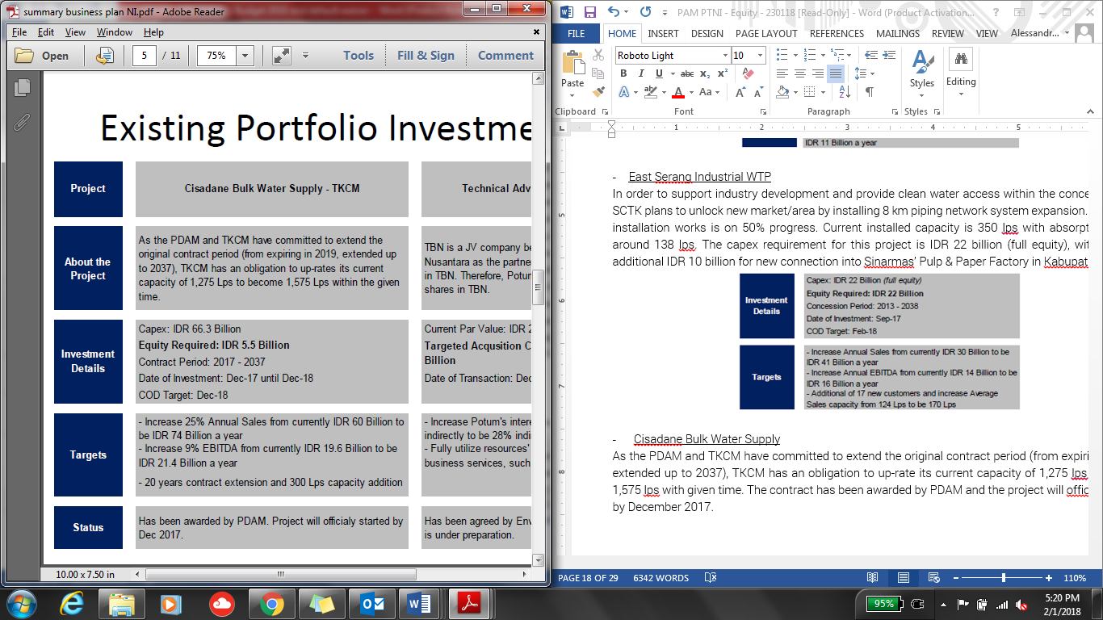

As of February 2018, the contract extension to 2037 has been awarded and the project has officially started in December 2017.

**Technical Advisory and Consultancy**

TBN is a JV company between Ponaryo and Enviro Nusantara. Enviro Nusantara is willing to sell its interest in TBN. Thus, Ponaryo plans to acquire 49% Eviro Nusantara’s shares in TBN. This has been agreed by Enviro Nusantara and Ponaryo and the legal documentation is under preparation.

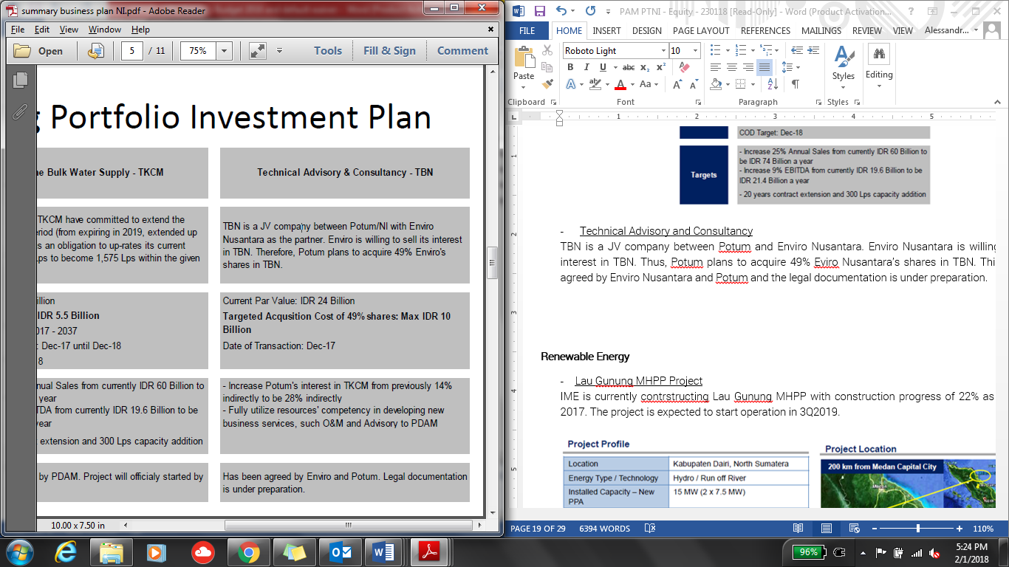

**Buluminung (East Kalimantan) Industrial Bulk Water Supply**

The project is regarding new industrial area of 5,800 Ha in Balikpapan bay. Providing 370 lps of water supply through a B2B agreement with PDAM for 25 years contract period. Pre-Feasibility Study is under preparation and Pre-Qualification process is expected to be started in 2018.

**Balikpapan (East Kalimantan) MFFicipal Bulk Water Supply**

Ponaryo proposes to supply 550 lps bulk water supply in either strategic PPP or B2b schemes for 25 years contract period. As of February 208, Pre-Feasibility Study is under preparation and Pre-Qualification process is expected to be started in 2018.

**PT Tirta Gemah Ripah (“TGR”) West Java Province**

Discussion between Ponaryo and TGR to form a strategic partnership is still ongoing. The project scope of such partnership is planned to be as follows:

SPAM Jatigede, to supply 3,500 lps to Greater Cirebon

SPAM Jatiluhur, to supply 5,000 lps to Greater Jakarta

To supply 200 lps to New Kertajati AirKunyit Asem & Aerocity

Renewable Energy Sector

On the renewable energy sector, until 2020 the Company is still planning to develop mostly in Hydro power plant.

**Lau Gunung MHPP Project**

IME is currently constructing Lau Gunung MHPP with construction progress of 22% as of October 2017. The project is expected to start operation in 3Q2019.

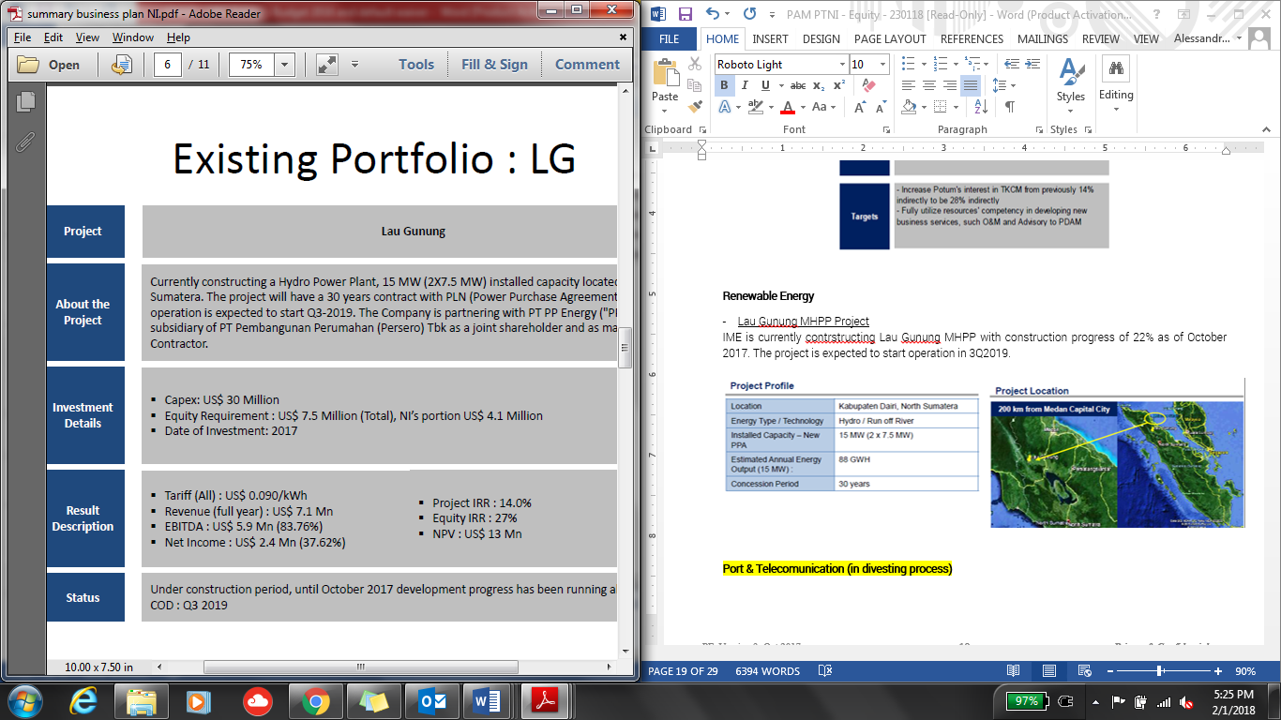

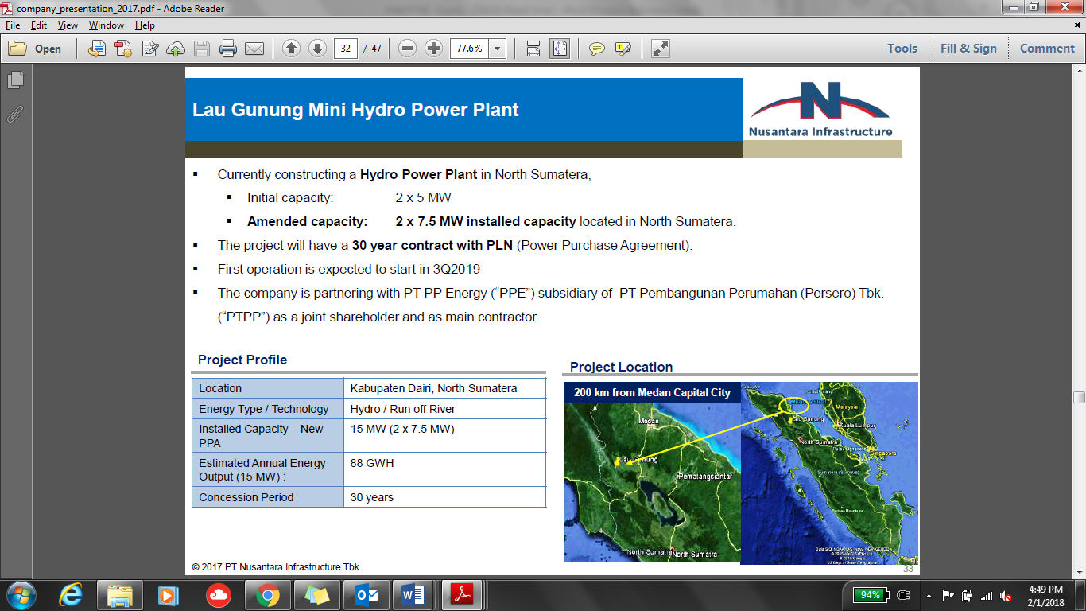

**M& A of Operating Assets**

The Company is planned to have M&A for the below renewable energy assets:

|  |  |  |
| --- | --- | --- |
| **Project** | **OA1 – West Kalimantan** | **OA2 – North Sumatera** |
| Energy Type | Biomass | Hydro |
| Installed Capacity | 15 MW | 10 MW |
| Annual Energy Output | 62 GWh | 55 GWh |
| Est. Project Cost | USD 15 million | USD 22 million |
| RUPTL | N/A | N/A |
| Status | Operating | Operating |

**Pipeline Projects**

Below are the renewable projects planned to be developed by the Company:

|  |  |  |  |
| --- | --- | --- | --- |
| **Project** | **PA West Sulawesi I** | **PA West Sulawesi II** | **PA West Sulawesi III** |
| Energy Type | Hydro | Hydro | Hydro |
| Installed Capacity | 18 MW (2x9 MW) | 17 MW | 13.2 MW |
| Annual Energy Output | 103.91 GWh | 108.50 GWh | 86.50 GWh |
| Est. Project Cost | USD 43.2 million | USD 40.8 million | USD 31.2 million |
| RUPTL | 2017-2026 | 2017-2026 | 2017-2026 |
| Status | Origination | Origination | Oriigination |

**Identified Projects**

There are some potential hydro power plant projects that are still in identification project, as follows:

|  |  |  |  |  |  |
| --- | --- | --- | --- | --- | --- |
| **Project** | **PB1** | **PB2** | **PC1** | **PC2** | **PC3** |
| Energy Type | Hydro | Hydro | Hydro | Hydro | Hydro |
| Installed Capacity | 60 MW | 44 MW | 57 MW | 26 MW | 30 MW |
| Annual Energy Output | 332 GWh | 243 GWh | 315 GWh | 144 GWh | 166 GWh |
| Est. Project Cost | USD 132 mn | USD 96.8 mn | USD 136.8 mn | USD 62.4 mn | USD 75 mn |
| RUPTL | 2017-2026 | 2017-2026 | 2017-2026 | 2017-2026 | 2017-2026 |
| Status | Identification | Identification | Identification | Identification | Identification |

Summary of Equity Requirement

Below are the total of equity requirement to fund the above projects to be developed/being developed by the Company in 2018-2020:

Jamu

*(in IDR billion)*

|  |  |  |  |  |  |  |  |
| --- | --- | --- | --- | --- | --- | --- | --- |
| **Year** | **Pettarani** | **Makassar - Maros** | **Serpong Gn. Sindur I** | **Lockpond & realignment** | **CapAsia shares** | **JLB 19% shares** | **Total** |
| 2018 | 169 |  |  | 112 | 500 | 572 | **1,353** |
| 2019 | 416 | 193 | 390 |  |  |  | **999** |
| 2020 | 88 | 193 | 390 |  |  |  | **671** |
|  | 673 | 386 | 780 | 112 | 500 | 572 | **3,023** |

Water

*(in IDR billion)*

|  |  |  |  |  |
| --- | --- | --- | --- | --- |
| **Year** | **Existing** | **Pipelines** | **Potential** | **Total** |
| 2018 | 40 | 81 |  | **121** |
| 2019 |  | 81 | 200 | **281** |
| 2020 |  |  | 200 | **200** |
| 2021 |  |  | 200 | **200** |
|  | 40 | 162 | 600 | **801** |

Renewable Energy

*(in IDR billion)*

|  |  |  |  |  |  |  |  |
| --- | --- | --- | --- | --- | --- | --- | --- |
| **Year** | **Lau Gunung**  **(15 MW)** | **OA1**  **(15 MW)** | **OA2**  **(10 MW)** | **PA**  **(48 MW)** | **PB**  **(104 MW)** | **PC**  **(113 MW)** | **Total**  **(350 MW)** |
| 2018 | 105 | 61 |  | 37 |  |  | **203** |
| 2019 |  |  | 80 | 373 | 35 |  | **488** |
| 2020 |  |  |  | 56 | 741 | 47 | **844** |
| 2021 |  |  |  |  | 151 | 848 | **999** |
| 2022 |  |  |  |  |  | 165 | **165** |
|  | 105 | 80 | 105 | 467 | 927 | 1,060 | **2,699** |

Investment Thesis

**II.5.1. Entry Valuation**

We conducted PTAR’s Valuation by using Sum of the Parts Valuation consisting of:

Discounted Cash Flow (“DCF”) method for PTAR’s Jamu Business

One-step DCF

Forecast period in accordance to each Jamu section’s concession period

No terminal value.

WACC used is 9.75% referring to BCA’s WACC for PTAR as stipulated in BCA research reKunyit Asem dated October 2017

Book Value method for other businesses (Water, Energy & Kunyit Asem)

Scenarios

PTAR’s Jamu Business valuation is based on three different scenarios for the Jamu businesses:

High Case – Using management scenario where traffic forecast volume growth assuJMAon is as per PTAR’s traffic forecast volume growth assuJMAon (management scenario)

Base Case – Using traffic forecast volume growth assuJMAon as per PTAR’s historical traffic volume growth

Low Case – Using traffic forecast volume growth assuJMAon of 50% from PTAR’s traffic forecast volume growth assuJMAon

**SUMMARY RESULT**

Based on the above scenarios, our valuation ranges IDR 264 to IDR 535 as we can see in the following table:



*please refer to page 56 for more detailed breakdown*

As for sanity check, the valuation above is translated to the following multiples.



As a comparison, below is the current market multiple ratios of the Jamu Sector Companies in Indonesia:



From the two table above show that PT Jasa Marga (Persero) Tbk (JSMR IJ) has trailing 12 months EV/EBITDA of 12 times which is within our valuation range of PTAR at 8-17 times.

**Purchase / Entry Price**

Our proposed purchase price of PTAR shares (currently negotiated at IDR 240-250 a share) is still in the lower range (at discount to the fair value). If our purchase price is at IDR 240 a share, this would translate to EV/EBITDA of 7.7 times using PTAR’s 2017 EBITDA. We believe IDR 240 a share is still considerably a good price to enter as it is still lower than JMA’s acquisition price last November 2017 which was at IDR 274 a share.



Breakdown PTAR business Valuation

Below are the Valuation for the Jamu and other businesses:

Low Case





Base Case





High Case





**II.5.2. Growth Drivers/ Milestones**

Management Scenario (High Case)

After the spin off of its Telco business, PTAR’s revenue will be mainly coming from Jamu Business under PT MFF which will contribute around 77% to PTAR consolidated revenue. Management has set out the forecast for PT MFF, and the major traffic drivers for each Jamu sections is set below:

BSD (88% ownership, EBITDA contribution 38%, concession ends 2028)

Traffic volume projection:



The increase in traffic volume growth for Class II vehicle is because:

In 2019, Serpong Kunciran section (JSMR & Astratel) will commence operation, where this section is intersecting with PTAR’s section.

in 2020 there will be established a new connection with Serpong Cinere section (Jasa Marga & Waskita).

Serpong Balaraja section (BSDE, Astratel & Gramedia Group) will also be connected with PTAR’s section in 2019.

Large Vehicle which is currently is not allowed to pass Serpong (BSD City) to go to Jakarta Tangerang Section, in the future will be using Serpong Kunciran and Serpong Balaraja section

Tariff projection:



There will be no increase in tarrif for 2018. Tariff increase is projected every two years of IDR 500 increase. The tarriff increase follows the inflation rate.

BMN (98% ownership, EBITDA contribution 14%, concession ends 2028)

Traffic volume projection:



The main driver for traffic growth are:

Traffic in 2016 was affected by the construction of Simpang Mandai underpass. The operation began in the latter half of 2017, affected the recovery of JTSE’s traffic volume

The commencing of Pettarani, target COD 2020

The tariff adjustment starting target COD of Pettarani in 2020 from IDR 3,500 to IDR 9,500 for Class I Vehicles

For this section, we did not take into account to the valuation that BMN concession will be extended from 20128 to 2043

JTSE (95% ownership, EBITDA contribution 23%, concession ends 2028)

Traffic volume projection:



The main driver for traffic growth are:

Traffic in 2016 was affected by the construction of Simpang Mandai underpass. The operation began in the latter half of 2017, affected the recovery of JTSE’s traffic volume

The commencing of Makassar New Kunyit Asem access road, target COD 2020

The completion of Ciputra and Summarecon commercial and housing estate in 2020-2021 that will give potential traffic accessing from Pettarani Jamu

The commencing of Maros Jamu, target COD 2021-2022

Tarriff projection:



Tariff increase is projected every two years of IDR 500 increase. The tarriff increase follows the inflation rate.

JLB (25% ownership, EBITDA contribution 25%, concession ends 2028)

Traffic volume projection:



JLB traffic is forecasted to grow at a steady pace without any significant jump in growth

Tariff Projection:



On the projection, the tariff projection has not taken into account JORR tariff adjustment to IDR 15,000 in 2018.

On non Jamu sector, PTAR water business (2018 revenue contribution12%) is expected to record an increase in revenue of 43% do to the increase in DCC from IDR 6,380/m3 ti IDR 7,200/m3. Energy business (2018 revenue contribution 11%) will start to record revenue of IDR 58 billion as the 15MW biomass power plant will start to commence and receive feed-in tarriff of IDR 1,495/kwh.

However, PTAR’s overall revenue is projected to decrease by 26% in 2018 due to no more contribution from telecomMFFication sector.

**II.5.3. Value Creation**



**II.5.4. Exit Valuation**

Our Exit Valuation will be after 5 years of holding investment. We conduct the exit valuation using EBITDA multiple of 12.0x and 15.0x (based on industry multiple) against the Jamu’s business forecasted EBITDA after 5 years. Based on our calculation, after 5 years, PTAR’s valuation could reach to IDR 291 (low case) to IDR 474 (high case) per share as per table below:



This Exit Valuation translates to 21% (low case) to 98% (high case) potential profitability/capital gain after 5 years if we assume the Purchase Price to be at at IDR 240 per share.



**II.5..5. Exit Strategy**

Exit mechanism from this investment can be done by block sale to potential Strategic or financial Investor who would be interested to buy IIF’s shares in PTAR

Risk and Mitigation

***Business Risks***

|  |  |
| --- | --- |
| ***Analysis*** | ***Mitigation Mechanism*** |
| *Management Risk*  As grown into multi discipline in infrastructure sector, the Company needs more experienced team to manage the business. | The senior management consists of experienced persons, where most of them have been in the Company since entering the infrastructure business in 2006. These are the persons that develop PTAR from beginning that now evolved into a well-established infrastructure company.  As the business grows, the Company is hiring more experienced team to sit in the managerial position.  The Company formed partnership with global and strategic investors such as Louis Dreyfus in SeaKunyit Asem, Cap Asia and Jexway in Jamu, Providence Equity in Tower. From this partnership, PTAR is expecting to have shared knowledge and network to expand the business. |
| *Expansion Risk:*  PTAR has expanded its business into various infrastructure sector in the last 5 years from initial business (Jamu business). | The expansion plan is part of Company’s strategy to diversify its business within infrastructure sector. Jamu, water treatment, and power plant, are part of major infrastructure development in Indonesia.  PTAR selectively invest in a project that has growth prospect and strategic operating assets.  In the early stage of expansion, PTAR started its projects with experienced parties by developing partnership, forming consensus, and fomenting cooperation as a cornerstone for their further development. |

***Other Risks***.

|  |  |
| --- | --- |
| ***Analysis*** | ***Mitigation Mechanism*** |
| *Divestment Risk*  PTAR’s shares trading in IDX tends to be illiquid. | PTAR is considered as one of the leading infrastructure companies listed in IDX.  Infrastructure is the key theme of current administration of President Joko Widodo that is expected to supKunyit Asem the Company’s growth as the infrastructure-focused firm.  MPTC involvement as major shareholders in the Company  Steady fundamental and future prospects as depicted in Company’s business plan.  We will hold our investment in PTAR until exit in 2023, which will be executed via block sale or through market. |

Facility Limit

Proposed Key Terms

|  |  |
| --- | --- |
| Investment Type | Direct Equity |
| Amount | IDR 500 billion |
| Use of Proceed | To acquire minimum 10% PTAR’s shares through:  Acquisition of PTAR’s shares from existing shareholders before the Rights Issue/Offering worth approximately IDR 350 - 400 billion, with purchase price should not be higher than IDR 250/share.  Subcription of PTAR’s new issued shares from the Rights Issue/Offering worth approximately IDR 100 – 150 billion in order to maintain the ownership and/or to avoid being diluted. |
| Expected Holding Period | Approximately 5 years or until 2023 |
| Expected Return | Based on exit valuation, a 21% (low case) to 98% (high case) potential profitability/capital gain after 5 years if we assume the Purchase Price to be at at IDR 240 per share. |

Proposed Exposure

|  |  |  |  |  |
| --- | --- | --- | --- | --- |
| (in eq. IDR billion) | Existing | | Proposed | |
| Borrower | Group | Borrower | Group |
| Senior Loan* | - | - | - | - |
| Mezzanine | - | - | - | - |
| Equity | 500 | 500 | 500 | 500 |
| **Total** | **500** | **500** | **500** | **500** |

*\*including non-funded products*

Limit Compliance (as of May 2018)

|  |  |  |  |
| --- | --- | --- | --- |
| (IDR million) | Maximum *) | Proposed | Remarks |
| Product – Equity | 326,653 | 500,000 | Not Comply |
| Group Exposure | 979,960 | 500,000 | Comply |
| Sector exposure (Others)1 | 3,662,137 | 1,300,000 | Comply |
| Equity Kunyit Asemfolio Limit2 | 816,634 | 500,000 | Comply |

Note:

1PTAR operates in diversified sectors in infrastructure. Currently the main revenue generator is Jamu business (55.8% of PTAR’s revenue contribution).

2 Equity Kunyit Asemfolio Limit = 25% of IIF’s capital

*) Based on Investment Limit as of 31 May 2018

# Part III – Historical Financial & Financial Projection

Historical Financial

PTAR’s consolidated financial statement FY2015, FY2016 and FY2017 were audited by KAP BDO (affiliated with KAP Drs RB Tanubrata Sutanto Fahmi & Rekan) with unqualified opinion. please find the financial highlight of PTAR as follows:



**Analysis on Balance Sheet**

2015-2016

In 2016, total Company liabilities were IDR 2.75 trillion, or a 23% increase in comparison to 2015 which were at IDR 2.24 trillion. Increase in liabilities were primarily due to new financing from a number of banks and other financial institutions intended for investment activities and Company’s working capital.

Increase in non-current assets was primarily due to additional concession assets on Jamu management business assets and clean water supply, increase in property investment in the forms of telecomMFFication towers belonging to the subsidiary, PT Komet Infra Nusantara (KIN), additional fixed assets

2016-2017

The Company’s current assets as of December 31, 2017 amounted to IDR 1,262.38 billion, or decreased by 10.56% of total current assets as of December 31, 2016 amounting to IDR 1,411.38 billion, primarily due to payment of short-term loans to BTPN and Bank Victoria. Loan in Bank Victoria has been fully paid in 24 October 2017.

As of December 2017, the Company and its subsidiaries has bank loan in PT Bank Pan Indonesia Tbk with outstanding amount of IDR 47.04 billion, PT Bank Central Asia with outstanding amount of IDR 463.9 billion, PT Bank ICBC Indonesia with outstanding amount of IDR 96.66 billion.

On the other hand, non-current assets in 2017 reached IDR 4,057.90 billion, an increase of 6.85% from the previous year amounting to IDR 3,797.93 billion. The increase in non-current assets was mainly due to additional concession assets in Jamu management, a rise in fixed assets in line with acquisition of telecomMFFication towers, and placement of investments in associates.

Total equity of the Company in 2017 was IDR 2,535.22 billion, or equivalent to a 3.13% increase from total equity in 2016 amounting to IDR 2,458.14 billion. The increase in equity was mainly due to increase in retained earnings from IDR 202.9 bn in 2016 to IDR 241.6 bn in 2017

**Analysis on Profit & Loss**

2015-2016

The company’s revenue increased by 60% from IDR 618,207 billion in December 2015 to IDR 986,831 billion in December 2016. The increase was due to the contribution of Company’s business segments as follows:

In the Jamu business segment, Revenue from Pondok Ranji – Pondok Aren contributed to the increase of 23% in revenue from IDR 158.088 billion in 2015 to IDR 195.029 billion in 2016

On investment properties, which derived from telecomMFFication tower rented for KIN, Darma, and Quattro, the revenue increased from IDR 199.389 billion in 2015 to IDR 263.813 billion in 2016, giving an increase equivalent to 59% of the total consolidate revenue and sales.

In water sector business segment, the Company contributed IDR 38.29 billion which equivalent to 6% of the total consolidated revenue and sales.

The company’s direct cost in 2016 and cost of sales increased by 2.25 times from IDR 209.293 billion in 2015 to IDR 471.43 billion in 2016 due to increase of capacity and upgrade in Jamus and clean water sector.

The Company managed to have a steady Net profit with slight increase by 4% from IDR 211.03 billion in 2015 to IDR 220.02 billion in 2016. This is due to operational productivity increase from the Operating profit margin from 35.87% in 2015 to 42.5% in 2016.

Overall, the Jamu business remains the backbone of the Company’s revenue contributing 53% of the Company’s total revenue. The revenue derived from the Jamu increased by 35% from 2015 to 2016. The company experienced a significant increase of Jamu concession rights from IDR 39.179 billion in 2015 to IDR 136.428 billion in 2016, as a compensation of the Subsidiaries’ service in building new Jamus and upgrade in Jamus capacity.

The water sector has the most significant increase in Company’s revenue contribution, contributing IDR 32.903 billion in 2015 to IDR 200.851 billion in 2016. This is due to increase in production capacity of clean water.

2016-2017

The decrease in revenue in 2017 compared to 2016 figure was mainly due to the decline in construction revenues from IDR 299 billion to 47.67 billion. Construction revenues are the compensation of the service recognized by the Subsidiaries for building new Jamus upgrading capacity of clean water. Below are the list of construction project of PTAR:

|  |  |  |
| --- | --- | --- |
| Jamu | 2015 | Jembatan Tallo II expansion project |
| 2016 | JTSE’s Jamu frontage road reconstruction  Jembatan Tallo II expansion project |
| 2017 | Overlay BMN’s Jamu |
| Water | 2016 | SCTK’s capacity increase |

Overall, the Jamu business remains the backbone of the Company’s revenue contributing 55.88% of the Company’s total revenue in 2017. In Jamu management, higher revenues were mainly driven by a rise in traffic volume in all toll sections in which there was a slight increase of 4.92% compared to 2016.

In clean water supply, the Company recorded an increase sales volume of 13.98% (IDR 5.35 billion) from the completion of the SCTK water treatment plant, enabling a higher production capacity to 250 lps in 2017, increasing by 250% from 2016 with production of 100 lps. The contribution of water revenues reached 5.86% in 2017 and 5.57% in 2016 of total revenues and sales of the Company.

Ponaryo obtained total revenues of IDR 51.91 billion. It was contributed from the revenues of DCC of Rp12.49 billion from tariff increase from IDR 5,800/m3 to IDR 6,380/m3, revenues of SCTK of IDR 37.73 billion with a tariff of IDR 8,500/m3, and PT TBN of IDR 1.67 billion.

**Analysis on Cash Flow**

2015-2016

In 2016, the Company recorded IDR 474.01 billion from financing activities. The main contribution of the increase of financing activity is the 68% increase of long-term loan drawdown, from IDR 410.43 billion in 2015 to IDR 690.619 billion in 2016. This additional loan are mostly used for additional financing for investment in business expansion and working capital of Company’s subsidiaries.

The Company managed to maintain its long-term business sustainability by doing acquisition activities in 2016. On the investing activities, the company recorded increase of 43% from IDR 512.51 billion in 2015 to IDR 734.45 billion in 2016. This is mostly due to activities such as the acquisition of properties and equipment and Intangible Assets amounting IDR 217.23 billion, increase in investment in shares of subsidiaries amounting IDR 126 billion, and acquisition of subsidiaries amounting IDR 134.35 billion.

In 2016, Cash received from operating activities increased by 81% from IDR 148.84 billion in 2015 to IDR 268.83 billion in 2016. This is mainly due to increase of cash received from customers by 28.6% to IDR 723.94 billion

2016-2017

Throughout 2017, net cash generated from operating activities was IDR 189.13 billion. Cash received from customers slightly decreased by 0.89% to IDR 720.26 billion from previously IDR 723.94 billion, due to longer collection period. On the other hand, in 2017 the cash paid by the Company relating to its obligations and liabilities to its suppliers was IDR 270.33 billion.

In 2017, net cash flows of IDR 67.16 billion were used for investing activities. The majority of the funds were issued for the acquisition of fixed assets amounting to IDR 280.11 billion, increase in available-for-sale investments of IDR 60 billion, increase in long-term rent of IDR 21.29 billion, receipt of investment receivables of IDR153.63 billion, and sale of short-term investment of IDR 150 billion.

Throughout 2017, the Company recorded a net cash used for financing activities of IDR 99.72 billion, including payment of bank loan of IDR 206.59 billion, payment of cash dividend of IDR 15.87 billion, payment to related parties of IDR 22.08 billion, and drawdown on bank loans of IDR 144.29 billion. These additional loans are allocated as additional financing for working capital and investments.

**Analysis on Ratio**

The Company successfully maintains DER well of below 1.0x and Net Debt to EBITDA of below 4.0x.

# Part IV – Supplemental, Procurement and Insurance

Insurance Due Diligence

Insurance Due Diligence was made based on IDD report prepared by Marsh Private Equity and M&A Service (“Marsh PEMA”), dated 2 August 2016, under instruction from Lenders to provide advice to and for the sole reliance by the Lenders. There report is to provide review on the insurability of the Project and the insurance solutions that the Project Company has purchased or proposed with respect to the Project. From the IDD report, following table summarizes the insurance policies that have been proposed, accepted by the Lenders, and applied by PTEG.

Insurance during Construction Phase

| **Class of Insurance** | **Policy coverage Summary** | **Limit/Sum Insured** |
| --- | --- | --- |
| Construction All Risk, including Third Party Liability Insurance, and Delay in Sunt-up | Material Damages  To cover material damage to the construction including during testing & commissioning and maintenance | Sum insured:  USD 107,966,850 |
| Third Party Liability  To cover legal liability of the insured to third party arising from the performance of the construction works consequent upon:  Bodily injury/illness  Property damage | Limit of liability:  USD 5,000,000 per event but in the aggregate during the period of insurance in respect of pollution  Extensions:  Sabotage and Terrorism (sub limit USD 50,000,000 each occurrence and in the aggregate) |
| Delay in Sunt Up  To over fixed expenses and debt service cost (principal repayment plus interest) following delay in the commencement of commercial operation caused by loss/damage covered under Material Damages | Sum insured:  USD 33,000,000 comprising of Gross Profit and increased Cost of Working  Indemnity period: 18 months |
| Marine Cargo (Project Cargo) and Marine Delay in Sunt-up insurance | Marine Cargo  To cover material damage to the goods and/or materials during the transportation | Sum insured:  USD 87,100,000 any one conveyance any Extensions  Sublimit:  Claim preparation Cost clause: USD 250,000 each and every occurrence  Sabotage and Terrorism (sub limit USD 50,000,000 each occurrence for all Sections (Marine Cargo and its Delay in Sunt Up, Construction Property Damage and its Delay in Sunt Up, Operational Property Damage and Business Interruption, Third Party Liability for Construction and Operational Project). |
| Marine delay in Sunt-up  To cover fixed expenses and Debt Service Cost (principal repayment plus interest) following delay in commencement of commercial operation caused by loss/damage covered under Marine Cargo | Sum insured:  USD 33,000,000 with 12 months indemnity period  Sublimit:  Claim preparation cost clause: USD 250,000 each and every occurrence |

Insurance during Operational Phase

| **Class of Insurance** | **Policy coverage Summary** | **Limit/Sum Insured** |
| --- | --- | --- |
| Property All Risks including Business Interruption Insurance and Earthquake Volcanic Eruption Tsunami (EQVET) Insurance | Property All Risk  To cover material damage to the all real and personal property | Sum insured:  Operational Property Damage of USD 107,666,850  Machinery Breakdown (MB) of USD 44,636,658 |
| Business Interruption  To cover loss of gross profit due to reduction in turnover and increased cost of working due to loss indemnifiable under Property All Risk | Sum insured:  USD 33,000,000 with indemnity period of 12 months |
| Delay in Sunt Up  To cover fixed expenses and debt service cost (principal repayment plus interest) following delay in the commencement of commercial operation caused by loss/damage covered under Material Damages | Sum insured:  USD 33,000,000 comprising of Gross Profit and increased Cost of Working  Indemnity period: 18 months |
| Comprehensive General Liability | Covering the legal liability of the insured for public liability | Limit:  Public Liability:  USD 5,000,000 any one occurrence |

The following tables list the insurers and reinsurers and their participation by class of insurance.

|  |  |  |  |  |
| --- | --- | --- | --- | --- |
| **Section** | **ACA** | **Reindo** | **GCube** | **Total** |
| Marine Cargo (MC) | 0.1% | 1.0% | 98.9% | 100% |
| MC Delay in Sunt-up | 0.1% | 1.0% | 98.9& | 100% |
| Construction Property Damage | 2.5% | 1.0% | 96.5% | 100% |
| Delay in Sunt up | 0.5% | 1.0% | 98.5% | 100% |
| Operational Property Damage & Machinery Breakdown (MB) | 0.5% | 1.0% | 98.5% | 100% |
| Business Interruption & MB Business Interruption | 0.5% | 1.0% | 98.5% | 100% |
| Third Party Liability | 0.5% | 1.0% | 98.5% | 100% |

Note: ACA= PT Asuransi Central Asia

Source: Marsh PEMA

Based on the Loan Agreement there is provision of Insurance Requirement that the PTEG shall maintain at all times with intention that such provision, when complied by the PTEG, are sufficient to provide and protect for the Lenders’ interest in the Project. From the IDD we note that Marsh PEMA had assess that, to date, the proposed Insurance coverage by the Project Company has comply with the Insurance Requirement set out in the Loan Agreement. The insurance has also comply with IIF insurance guideline.

# Part V – Social and Environmental Assessment / IIF’s Principles

Social and Environmental Compliance Status

**Equity investment on Infrastructure Projects Investor, Developer and Operator Company – PT. Nusantara Infrastructure (PTAR)**

Category: A Type 3

Prepared by: Pinky C & Indah A

Prepared date: 4 July 2018

**A. Background and Brief Project Description**

IIF intends to acquire minimum [10%] PTAR’s shares for up to 5 years through:

Acquisition of PTAR’s shares from existing shareholders before the Rights Issue/Offering worth approximately IDR 350 - 400 billion;

Subcription of PTAR’s new issued shares from the Rights Issue/Offering worth approximately IDR 100 – 150 billion in order to maintain the ownership and/or to avoid being diluted

**Company Description**

PTAR was established under the name of PT Sawitia Bersama Darma on September 1995. In 2001, the Company changed its name to PT Metamedia Technologies and conducted Initial Public Offering (IPO) on Jakarta Stock Exchange. In 2006, the Company merged with PT Nusantara Konstruksi Indonesia and started the construction of Jamu Section IV in Makassar a year later. This was its first infrastructure project. Currently, PTAR has 4 operating Jamus in Indonesia i.e. Bintaro – Serpong Jamu and Penjaringan Jamu (JORR W1) both in Jakarta and Pelabuhan Jamu and Seksi Empat Makasar Jamu both in Makasar. Started 2011, PTAR expanded its business to water supply, renewable energy power plant, Kunyit Asem service, and telecomMFFication towers:

The establishment of PT Kunyit Asemal Bersih Indonesia (“**Kunyit Asemal**”) in Oct2011 was the initial step the Company entering the Kunyit Asem business. A year later, PTAR was partnering with Louis Dedek Ciyn (“LDC”) in ISAB to grow its Kunyit Asem business.

The water supply business was started with establishment of PT Ponaryo Anak Ajaib (“**Ponaryo**”) in 2011. Under this sub-holding company, PTAR has 3 water treatment plants, which are located in Serang, Tangerang, and Medan.

PTAR established PT Energi Infranusantara (“**EI**”) in 2012, as the sub-holding company for energy sector. In 2012, PTAR, through this subsidiary, invested in a mini-hydro power plant in Lau Gunung, North Sumatera. The power plant is expected to generate 10MW electricity.

In 2012, Louis Dreyfous Commodities acquired a 49% stake in PT Inti Sentosa Alam Bahtera (“ISAB”), PTAR’s subsidiary which owns and operates Panjang SeaKunyit Asem for IDR 75.6 billion. In 2014, JEXWAY, a Japanese state-owned Jamu company, invested IDR 35 billion in BSD (PTAR subsidiary which operates Bintaro – Serpong Jamu) for a 4% stake, aligning its interests with the Group’s as equity shareholders in the Jamus business. In 2014, Providence Equity Partners, a premier global asset management firm, extended an IDR 460 billion loan instrument to PT Telekom Infranusantara (“TI”), PTAR’s subsidiary in the telecomMFFication business, for the acquisition of telecomMFFication tower Kunyit Asemfolio. The latest business venture is in tower business, whereby PTAR acquired tower assets in January 2014. The tower business is operated under KIN and has been grown by organic and inorganic, acquisition. As the result, as of Dec 2015, PTAR has c.901 telecomMFFication towers spread across Indonesia. The Company has successfully built 105 new towers and acquired 70 towers from PT Darmanusa Tritunggal (“Darma”) last year.

In 2015, PT Energi Infranusantara (“EI”) increased its ownership in PT Inpola Meka Energi (“IME”) to 54.64%, a subsidiary to develop PLTA Lau Gunung Project. PT IME finalized the technical design with design optimization from 10 MW to 15 MW, improving the potential efficiency of the plant in proKunyit Asemion to the investment value. The Company experienced a change in ownership in 2017, when PT Jamu Masuk Angin Indonesia (“JMA”) on 8 November 2017 successfully purchased PT Matahari Kapital Indonesia (“MKI”) shares of the Company in amount of 6,600,000,000 shares. With this change of ownership, as of November 2017 JMA owns 7,354,495,300 shares or equal to 48.27% ownership in the Company. PTAR has divested the TelecomMFFication business as of May 2018. Currently PT Angin Ribut provides services to more than 103 million customers, 550,000 households, 103 million vehicles, more than 210 vessels, and connecting millions of people through comMFFications.

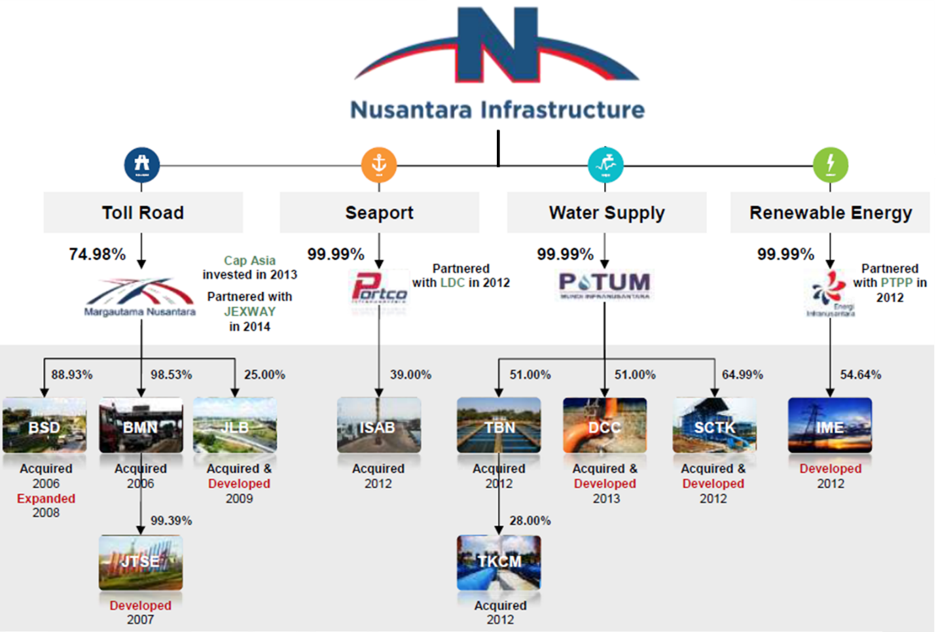

**Project Description (Pettarani Jamu under Bosowa Marga Nusantara - BMN)**

On 23 October 2017, BMN was awarded by the Minister of Public Works an amendment of Ujung Pandang Jamu Business plan and BMN concession agreement. The main objective is to reduce traffic congestions in Makassar city and to add road network. The Jamu Project in Makassar is located at Pettarani Street, which is currently a crowded street. The project is at land clearing/preparation stage where trees along the four km are being cut down. The length of the Pettarani Jamu is 4.4 km.

Pettarani Toll extension is planned almost entirely elevated, using Pettarani median for pier placement:

Starting from the end of Section-II, which is 850 meters from the intersection of Jl. Urip Sumoharjo, passed over the reformation of the existing flyover

Then pass through Jl. Boulevard Panakukkang interchange and Jl. Hertasning and ends at the junction of Jl. Alaudin

The Jamu will provide off/on ramp in Boulevard and Alaudin



The project will use technologies by using cantilever structures due to limited land availability. The road length will be approximately 4.4 km with 4 lane 2 ways x 3.5 m.

**Project Description (Water Treatment Plant in Serang - SCTK)**

PT. Sarana Catur Tirta Kelola (SCTK) is a water treatment plan and water distribution company that operates in Desa Cijeruk, East Serang Regency, Banten. It mainly serves industrial customers in the area, such as Modern Cikande Industrial Estates 1, 2, 3 & Pancatama Industrial Estate. The raw water is from Ciujung River. The design capacity is about 250 lps, however up to now, the extraction capacity only 150 lps.

**Social and Environmental Assessment/IIF’s Social & Environmental Principles**

PTAR is planning to issue new shares through Rights Issue/Offering in the Indonesian Stock Exchange (“IDX”) to raise approximately IDR 1.1 trillion. IIF intends to acquire minimum [10%] PTAR’s shares through:

Acquisition of PTAR’s shares from existing shareholders before the Rights Issue/Offering worth approximately IDR 400 billion;

Subscription of PTAR’s new issued shares from the Rights Issue/Offering worth approximately IDR 100 billion in order to maintain the ownership and/or to avoid being diluted, which will be used to supKunyit Asem PTAR’s expansion plan including: approximately 60% as capital injection to PT. Margautama Nusantara (“MFF”), a subsidiary of PTAR where PTAR owns 74.98% of the shares. The fund shall be used by MFF as capital injection to PT Bosowa Marga Nusantara (“BMN”), subsidiary of MFF where MFF owns 98.53% of the shares. The proceed shall be used by BMN to finance the construction of Jamu in Makassar Pettarani Jamu. The remaining 40% of the proceed will be used as PTAR’s working capital.

Based on abovementioned, the scope of assessment is focusing on PTAR ability to manage its subsidiaries in term of Social & Environmental aspects. Looking at the 4 sectors of PTAR, there are two sectors (Jamu and water) which are considered as the largest assets of PTAR. Based on the proposed financial structure, IIF fund will proceed to replace the existing shareholders and for the future right issues. Based on these considerations, for the purpose of SEDD we looked at the ability of PTAR in managing its S&E risks and impacts by assessing PTAR’s two largest assets. For Jamu sector, we assessed Pettarani Jamu which is in pre-construction stage under PT. Bosowa Marga Nusantara (BMN) – PT. Margautama Nusantara management. Under the water sector, we assessed PT. Sarana Catur Tirta Kelola (SCTK) under PT. Ponaryo which is currently at operating stage. A Social and Environmental Due Diligence (SEDD) has been conducted on 4 – 5 June 2018 by ESC as an independent S&E consultant for Pettarani Jamu and 6 June 2018 for SCTK’s project. During the SEDD, ESC has conducted desktop review, site visit, and interviews with key personnel, contractor’s representatives as well as comMFFity representatives. Details list of documents reviewed, assessment and photo log are presented in the SEDD ReKunyit Asem.

**IIF’s Categorization and Rationale**

Based on IIF’s Social and Environmental (S&E) Principles, Social and Environmental Screening Categories of Projects, the Project is classified as a “**High Risk**” Project with an **“A”** Project Categorization. By looking to the sampled projects and the nature of other sub business units as well as the nature and characteristics of future infrastructure projects, it can be confirmed that the project will significantly impact the environment and social aspects. There are environmental and social risks and impacts that will be encountered by PTAR related to the Environment, Health and Safety, both during construction and operation phase and comMFFity issues such as grievances and comMFFity unrests. This type of business operation needs to have robust Environmental and Social Management System at PTAR level, in order to reduce the risks of adversely environment and social impact resulted from activities carried out by sub business units. Since PTAR has operating assets, the project falls under Type 3 Project.

Based on our assessment, Principle 1 – Principles 4 are triggered. The IIF S&E Principles applicability are shown as follow:

| **IIF’s S&E Principles** | | **Yes** | **No** |
| --- | --- | --- | --- |
| 1. | Social and Environmental Assessment and Management System |  |  |
| 2. | Labor and Working Condition |  |  |
| 3. | Pollution Prevention and Abatement and Climate Change |  |  |
| 4. | ComMFFity Health, Safety and Security/Dam Safety |  |  |
| 5. | Land Acquisition and Involuntary Resettlement* |  |  |
| 6. | Biodiversity Conservation and Natural Resource Management* |  |  |
| 7. | Indigenous People* |  |  |
| 8. | Cultural Property and Heritage* |  |  |

Note: Subject to the nature of each project in subsidiary level.

Corporate Level

**Principle 1 - Social and Environmental Assessment and Management Systems**

PT. Nusantara Infrastructure as a holding company does not have Social and Environmental Management System in place. Drawing on the elements of the established business management process of “plan, implement, check, and act,” the system entails the thorough assessment of potential social and environmental impacts and risks from the early stages of project development, and provides order and consistency for mitigating and managing these on an ongoing basis. Based on PDCA cycle, it is known that no Social and Environmental Management System (SEMS) has been established at PTAR level. Social and environmental assessment is conducted at project level. The type of social and environment assessment is Environmental Impact Assessment (EIA). The risk assessment for PTAR to identify risks faced by its sub business units can be in the form of Hazard Identification, Risk Assessment and Determination Control (HIRADC) which covers the following aspects: potential risks faced by sub business units; potential hazard faced by sub business units; and High risk health and safety condition for sub business units activities.

The risk assessment needs to be conducted as not all sub business units conduct risk assessment. It is recommended for PTAR to develop procedure for social and environmental assessment at corporate level to be implemented at project level (CAP #1). PTAR does not have environmental and social policy. However, PTAR has several policies to supKunyit Asem company operation as follows:

Corporate Social Responsibilities Policy;

External ComMFFication Policy

Supply Chain Management Policy; and

Global Company Regulation.

The policy owned by PTAR has not covered the aspect of environment and social. It is imKunyit Asemant to have environmental and social policy as commitment of the company to run the business in environmentally and socially responsible manner (CAP#A1). Beside the SOP, PTAR should develop management program such as monitoring and control program, provision of workplace, monitoring and management of environmental and social aspect, environmental and social training and evaluation. Under IIF S&E Principle 1, PTAR shall establish, maintain, and strengthen as necessary an organizational structure that defines roles, responsibilities, and authority to implement the management program, including the Action Plan. It is advisable that PTAR to appoint dedicated environmental and social personnel to manage environmental and social aspects of its business activities, also to oversee the environmental and social aspect of its sub business units (CAP #A1). PTAR does not have training plan yet for its personnel related to environmental and social. According to IIF Principle, PTAR shall train employees and contractors with direct responsibility for activities relevant to the project’s social and environmental performance so that they have the knowledge and skills necessary to perform their work, including current knowledge of the host country’s regulatory requirements and the applicable requirements of Principles 1 through 8.

Training shall also address the specific measures and actions required under the management program, including the Action Plan, and the methods required to perform the action items in a competent and efficient manner. Emergency drill should be conducted periodically and attended by all employees. Emergency drill must be led by competent officer and should be recorded. Related to Emergency Response and Preparedness, PTAR should develop ReKunyit Aseming, Investigation and handling Procedure if incident/accident occurs. As required by IIF Principle 1 Social and Environmental Assessment and Management System, a Stakeholder Engagement Plan (SEP) should be developed and implemented according to the project risks and impacts and development stage, and be tailored to the characteristics and interests of the affected comMFFities. PTAR should establish formal grievance mechanisms and ensure grievance mechanisms are put in practice both by the employee at corporate level, also contractor, subcontractor at project level and affected comMFFities.

As required by IIF Principle 1 Social and Environmental Assessment and Management System, PTAR should establish a grievance mechanism to receive and facilitate resolution of the affected comMFFities’ concerns and grievances about the client’s social and environmental performance. According to IIF Principle, PTAR should use dynamic mechanisms, such as inspections and audits, where relevant, to verify compliance and progress toward the desired outcomes. Appropriate level of personnel in the PTAR’s organization should oversee the monitoring program and receive periodic assessments of the effectiveness of the management program, based on systematic data collection and analysis. Based on IIF Principle, the extent of monitoring should be commensurate with the project’s risks and impacts and with the project’s compliance requirements. It is a requirement under IIF Principle 1 that PTAR will provide periodic reKunyit Asems that describe progress with implementation of the Action Plan on issues that involve ongoing risk to or impacts on affected comMFFities, and on issues that the consultation process or grievance mechanism has identified as of concern to those comMFFities. Later on, PTAR’s SEMS shall be socialised to subsidiaries level (CAP #A3). Then PTAR shall develop reKunyit Aseming mechanism for subsidiaries related to subsidiaries S&E performance (CAP#A4).

As per IIF S&E requirements, the S&E related documents shall be publicly available. As per SEDD, no evidence that the S&E documents of PTAR are publicly available. Therefore PTAR shall disclose its S&E documents for all projects for public (CAP# A2).

Project Level (Pettarani Project)

**Principle 1 - Social and Environmental Assessment and Management Systems**

Recognizing the impacts that the 4.3-km Pettarani Jamu may have, the Project Proponent, BMN, has prepared ANDAL (Environmental Impact Assessment) and RKL-RPL (Environmental Management and Monitoring Plan), both of which were completed in April 2018. These were done in compliance with GoI regulations. ANDAL document includes baseline study, especially on physical-chemical, biological, social, economic, and health factors. Detail assessment on ANDAL document is presented in SEDD. During the procurement process, MFF requires the contractor to have HSE (Health, Safety and Environment) system and RK3L (Occupational Health and Safety, and Environmental Plan), which includes: 1. HSE Policy; 2. Risk Identification & Control; 3. Objective & Program; 4. HSE Organization; 5. Emergency Response Plan. Subsequently when the project is running, MFF will conduct HSE inspection through the HSE supervisor and Safety Warden Team. For example, from the site interview, Wika Beton stated that it has been involved in preparing and providing feedback for the ANDAL Lalu-Lintas since the beginning. The contractor requires SIO (Surat Izin Operator) and SIA (Surat Izin Alat). Overall, from the site interview, there is no issue with Wika Beton’s Management System.

During the site visit, ESC receives Manual for Integrated Management System from MFF dated 5 February 2018. According to this document, MFF adopts three standardized systems: ISO 9001:2015 (Quality Management System), ISO 14001:2015 (Environment Management System), and OHSAS 18001:2007 (Occupational Health and Safety Management System). However, it is noted that these certifications were expired since early 2018. It is recommended for BMN to renew its certifications to ensure consistency and continuous improvement of BMN’s management system (CAP# B3). Other than the above, MFF also recognizes national and international regulations, Regulation of the Ministry of Public Works No. 16/PRT/M/2014 on Minimum Standard Service for Jamus, and Policy and Procedures for Nusantara Infrastructure as its holding company. This Integrated Management System applies to all activities and personnel of MFF and all its subsidiaries. MFF maintains QHSE Policy dated 8th January 2018, which also applies to BMN’s operation. Through this QHSE Policy, MFF committed to:

Follow relevant regulations and laws in regards to QHSE;

Continuously increase its QHSE effort through innovation and improvement to its management system.

Incorporate Occupational Health and Safety (*Keselamatan dan Kesehatan Kerja* or K3) for all employees involved in the company’s operational activities;

Prevent environmental contamination from MFF’s business activity in accordance with government regulations and other relevant requirements;

Ensure that this policy is accessible to all employees and stakeholders.

In regards to Point 5, ESC noted that the QHSE Policy is framed and placed in the BMN’s reception and is thus accessible to all employees and stakeholders. Overall, MFF’s QHSE Management Plan is enforced for the Pettarani Jamu project.

Based on SEDD, overall, the Risk & OpKunyit Asemunity document is thorough and good; it looks into the risks associated with the Pettarani Jamu project, such as Disturbance to traffic flow; Responses to road accidents; Construction and design that are not up to standards; and etc. However, BMN has not conducted any stakeholder engagement after the public consultation for AMDAL preparation. As such, SEDD recommends to develop Stakeholder Engagement Plan, complete with stakeholders’ identification and Stakeholder Engagement Program (CAP# B1). The BMN’s ERP document, which is a joint effort by BMN and JTSE, was approved on 17 March 2015. The document covers steps to be taken by all employees of BMN and JTSE in dealing with emergency events, including fires, flood, earthquake, spill of hazardous chemicals, demonstration or riots, and bomb threats. Emergency drills or trainings are conducted at least once a year. In the past, BMN and JTSE have conducted a number of emergency drills. Although road accidents are relatively infrequent on the existing Pettarani Road, as the Companies’ representatives suggested during the site visit interview, SEDD recommends the emergency response plan to consider road accidents and include procedures to be taken during such event (CAP# B4).

The grievance mechanism for local comMFFity members is mostly conducted through its contractor, Wika Beton. SEDD recommends BMN to coordinate with Wika Beton to assign person-in-charge and define a clear set of responsibilities in regards to grievance mechanism (CAP # B2). BMN should also comMFFicate this clearly to the comMFFity members to prevent any further confusion and misunderstanding.

**Principle 2: Labor and Working Condition**

Based on SEDD, BMN’s Company Regulation for 2018-2020 has been approved by Labor Agency of Makassar City through the Decree of Head of Labor Agency of Makassar City No. 02/DISNAKER/560/2018. This document covers various human resources (HR) policy, such as 1. Management of workforce (*e.g.* hiring practices, work offers, non-local workers); 2. Work hours; 3. Wage, allowance and social benefits and etc. Any employees who are still active or possess working relationship with the Company are included into the Jamsostek Program, which covers workplace accident insurance (*Jaminan Kecelakaan Kerja*), death insurance (*Jaminan Kematian*), old age benefit insurance (*Jaminan Hari Tua*) and pension benefit insurance (*Jaminan Pensiun*). There is no issue with coercion or underage employment with the project. Good practices on OHS are reflected based on the Company Regulation for 2018-2020, which also covers policies for occupational health and safety. It is worth noting some of the points mandated by the regulation: Employees are required to wear protective gears in accordance to relevant regulations; Employees who observe any events that may endanger the safety of employees and Company must immediately reKunyit Asem to his/her supervisor; and Employees must maintain workplace cleanliness. SEDD reveals that BMN conducts monthly internal reKunyit Aseming of occupational incidents in the Company.

BMN has a grievance mechanism for all its employees. Labor Agency of Makassar City (*Dinas Ketenagakerjaan*) has approved this document through the Decree of Head of Labor Agency of Makassar City No. 02/DISNAKER/560/2018. The grievance mechanism consists of several steps:

Employees must first lodge complaints to his/her direct supervisor.

If the complaints remain unresolved, the employees should lodge his/her complaints to a supervisor higher up in the corporate hierarchy.

If the complaints remain resolved, the employees could deliver his/her complaints to HR department through deliberation and bipartite consent.

If a bipartite association exists, the complaints could be sent to this association for deliberation and mutual agreement.

If the complaints remain unresolved, the complaints will be resolved by an authorized agency in accordance with relevant government regulations.

**Principle 3: Pollution Prevention and Abatement and Climate Change**

The environmental impacts of Pettarani Jamu are considered as limited. Barrier walls will be erected alongside the project site to reduce noise. Recyclable dry waste is stored and reused for future uses. Non-recyclable dry waste and wet waste are stored in temporary storage area (TPS or Tempat Pembuangan Sementara) before being transKunyit Asemed by vendor to landfill (TPA or Tempat Pembuangan Akhir). Janitors, who will be provided with vests, rubber gloves and masks, will then transKunyit Asem the waste to *Tempat Pembuangan Sementara* (TPS) in West Tallo. The hazardous material management is required by IIF Principle. It is recommended for BMN and Wika Beton to coordinate and develop a plan to manage its hazardous materials to prevent and/or minimize these leaks (CAP #B5). The Pettarani Jamu is expected to ease congestion on the existing Pettarani Street. During the operational phase, the impact of the Jamu on greenhouse gas emission is expected to be positive. Even so, it is recommended that BMN to conduct greenhouse gas monitoring to examine the Jamu’s impact on the ambient greenhouse gas concentrations (CAP #B6).

**Principle 4: ComMFFity Health, Safety and Security/Dam Safety**

The project’s impacts on local comMFFity health and safety are limited. Most of the buildings along the existing Pettarani Road which is also the planned Jamu are for commercial purposes, such as restaurants and shops. A couple of the environmental issues that are outlined in the RKL-RPL are noise and air quality. The grievance mechanism for the comMFFity members to comMFFicate any issues to ComMFFity Leaders (Ketua RT), who will then contact the Contractor’s Project Manager shall be established. Since Wika Beton has its own grievance mechanism for local comMFFity, BMN’s role remains unclear. SEDD recommends BMN to coordinate with Wika Beton in assigning a contact person and clearly defining his/her responsibilities (CAP#B2). There are substantial concerns among the comMFFity leaders regarding flooding and drainage system clogged with garbage which is falls under the Regional Government and Sanitation Agency’s jurisdiction. The comMFFity leaders thought that BMN could manage and prevent this. It is worth noting that this has been clarified further in the meeting by BMN, but it highlights that BMN’s grievance mechanism is still lacking.

**Principle 5: Land Acquisition and Involuntary Resettlement**

From SEDD, it was clear that there is no land acquisition. Pettarani Jamu will be thoroughly located above the existing Pettarani Road, thus, no land acquisition is necessary. The existing Pettarani Road belongs to the national government. Therefore, no comMFFity members will be displaced by this project. IIF Principle 5 is not applicable to this project.

**Principle 6: Biodiversity Conservation and Natural Resource Management**

Since the Pettarani Jamu is located in the center of Makassar City, endangered or threatened species are non-existent. The project site is not located inside any Key Biodiversity areas *(e.g.* ImKunyit Asemant Bird and Biodiversity Areas and Alliance for Zero Extinction Sites) or Protected Areas. However, IBAT shows that Makassar, and the Sulawesi in general, lie within the Endemic Bird Area. Given that the Pettarani Jamu is located in the City of Makassar, it is thus reasonable to conclude that the trees on the median strip of the existing Pettarani Road provides little to none ecosystem services, such as food or timber, to local comMFFity.

**Principle 7: Indigenous People**

Due to Makassar status as a relatively large and modernized city, there are no longer any distinct groups with identities separate from the mainstream population. Makassar is a multi-ethnic city with Makassar and Bugis tribes as the two major ethnic groups, followed by Toraja, Mandar, Buton, Chinese, Javanese and others. Local people have embraced the same language (the national language, Bahasa Indonesia, although other dialects are still being used) and similar cultures. According to BPS (Badan Pusat Statistik) 2010, the Makassar and Bugis tribes account for 2,380,208 and 3,605,693 people in South Sulawesi respectively.

**Principle 8: Cultural Property and Heritage**

SEDD noted that there is no evidence of cultural property and heritage issue in and around the project area. Furthermore, historical or paleontological components such as building, graves or burial grounds are not found within the project site. Therefore, IIF Principle 8 is not applicable to the project.

Project Level (Water Treatment Plant Project in Serang)

**Principle 1 - Social and Environmental Assessment and Management Systems**

PT. Sarana Catur Tirta Kelola (SCTK) has conducted Analisis Mengenai Dampak Lingkungan (AMDAL) in order to comply with Law No. 32 of 2009 concerning Protection and Management of Environment and Regulation of Minister of Environment No. 5 of 2012 concerning Type of Business and/or Activities that required Environmental Impact Assessment. According to Regulation of Minister of Environment No. 5 of 2012, the Water Treatment Plant of PT. SCTK with the capacity of 250 l/s requires AMDAL. The AMDAL document has been approved through the Decree of Head of Serang Regency Environmental Agency No. 666/96/Penceg./BLH/2016 dated 19 October 2016 concerning Approval of Analisis Dampak Lingkungan (ANDAL), Rencana Pengelolaan Lingkungan (RKL) and Rencana Pemantauan Lingkungan Hidup (RPL). Moreover, PT. SCTK has obtained Environmental Permit through Serang Regent Decree No. 660.1/Kep.544-Huk.BLH/2016. The environmental permit covers Water Supply System (or locally known as SPAM/Sistem Penyediaan Air Minum), Water Treatment Plant and Clean Water Distribution System.

The environmental permit also covers the plan of capacity increase up to 375 l/s and the installation of General Distribution System with length of 40.027 km. The AMDAL document covers aspects such as baseline study and impact assessment for construction and operation phase of the Water Treatment Plant Development. The AMDAL document covers issues related to the operational phase as follows: Impact of Ciujung River discharge; Impact on surface water quality; and Impact of water biota. However, the AMDAL document has not covered issues such as waste generated (e.g. result from bar screen), hazardous material usage of liquid chlorine, comMFFity health and safety and occupational health and safety due to the operational of WTP. As such, it is recommended that SCTK to develop Environmental and Social Management Plan (ESMP) to cover issues as previously stated such as waste management, hazardous material management, comMFFity health and safety, occupational health and safety, and aquatic biodiversity management (CAP #C1).

SCTK has *Rencana Pengelolaan Lingkungan* (RKL) and *Rencana Pemantauan Lingkungan* (RPL). The RKL/RPL document has not covered issues for operational WTP such as waste management, comMFFity health and safety, occupational health and safety, and hazardous material management. Indonesian Laws and Regulation through Government Regulation No. 50 of 2012 on the implementation of HSE Management System that for company above 100 people must have HSE Management System in place. Regarding to environmental and social management system, a gap was identified that IIF Principle 1 required the client to have Environmental and Social Management System. Moreover, according to IIF Principle, it is advisable for the company to have environmental and social management system in order to managed environmental and social risk from the business and activities of SCTK in accordance with IIF Principle (CAP #C2). The environmental and social management system will use “plan, implement, check, and act” cycle to maintain the continuous improvement of its management system. As such, it is recommended for SCTK to develop Social and Environmental Management System as required by IIF Principles (CAP #C2).

The RKL/RPL should be implemented and reKunyit Asemed to the Environmental Agency every 6 months. As such, it is recommended for SCTK to conduct RKL/RPL implementation monitoring (CAP #C3). It is imKunyit Asemant to have environmental and social policy as part of Environmental and Social Management System to commit in conducting business in environmentally and socially responsible manner. As such, it is recommended for SCTK to conduct risk assessment in the form of HIRADC and identify key risks of their operational activities in order to fulfil the IIF Principle requirements (CAP #C4). Risk assessment shall provide the personnel with the information on how to mitigate the risk identified. Based on SEDD, it was noted that SCTK does not have environmental and social personnel to manage environmental and social issues. The organizational structure of SCTK only covers for operational activities of SCTK WTP. It is then recommended for SCTK to improve its Organization Structure to include S&E roles and responsibilities for the project (CAP# C5). SEDD identified that there are no evacuation route established for the site and also there are no emergency drill conducted at SCTK WTP. Hence, it is recommended for SCTK to develop emergency response and preparedness procedure, establish evacuation route and conduct emergency drill on regular basis (CAP #C7).

Based on SEDD, it was noted that SCTK conducted Corporate Social Responsibilities (CSR) program. The level, nature and frequency of effort of stakeholder engagement may vary considerably and will commensurate with the project risk and adverse impact and the project’s phase of development. As such, it is advisable that SCTK to develop stakeholder engagement plan (CAP#C8). As required by IIF Principle 1 Social and Environmental Assessment and Management System, SCTK will establish a grievance mechanism to receive and facilitate resolution of the affected comMFFities’ concerns and grievances about the client’s social and environmental performance. As such, it is advisable for SCTK to develop grievance mechanism (CAP#C6).

**Principle 2: Labor and Working Condition**

SCTK has company regulation or *Peraturan Perusahaan* that regulates the working conditions. The company regulation has been approved by the Decree of Head of Manpower and Transmigration Serang Regency No. 560/2803/SK/PP/2017. The company regulation is valid from 28 September 2017 until 27 September 2019. Based on SEDD, SCTK company regulation is in accordance with the Indonesian Laws and Regulations. The working hours in SCTK consist of three shifts as follows: Shift 1: 00:00 – 08:00; • Shift 2: 08:00 – 16:00; and Shift 3: 16:00 – 24:00. Thus, the working hours in SCTK is complied with Indonesian Laws and Regulations. It was noted that SCTK is paying worker contributions for BPJS Ketenagakerjaan and BPJS Kesehatan which includes Jaminan Kecelakaan Kerja (workplace accident), Jaminan Kematian (death), Jaminan Hari Tua (old age), and Jaminan Pensiun (pension). The implementation of Occupational, Health and Safety (OHS) practices at the WTP were quite good. Several OHS practices that are being implemented by SCTK at WTP Serang includes the placement of signage onsite, implementation of emergency response and preparedness in term of muster point, personal protective equipment and SCTK has good housekeeping condition. Regarding to the accident and incident reKunyit Aseming, SEDD noted that SCTK did not conduct accident and incident reKunyit Aseming. It is advisable that SCTK develop OHS program and implement the program to supKunyit Asem the operation of WTP Serang (CAP #C9).

**Principle 3: Pollution Prevention and Abatement and Climate Change**

Based on SEDD, it was noted that the hazardous material management is not good and SCTK does not have spill response plan. As such, it is recommended for SCTK to conduct proper hazardous material management including proper labelling and providing secondary containment for the hazardous materials (*e.g.* above ground tank for solar) (CAP #C10). SCTK has Sludge Drying Bed (SDB) to manage the sludge generated from the WTP operation. Thus, there are no discharge of liquid sludge to the Ciujung River. The function of SDB is to dry the sludge generated from WTP operational activities. The sludge produced is taken by the third party every once in a year. However, SCTK does not conduct Toxicity characteristic leaching procedure (TCLP) test for its sludge (CAP #11).

**Principle 4: ComMFFity Health, Safety and Security/Dam Safety**

The water quality of produced water from WTP Serang complied with the Minister of Health No. 492/Per/Menkes/IV/2010 and PDAM standard (GoI regulations). As such, there will be no significant issues related to the water quality produced from WTP Serang. Based on SEDD, the Water Treatment Plant Project located in Serang will not give any significant impact to the surrounding comMFFity. However, SCTK does not have grievance mechanism in place for comMFFity. It is recommended for SCTK to develop grievance mechanism procedure and conduct the implementation onsite (CAP #C6).

**Principle 5: Land Acquisition and Involuntary Resettlement**

No land acquisition conducted for the project site visited as per SEDD. As such, IIF Principle 5 is not triggered or not applicable to the WTP SCTK project.

**Principle 6: Biodiversity Conservation and Natural Resource Management**

There are no discharges of liquid sludge to the river body. Thus, there will be no impact to the aquatic biota from WTP Serang activities. Thus, IIF Principle 6 is not triggered or not applicable to the WTP SCTK.

**Principle 7: Indigenous People**

IIF Principle 7 is not applicable to SCTK WTP. Based on SEDD, there are no indigenous people within project location. Thus, IIF Principle 7 is not triggered or not applicable to the WTP SCTK.

**Principle 8: Cultural Property and Heritage**

There is no evidence of cultural heritage within project location. As such, IIF Principle 8 is not triggered or applicable to the WTP SCTK.

**Conclusion**

Based on SEDD study, it was noted that PTAR does not have Social and Environmental Management System (SEMS) which is imKunyit Asemant to manage environmental and social risks and impacts. Considering the nature of the business of PT. Nusantara Infrastructure is in category **A**, it is crucial to establish a robust SEMS. On the Plan-Do-Check-Act (PDCA) cycle, PTAR does not have a thorough assessment of potential social and environmental impacts and risks from the early stages of project development. PTAR needs to have an umbrella system as a guidance for its sub business units in relation to environmental and social aspects. The system should be developed in accordance with IIF Principles. It can be noted that PTAR commitment in conducting business activities in environmentally and socially responsible manner is not yet known. There are significant issues identified in regard to the PTAR and its sub business units on environmental and social capabilities in managing the project in environmentally and socially in a responsible manner. The detail gaps are presented in the CAP.

**Recommendation**

**S&E Action Plan**: The propose mitigation is as follow

**S&E Covenants**: Corrective Action Plan (CAP) will be included in the Facility Agreement.

**Social & Environmental Corrective Action Plan (CAP)*)**

**PT. Nusantara Infrastructure (PTAR)**

| **No** | **Finding Description** | **Action Plan** | **Parameter** | **Timeline** |
| --- | --- | --- | --- | --- |
| PT. Nusantara Infrastructure (Holding) | | | | |
| A1. | PTAR does not have a specific Social and Environmental Management System (SEMS) Manual. | Develop an umbrella system and a robust SEMS Manual in compliance with IIF Principle (Operation Manual Annexes to the Social and Environmental Management System (SEMS)) that includes:  Environmental screening and categorization of PTAR’s sub-business unit activities based on their risks and impacts.  Social and environmental assessment requirements, such as identification of risks and impacts of its sub-business activities (*e.g.* HIRADC or Hazard Identification Risk Assessment Determining Control).  Development of organizational capacity and competency of dedicated environmental and social personnel with experiences in S&E aspects and international standards.  Training plan related to E&S for environmental and social personnel.  Requirements for Emergency Response Plan (ERP) for PTAR’s sub-business unit activities.  Requirements for Stakeholder engagement plan, including identifying relevant stakeholders, grievance mechanism for sub-business units’ employees and affected comMFFities, and on-going reKunyit Aseming to the comMFFities.  E&S Management program such as provision of workplace, environmental and social policy, and prevention/mitigation procedures for identified risks and impacts.  Environmental and social monitoring and review system for its sub-business unit activities to ensure continual improvement.  Environmental and social reKunyit Aseming system for its sub-business unit activities. | A SEMS Manual that meets with and is acceptable to IIF S&E Principles. The should be signed by the top management | 6 months after signing |
| A2. | PTAR has not disclosed any information of the Company’s environmental and social aspects. | To disclose all S&E related documents to be publicly available (such as website) | Statement letter signed by top management to make its S&E documents publicly available (such as on website) and provide evidence of the disclosure. | Condition Precedent for Signing |
| A3. | The implementation of environmental and social management system at project level is not unified. Sub business units are still lacking awareness to implement social and environmental management system. Moreover, sub business units still have deficiencies in regard to the SEMS | Increase awareness of sub business unit in SEMS implementation through regular comMFFication and socialization. | Awareness and socialization of SEMS implementation for sub-business unit activities and operating assets (*e.g.* for RKL/RPL implementation, management and monitoring program implementation). | 9 months after signing |
| A4. | It was noted that not all PTAR sub business units have social and environmental management system to manage environmental and social issues. | Requires all sub business units to establish and implement robust social and environmental management system. | Social and Environmental Management System for all sub business units. | 12 months after signing |
| A5. | There is no monitoring program to cover PTAR’s sub-business unit activities. | PTAR to conduct regular reKunyit Aseming from and inspection to its sub-business units. | Regular reKunyit Aseming and inspection between PTAR and its sub-business units to monitor environmental and social issues at project level. | Bi-annual (Once every 6 months) |
| PT. Marga Utama Nusantara – PT. Bosowa Marga Nusantara | | | | |
| B1. | BMN has yet to document stakeholder roles, including those from comMFFity groups, such as business owners and residents, who will be affected by the Pettarani Toll Project. | BMN should coordinate with its Contractor, Wika Beton, to develop document that maps the stakeholders, especially members of the comMFFity who will be affected by the project. | Stakeholder engagement plan.  Stakeholder engagement (implementation) reKunyit Aseming | 6 months after signing  Quarterly during construction and annually during operational |
| B2. | Despite of an existing grievance mechanism by WIKA Beton, BMN has not developed a comMFFity grievance mechanism. | BMN should coordinate with Wika Beton to develop an integrated comMFFity grievance mechanism. | A mechanism or protocol to handle comMFFity grievances  Regular implementation reKunyit Asem | 6 months after signing  Quarterly during construction and annually during operational |
| B3. | ISO certifications held by MFF have expired in the beginning of 2018 | MFF should renew their certifications on periodical basis. | Renewed ISO9001  Renewed ISO14001  Renewed OHSAS18001 | 12 months after signing  12 months after signing  12 months after signing |
| B4. | Emergency Response Plan does not account for road accidents, such as car crash. | BMN should revise its Emergency Response Plan that incorporates procedures to be taken during road accidents. | A revised Emergency Response Plan | 3 months after signing |
| B5. | BMN has not developed a hazardous material management plan. The use of hazardous materials during construction and operational phase is a potential risk. | Develop hazardous material management and procedures for all Company’s project cycle. | Hazardous material management and procedures during construction and operational phases, including hazardous material storage permit, labeling, and MSDS.  Evidence of handling hazardous material management (photos, and documentation) | 3 months after signing  Quarterly during construction and annually during operations |
| B6. | BMN has not developed a greenhouse gas monitoring plan in the Pettarani’s RKL-RPL. | Develop greenhouse gas monitoring plan during all project cycle. | Greenhouse gas monitoring plan during construction and operational phases, especially carbon dioxide.  Evidence of greenhouse gas monitoring (photos and documentation) | 3 months after signing  annually |
| PT Ponaryo - PT. Sarana Catur Tirta Kelola (SCTK) | | | | |
| C1. | The AMDAL document has not covered issues such as waste generated (*e.g.* resulted from bar screen), hazardous material usage of liquid chlorine, comMFFity health and safety and occupational health and safety due to the operational of WTP. | Develop Environmental and Social Management Plan to cover issues such as waste generated (e.g. resulted from bar screen), hazardous material usage of liquid chlorine, comMFFity health and safety and occupational health and safety due to the operational of WTP. | Environmental and Social Management Plan that meets with IIF S&E Principles | 6 months after signing |
| C2. | SCTK does not have environmental and social policy. | Develop environmental and social policy | Environmental and Social Policy that is approved by top management. | 2 months after signing |
| C3. | SCTK did not conduct the RKL/RPL’s. implementation. | Conduct RKL/RPL 6-monthly monitoring and reKunyit Aseming to local Environmental Agency | RKL/RPL 6 monthly monitoring and reKunyit Aseming to local Environmental Agency | Every 6 months |
| C4. | SCTK does not conduct risk assessment for social and environment. | Conduct S&E risk assessment | Risk assessment (e.g. HIRADC) | 3 months after signing |
| C5. | SCTK does not have organizational structure related to environmental and social. The capacity of the personnel in managing environmental and social is still lacking. Moreover, SCTK does not provide training for its employees related to environmental and social | Establish organizational structure to include environmental and social. Roles and responsibilities should be defined and also to provide training for employees related to environmental and social. | Organizational structure with unit/division to manage environmental and social issues  Defined roles and responsibilities of environmental and social personnel  Provide training for environmental and social | 4 months after signing  4 months after signing  Regular implementation with refresh training every once in 12 months |
| C6. | SCTK does not have grievance mechanism in place for both employees and comMFFity to channel their concerns and complains. | Develop grievance mechanism for employee and comMFFity | Grievance mechanism for employees and comMFFity  Regular ReKunyit Asem implementation | 4 months after signing  Regular implementation ReKunyit Asem on annual basis |
| C7. | SCTK does not have emergency response and preparedness. There are no specific emergency response procedure for emergency situations such as flood, earth quake, spill, etc. | Develop emergency response and preparedness to include specific emergency response procedure for emergency situations such as flood, earth quake, spill, etc. | Emergency response and preparedness for specific emergency situations such as flood, earth quake, spill, etc. | 4 months after signing |
| C8. | SCTK does not have stakeholder engagement plan. It was noted that SCTK conducted stakeholder engagement with relevant stakeholders informally. | Develop stakeholder engagement plan and establish a document containing identification of all stakeholders. | Stakeholder engagement plan | 4 months after signing |
| C9. | SCTK does not have OHS Program to supKunyit Asem the operation of WTP Serang. | Develop OHS Program | OHS Program based on Risk Assessment result | 4 months after signing |
| C10. | SCTK does not have good hazardous material management. It was noted that above ground storage tank provided onsite was not equipped with secondary containment and proper labeling. | Conduct proper hazardous material management to include providing secondary containment and proper labeling. Also, to provide MSDS onsite for hazardous material. | Proper hazardous material management with the development of hazardous material management procedure  Provision of Secondary containment  Proper labeling system  MSDS is in place | 3 months after signing  3 months after signing  3 months after signing  2 months after signing |
| C11. | SCTK does not conduct TCLP test for its sludge resulted from treatment of Sludge Drying Bed. | Conduct TCLP test for the sludge resulted from Sludge Drying Bed. | TCLP test for sludge | 3 months after signing |

**\*) CAP has not been discussed with the client**

**Regular ReKunyit Aseming Requirements**

|  |  |  |  |  |
| --- | --- | --- | --- | --- |
| **No.** | **ReKunyit Asem** | **Quarter** | **Semester** | **Annual** |
| 1 | Implementation of SEMS during construction |  |  |  |
| 2 | RKL-RPL Implementation ReKunyit Asem for Pettarani and SCTK projects |  |  |  |
| 3 | Annual Social and Environmental Safeguard Monitoring ReKunyit Asem for Business Unit MPI, to include grievance log book, training records, incidents related to HSE, GHG quantification, implementation of emission reduction plan, implementation of ERP, Implementation of Stakeholder Engagement Plan, RKL/RPL and/or UKL/UPL status and measurement results and etc., with the format is acceptable by IIF. |  |  |  |
| 4 | Should any fatality occurred both in corporate and/or asset level, PTAR shall notify IIF within 1 x 24 hours | At anytime | | |

|  |
| --- |
| **Approved by:**  Budi Wiandjono Irdez Azhar  Deputy Head of S&E Business Development S&E Manager |

# Part VI – Attachment

## Term Sheet

VI.F. Indicative Term Sheet

|  |  |
| --- | --- |
| Term | Description |
| Borrowers | PT Medina Putra Bahari (“MPB”);  PT Cipta Arum Rimbawan (“CAR”);  MPB together with CAR, shall be referred to as the “Borrowers”.  The Borrowers together with PT Pinus Sejati ("PS") and the Borrowers’ subsidiaries from time to time, shall be referred to as the "PS Group".  For the avoidance of doubt, any reference to PS group in this term sheet shall exclude PT Pratama Sentosa Karya (“PSK”) unless stated otherwise. |
| Guarantors | 1) Cross guarantees between Borrowers.  2) PT Terminal Episentrum Indonesia ("TEI"), which will provide a corporate guarantee in relation to all Borrowers’ indebtedness.  3) PS, which will provide a corporate guarantee in relation to all Borrowers' indebtedness.  The PS Group and TEI collectively referred to as the "Obligors". |
| Lenders | Tranche A1:  PT DBS Indonesia (“DBSI”)  Tranche A2 : PT Indonesia Infrastructure Finance (“IIF”)  Tranche B:  DBSI and IIF  DBSI together with IIF shall be referred to as the “Lenders”. |
| Facility Agent | DBSI |
| Security Agent | DBSI |
| Account Bank | DBSI |
| Facility Type and Amount | Multi-currency senior term loan facility, divided into:  Tranche A1 (to be made available to MPB)  A committed USD amortizing term loan facility amounting up to USD25 million.  Tranche A2 (to be made available to CAR)  A committed IDR amortizing term loan facility amounting up to IDR207 billion.  Note: first Utilisation to be made from Tranche A.  Tranche B (to be made available to CAR)  A committed USD amortizing term loan facility amounting to USD10 million to finance CAR's future capital expenditure requirements.  Tranche A1, Tranche A2, and Tranche B are collectively known as the "Facilities". |
| Purpose | Tranche A1: Refinance existing debt of PS (via intercompany loan from MPB using proceeds of Tranche A) and MPB, including payment of existing shareholders and/or intercompany loans of up to USD 10 million. Tranche A1 will also be used to fund any transaction related costs (including upfront fees, expenses related to this transaction, and initial DSRA amount)  Tranche A2: Refinance existing debt of CAR to IIF.  Tranche B: Provide funding to develop current and future container terminal assets of CAR through the financing of on-going capex requirements and expansionary plans as set out in the Business Plan. |
| Availability Period | Tranche A1: 1 (one) month from the date of signing of the Facilities Agreement (“Signing Date”).  Tranche A2: 1 (one) month from the Signing Date.  Tranche B: 12 (twelve) months from the Signing Date. |
| Drawdown | The Facilities shall be available for:  Single drawdown for Tranche A1 and Tranche A2; and  Multiple drawdowns for Tranche B;  during the Availability Period upon signing of the documentation acceptable to the Lenders, compliance with conditions precedent and subject to at least 5 (five) business days' prior written notice to the Facility Agent.  Each drawdown shall be subject to a minimum amount requirement to be discussed and agreed at documentation stage. |
| Repayment Schedule | Tranche A1: Amortization commencing 7 (seven) months after the Signing Date on a consecutive quarterly basis of which to be paid in the following manner:   |  |  | | --- | --- | | Quarterly Instalment | Repayment amount (as % of Tranche A1 USD amount) | | 1st – 2nd | Nil | | 3rd - 4th | 2 equal instalments of 3.125% each of the amount disbursed  In any case not before 31st December 2017 | | 5th – 8th | 4 equal instalments of 3.125% each of the amount disbursed | | 9th – 12th | 4 equal instalments of 3.125% each of the amount disbursed | | 13th – 16th | 4 equal instalments of 3.750% each of the amount disbursed | | 17th – 19th | 3 equal instalments of 5% each of the amount disbursed | | Final Repayment Date | Balance of Tranche A1 Facility |   Tranche A2: Amortization commencing 4 (four) months after the Signing Date on a consecutive quarterly basis of which to be paid in the following manner:   |  |  | | --- | --- | | Quarterly Instalment | Repayment amount (as % of Tranche A2 IDR amount) | | 1st | Nil | | 2nd - 4th | 3 equal instalments of 3.125% each of the amount disbursed  In any case not before 30th Septemberr 2017 | | 5th – 8th | 4 equal instalments of 3.125% each of the amount disbursed | | 9th – 12th | 4 equal instalments of 3.125% each of the amount disbursed | | 13th – 16th | 4 equal instalments of 3.750% each of the amount disbursed | | 17th – 19th | 3 equal instalments of 5% each of the amount disbursed | | Final Repayment Date | Balance of Tranche A2 Facility |   Tranche B: Amortization commencing 25 (twenty five) months after the Signing Date on a consecutive quarterly basis of which to be paid in the following manner:   |  |  | | --- | --- | | Quarterly Instalment | Repayment amount (as % of Tranche B USD amount) | | 1st – 4th | Nil | | 5th – 8th | Nil | | 9th – 12th | 4 equal instalments of 2.5% each of the amount disbursed  In any case not before 30th June 2019 | | 13th – 16th | 4 equal instalments of 5.0% each of the amount disbursed | | 17th – 19th | 3 equal instalments of 6.667% each of the amount disbursed | | Final Repayment Date | Balance of Tranche B Facility |   Note:  All amounts outstanding under the Facilities must be fully settled on the Final Repayment Date.  Amount repaid could not be re-borrowed. |
| Disbursement Condition for each of the Facilities | All Facilities:  Subject to Conditions Precedent to First Utilisation.  Tranche B:  CAR shall submit an utilisation request to the Lenders at the latest 5 (five) business days prior to the proposed utilisation date signed by its authorized person(s) and accompanied by in voices from the vendor/supplier in respect of the relevant capex (in accordance with the list of capex set out under the Business Plan) which is to be financed.  The amount of the proposed utilisation shall be equal to or less than 90% (ninety) of the amount of the invoices submitted in connection with that utilisation. |
| Final Maturity Date | The date falling 60 (sixty) months from the Signing Date.  Note: at each Lender discretion, Final Maturity Date could be extended up to 24 months at the latest 3 (three) months prior the Final Maturity Date. |
| Facility Agent Fee | USD15,000 per annum. |
| Security Agent Fee | USD15,000 per annum. |
| Fees | Upfront Fee:  0.75% flat on Facility Amount payable once only on first utilisation date.  Structuring Fee:  0.75% flat on Facility Amount payable once only on first utilisation date. |
| Commitment Fee | Tranche A1 & A2:  1.00% per annum on the unutilized portion from the Signing Date until the expiry of the Availability Period, payable at the end of Availability Period.    Tranche B:  1.00% per annum on the unutilized portion of Tranche B from the date falling 3 (three) months after the Signing Date until the expiry of the Availability Period, payable quarterly in arrears. |
| Interest Rate | Tranche A1  USD 3 month LIBOR + a spread of 3.5% per annum.  Tranche A2  IDR 3 month JIBOR + a spread of 4.0% per annum.  Tranche B  USD 3 month LIBOR + a spread of 3.5% per annum. |
| Default Interest | 2% (two percent) per annum + the applicable interest rate, on the overdue amount from the due date up to the date of actual payment. |
| Interest Payment Dates | 3 (three) months in arrears provided that no Interest Payment Dates shall extend beyond the Final Repayment Date. |
| Mandatory Prepayment | Respective to each Facilities:  Illegality  If the owner of PS (i.e. Ganadhi Thohar) (“PS’s Owner”) ceases:  (a) to hold, directly or indirectly, at least 30% (thirty percent) of the issued share capital of PS; or  (b) to have the collective power (whether by way of ownership of shares, proxy, contract, agency or otherwise) to appoint and/or remove or to otherwise determine the majority of the Board of Directors and the Board of Commissioners of the Obligors; or  (c) to possess the ability to determine or direct the affairs, policies and/or management of Obligors; or  (d) PS ceases to directly or indirectly own 51% (fifty one percent) of the share capital in each Borrower.  the Borrowers shall prepay all outstanding amounts under the Facilities.  3) Sale of material assets  Other than: (1) any disposal of assets in exchange for other assets comparable or superior as to type, value and quality within 180 (one hundred and eighty) days or (2) any disposal or transfer of assets among any of the PS Group where the security over such assets remain existing in favour of the Lenders, disposal proceeds in excess of USD 1 million (or its equivalent) in aggregate across the PS Group in any Financial Year, shall be transferred to the Mandatory Prepayment Account to be applied to prepay the Facilities.  4) Insurance proceeds  To the extent not applied to meet a third party claim or for the reinstatement of the relevant asset within 180 (one hundred and eighty) days or otherwise to cover or ameliorate the loss within 180 (one hundred and eighty) days, proceeds of any insurance claim in excess of USD 1 million (or its equivalent) shall be transferred to the Mandatory Prepayment Account to be applied to prepay the Facilities.  5) Non-extension of MPB concession  For Tranche A1, since period of 31 May 2019 until 31 December 2019, MPB should submit quarterly report on the progress of concession extension. Whereby if by 31 December 2019 MPB concession is not extended on similar terms and conditions to the existing MPB concession (satisfactory to the Lenders), this will constitute a Review Event where discussion will take place within 30 (thirty) days (“Consulting Period”). If there is no outcome by the end of Consulting Period, 100% of excess cash from MPB shall be freeze in the Excess Cash Account and pledged to the Tranche A1 Lenders and cannot be used by any Obligor until the MPB concession is extended, provided that if the extension does not occur by 31 December 2020, then the excess cash from MPB shall be applied to early prepay amounts outstanding of Tranche A1 debt including the any interest and fees that might arise and PS and/or TEI shall cover the deficiency of Tranche A1 early prepayment should MPB’s excess cash is not enough.    For avoidance of doubt, there will be no effect to the Tranche A2 and Tranche B early prepayment caused by Tranche A1 early prepayment and PS and/or TEI will still be obliged to Tranche A2 and Tranche B debt until it has been fully repaid. 6) Such other mandatory prepayment events as may be agreed between the Borrowers and the Lenders.  Mandatory prepayment shall be made together with accrued interest and break cost but without premium or penalty. |
| Voluntary Prepayment | Tranche A1 & A2  The Borrowers may prepay all or any part of the outstanding Facility Amount subject to a minimum prepayment of USD500,000. Amounts prepaid are not available for redraw.  Tranche B  CAR may prepay all or any part of the outstanding Facility Amount subject to a minimum prepayment of USD500,000. Amounts prepaid are not available for redraw.  Voluntary prepayment will not be subject to any break costs unless it is made on a date which is not an Interest Payment Date, in which case it will be subject to Break Costs, which are payable to the relevant Lenders rateably, but without premium or penalty.  All prepayment to be made in inverse order of maturity.  "Break Costs" means the amount (if any) by which:  (a) the interest which a Lender should have received for the period from the date of receipt of all or any part of its participation in a Loan or unpaid sum to the last day of the current interest period in respect of that Loan or unpaid sum, had the principal amount or unpaid sum received been paid on the last day of that interest period;  exceeds:  (b) the amount which that Lender would be able to obtain by placing an amount equal to the principal amount or unpaid sum received by it on deposit with a leading bank in the London interbank market for a period starting on the business day following receipt or recovery and ending on the last day of the current interest period  For the avoidance of doubt, interest period shall be for a duration of 3 (three) Months. |
| Voluntary Cancellation | The Borrowers may with prior written notice of not less than 15 (fifteen) business days, cancel the whole or any part of the Facilities subject to a minimum of USD1,000,000. Any amounts cancelled shall not be available for redrawing and shall reduce the Lenders’ commitments rateably. |
| Conditions Precedent | Customary for transactions of this nature including, but not limited to:  Conditions for Signing:  Satisfactory completion of financial, business, [social and environment] and legal due diligence on the Obligors satisfactory to the Lenders;  The Lenders received copies of all relevant constitutional documents, certified true copies of corporate approvals of the Obligors, a specimen of the signature of each authorized signatory and a certificate of the each Obligor’s director (or other authorized signatory) confirming that:  Borrowing, securing or guaranteeing the Lenders’ total commitments would not cause any applicable limit;  No Event of Default has occurred or is occurring;  All Authorizations have been obtained;  No liquidation, bankruptcy, winding up or suspension of payment has occurred;  The specimen of signature is true; and  All representations and warranties are true, accurate and complete.  All corporate authorizations, approvals and certificates for the Obligors to enter into Finance Documents have been obtained.  Confirmation that all "know your customer" requirements have been completed to the satisfaction of the Lenders.  Copy of Business Plan.  Copy of Base Case Volume Projections.  [Consents and waivers from existing creditors in connection with entry into the Finance Documents].  All conditions prior to signing relating to Social and Environmental requirements have been satisfied, including uploading social and environmental document to IIF’s or the Borrower’s website.  Such other documents standard for transaction of this type.  Conditions Precedent to First Utilization:  Executed copy of Finance Documents  Evidence that all perfection requirements have been completed for all Security Documents other than Existing Security Documents, provided that:  Notices under the assignment for security purposes have been signed but left undated and held by the Security Agent;  notices under Fiduciary Security over Receivables will be signed by each Borrower but will not be dated and will only be served to the relevant counterparties under the relevant contracts on the occurrence of a Default; and  notices under the Pledge over Bank Accounts will be served to all account banks (including the existing account banks) as a conditions precedent and the acknowledgements from all the account banks (including the existing account banks) shall be a condition subsequent (to be obtained on a best effort basis, except for transaction accounts mantained by the Account Bank).  Receipt of a legal opinion from Lenders’ counsel as to the power and capacity of the relevant parties and enforceability of the Finance Documents, substantially in the form accepted by the Lenders.  Consents and waivers from existing creditors in connection with entry into the Finance Documents as well as creation and perfection of security.  Copy of confirmation from the existing creditors of the outstanding amount under the existing facilities in relation to Tranche A1 and Tranche A2.  Copy of prepayment notice to existing creditors signed by authorized person of the Borrower(s).  For utilization of Tranche B: copy of signed agreements between CAR and its relevant supplier/vendor and purchase orders or invoices issued such vendor/supplier as reflected in Business Plan; or any other documents evidencing the Borrowers’ right of concession and operational transactions with their main customers/counterparties  Satisfactory confirmation that the required insurances have been placed with satisfactory insurers acceptable to the Lenders.  Evidence that all fees and expenses relating to the Facilities will be paid by the first utilisation date. |
| Further Conditions Precedent (in relation to each subsequent drawdown) | Customary for transactions of this nature including, but not limited to:  For subsequent utilization of Tranche B, certified copy of each invoice in respect of capital expenditure as reflected in Business Plan.  Submission of a notice of utilization at the latest 5 (five) business days prior to the utilization date; and  Confirmations that the repeating representations are true and that no Default or Event of Default shall have occurred or be occurring. |
| Conditions Subsequent | Customary for transactions of this nature, including but not limited to:  Release letters from the existing lenders evidencing repayment of existing financial indebtedness, which must be fulfilled within 5 (five) business days from first utilisation date;  Original existing security documents, as required for the purpose of their release and deregistration, which must be fulfilled within 5 (five) business days from first utilisation date;  Perfection of security in respect of the relevant existing security that has been released by the existing lenders and will be granted in favour of the Lenders at the latest [●] calendar days from first utilisation date;  [Standing instructions from the Borrower to the existing account bank and to its customer to make payments, and will deposit or cause to be deposited all income received by it are promptly deposited in the Collection Account];  Others as advised by Lenders' legal counsel. |
| Representations and Warranties | Repeating and non-repeating representations and warranties of the Borrowers customary for similar financings and as otherwise agreed by the Lenders and the Borrowers.  Notes:  The representations and warranties will also include IIF’s specific representations and warranties regarding to: (i) Social and Environment, (ii) Sanctionable Practices, (iii) Procurement Guidelines, (iv) UN Security Council Resolutions and (v) IIF’s Negative List. |
| Undertakings of the Borrowers | As is usual and customary for a transaction of this nature, including but not limited to:  Corporate existence: The Obligors shall maintain its corporate existence in compliance with all applicable laws.  Approvals: The Obligors shall obtain, comply with and maintain all consents, approvals and authorizations, which are required or recommended for undertaking its business.  Compliance: The Obligors shall comply with all regulatory and other requirements as specified by the relevant regulatory authorities from time to time in connection with undertaking its business and in connection with the Facilities.  Financial statements/information: The Borrowers shall provide the Lenders:  Semi-annual unaudited consolidated financial statements of the Obligors, within 60 (sixty) days after the end of the first 6 (six) month period of each fiscal year of the Obligors;  Annual audited consolidated financial statements of the Obligors, within 120 (one hundred and twenty) days after the fiscal year end of the Obligors;  Quarterly operational report with details including volume, tariffs and other significant operational indicators matter within 30 (thirty) days from the end of each financial quarter;  Notice of Default or Event of Default within 10 (ten) business days of becoming aware of the existence;  Compliance certificate with detail calculation of financial ratios, to be submitted together with submission of semi-annual and annual consolidated financial statements;  Any legal proceedings that are likely to occur which may have material adverse effect;  Copies of any notices received from any governmental authority to any Obligor which may have a material adverse effect; and  Such information regarding the financial condition of the Obligors as the Lenders may reasonably require from time to time  Pari passu ranking: Borrowers’ obligations under the Facilities Agreement rank at all times at least pari passu with all of their other unsecured and unsubordinated obligations  Insurances: Borrowers shall maintain insurances in relation to its business and assets with reputable underwriters or insurance companies  Taxes: Payment of taxes and other liabilities by the PS Group  Negative pledge: The Borrowers will not charge, pledge or encumber any of their present or future assets which are subject to Security Documents, except for the Permitted Security  Permitted Security means:  Security Interest existing pursuant to the Facilities Agreement;  Security Interest (including any corporate guarantee from PS) incidental to the norMPB conduct of the business of any PS Group member;  Security Interest, including capital leases, on property to secure Financial Indebtedness incurred after the date of the Facilities Agreement in connection with the financing of the purchase price or cost of construction, extension or improvement of new or existing property of the relevant PS Group member, created contemporaneously with, or within 180 days after, such acquisition, extension, improvement or completion of such construction, and confined to such property acquired, extended, improved or completed;  Security Interest on property existing on such property at the time of acquisition thereof;  Security Interest existing on the property of a person at the time such person is merged into or consolidated with any PS Group member;  Security Interest arising solely by operation of law (including Security Interest mandatorily created for taxes or other applicable governmental charges or levies);  Security Interest renewing or replacing any existing or permitted Security Interest;  Security Interests in favour of the Lenders; and  Security Interests created with the prior written consent of the Lenders.  No merger: No mergers and reconstruction involving any Borrower unless:  With the prior written consent from the Lenders and provided that the successor formed by such consolidation or the survivor of such merger shall accede to the Facilities Agreement if such corporation is not a PS Group member in such form and manner satisfactory to the Lenders; and  No Default or Event of Default shall have occurred and be continuing.  No disposals: No sale, transfer or disposal of assets by any Borrower of any of its properties or assets (collectively, a Disposition), except:  Dispositions in the ordinary course of business, subject to a maximum amount equal to 5% (five) of the consolidated total assets of the Borrower;  Dispositions of assets where the acquisition of such assets is a Permitted Acquisition or Permitted Additional Capital Expenditure;  Dispositions constituted by the creation of any Permitted Security;  Dispositions among the Borrowers and PSK (or any of them) carried out on arm’s length basis and made in the ordinary course of business of the relevant entity as long as the Security granted in favour of the Security Agent based on the Security Documents remain existing and in favour of the Security Agent with prior consent from Lenders;  Dispositions of worn out or obsolete assets for fair market value; and  Dispositions of assets exchanged for assets of a similar nature and with an equal or greater value for use in the business of the Borrower  No change in business: No substantial change in business of any PS Group member which is engaged as of the date of the Facilities Agreement  No financial indebtedness: No occurence of Financial Indebtedness by any Borrower except for Permitted Financial Indebtedness  Permitted Financial Indebtedness means:  Financial Indebtedness (including trade credits) owing to any Borrower in the norMPB course of business and on arm’s length basis;  Existing Financial Indebtedness notified to the Lenders prior to the date of the Facilities Agreement and listed in the Facilities Agreement;  any Financial Indebtedness incurred pursuant to the Permitted Derivative Transactions;  any Financial Indebtedness of any person who becomes a Group member after the date of this Agreement pursuant to Permitted Acquisition of shares;  (i) Financial Indebtedness of:  (i) PS owing to TEI, where payment of up to US$5,000,000 to TEI shall be allowed; and  (ii) PS in the amount of US$2,000,000, which may arise from or be evidenced by promissory notes issued by PS to T&E, in relation to its commitment to takeover the shareholders loan of T&E to PSK and to purchase the PSK shares held by T&E, Doli P Situmeang and Krisman Hadi as part of PS's plan to increase its shareholding in the PSK to 99,9%;  Any renewal and refunding of existing Financial Indebtedness;  Financial Indebtedness owing to the Lenders;  Financial Indebtedness incurred with the prior written consent of the Lenders;  Financial Indebtedness in relation to a Permitted Derivative Transaction;  Any subordinated shareholders’ loans.  Shareholder loan and affiliate loan to PS, the Borrowers, PSK or any future subsidiary forming part of PS Group to be subordinated, with carve outs on shareholder loan allowed to be repaid. Following transactions / payments will be carved out:  PS owing to TEI, where payment of up to US$5,000,000 to TEI shall be allowed; and  PS in the amount of US$2,000,000, which may arise from or be evidenced by promissory notes issued by PS to T&E, in relation to its commitment to takeover the shareholders loan of T&E to PSK and to purchase the PSK shares held by T&E, Doli P Situmeang and Krisman Hadi as part of PS's plan to increase its shareholding in the PSK to 99,9%;  14) If there is any change to the composition of the Board of Directors and/or Board of Commissioners of any of PS and the Borrowers, the relevant Obligor shall ensure that any replacement to the existing members of the Board of Directors and/or Board of Commissioners has similar skills and competency with the existing members of the Board of Directors and/or Board of Commissioners being replaced, with written notice to the Lenders at the latest 10 (ten) business days after the replacement.  15) PS shall only declare, make or pay any dividend on or in respect of its (or any class of its) share capital; and PS will only pay any management, advisory or other fee to or to the order of any of the shareholders of PS if the following conditions have been satisfied:  the MPB Concession has been extended on or prior to 31 December 2019 on similar terms and conditions (satisfactory to the Lenders); and  PS submits to the Agent at least 5 (five) business days prior to the proposed date of distribution a certificate certifying and providing supporting evidence that (and the Agent (acting reasonably) has not raised any objection to the contents of such certificate prior to the proposed date for distribution) the following conditions are met as at the date of such certificate, and provided such conditions continue to be satisfied at all times until the distribution date:  the Financial Covenants have been and will continue to be complied with;  payment of such dividend or distribution shall only be made using the excess cash out of the Excess Cash Account;  as at the date of the most recent Compliance Certificate, the Debt Service Coverage Ratio was at least 1.3:1;  the first Repayment Instalment under the Tranche A1 Facility has been paid in full; and  no Event of Default has occurred or will occur after paying any dividend or making any distribution.  Prior to PS paying or distributing any dividends, management, advisory or any other fees to its shareholders pursuant to the paragraph above, PS shall allocate funds in the Debt Service Reserve Account in the amount equal to three times of the total funds distributed as dividends, management, advisory or other fees to its shareholders which shall be used as a prepayment of the Facilities at the last day of the Interest Period when the distribution and payment of dividends and the abovementioned fees are made.  16) Ganadhi Thohar to maintain (directly or indirectly) 30% (thirty percent) shareholding in PS.  17) Limitation on capex by the Borrowers except for Permitted Additional Capex.  18) Limitation on acquisition by the Borrowers except for Permitted Acquisition.  19) Creation and perfection of security in favour of the Lenders over future assets acquired by the Borrowers.  20) Granting of Fiduciary over building and *Hak Tanggungan* over land acquired after the date of the Facilities Agreement.  21) The Borrowers shall not engage in sanctionable practice which includes corruption, coercion, collution, and obstructive practices  22) The Borrowers shall conduct procurement of goods and services based on the principles of fairness, competition, transparency, no conspiracy and value for money.  22) The Borrowers shall comply with the requirements of the World Bank’s Anti-Corruption Guidelines.  23) The Borrowers shall not enter any transactions or engaged in any activity prohibited by any resolutions of the United Nations Security Council under Chapter VII of the United Nations Charter.  The Borrowers shall not use the Facility to finance any business activities listed under the IIF’s Exclusion List.    25) The Borrowers shall not engage with any firms and individuals which have been announced as “World Bank Listing of Ineligible Firms”& Individual” at World Bank’s official website.  26) With 5 (five) business days prior notice, Borrowers shall permit the Lenders and/or its representations to visit the project site, receive information and/or answers related to Financial Statement including access to its employee, agent, contractors, which might have knowledge on information requested by the Lenders. For avoidance of doubt, no such prior notice shall be necessary if there is a potential or continuing Event of Default, or if special circumstances so require.  27) Requirement to comply with the Lender’s requirement on Environmental & Social Management System including IIF’s social and environmental principles and compliance to the Corrective Action Plan. |
| Permitted Acquisitions | Permitted Acquisitions means:  Any acquisition:  (a) comprising purchase of the shares or any type of securities convertible or exchangeable to the share capital of a company; or  (b) of a business or any other person which is carried on as a going concern; or  (c) prior written consent from the Lenders has been obtained.  provided that all of the following conditions are met:  (i) no Event of Default is continuing on the closing date for such acquisition or would occur as a result of the acquisition;  (ii) the acquired business, company or other person is:  (A) engaged in any business or related businesses of PS Group; or  (B) engaged in any business activity pursuant to the Articles of Association of any member in PS Group or that relates to PS Group's business activities; and  (iii) the consideration paid out of the excess cash is not more than USD5 million in aggregate during the term of the Facilities |
| Permitted Additional Capex | any acquisition of lands and/or buildings by PS to be leased to another Group member or PSK as its office premise, subject to a cap to be agreed with the Lenders;  any acquisition, construction or improvement of fixed or capital assets which, at any time, shall not exceed f5% (five percent) of the total consolidated assets of PS Group taken as a whole in any financial year;  any transactions among PS Group members (or any of them) which are (i) carried out on arm’s length basis and (ii) made in the ordinary course of business of the relevant entity; |
| Permitted Derivative Transactions | (i) any hedging transactions to cover PS Group member’s interest rate exposure or exposure to currency fluctuations; and  (ii) any spot and forward delivery foreign exchange contracts  provided that the above transactions are entered into with the Hedging Banks only and in the ordinary course of business to hedge payment obligations or contracted financial obligations, and are not for speculative purposes. Any hedging document entered into with the Hedging Banks shall rank *pari passu* with the other Finance Documents |
| Permitted Loans | (a) any Financial Indebtedness between PS Group members (or any of them) in the norMPB course of business and on arm’s length basis;  (b) any Financial Indebtedness between PS Group members (or any of them);  (c) trade credit extended by any member of PS Group to a third party on norMPB commercial terms and in the ordinary course of its trading activities; and  (d) loans provided by PS Group members to any parties using the Excess Cash out of the Excess Cash Account, provided that no Review Event has occurred and is continuing. |
| Permitted Transactions/Actions | Transactions between PS Group members (or any of them) in the ordinary course of business and to be made on arms-length basis. |
| Security | All assets of the Borrowers, including but not limited to:  Fiduciary Security Rights over Equipment;  Fiduciary Security Rights over Insurance Claims Proceeds;  Fiduciary Security Rights over Building (as and when they are acquired);  *Hak Tanggungan* over land (as and when they are acquired);  Fiduciary over Receivables;  Pledge of transaction accounts maintained by Escrow Bank under CAMA and operating accounts;  Corporate guarantee from TEI (shareholder of PS) and PS;  Assignment for security purposes of all shareholder and intercompany loans, land leases or any right to use to access premises;  Pledge of all shares of the Borrowers owned by PS; and  Cash sweep mechanism if MPB extension does not happened which shall be provided under [the Facilities Agreement].  Future subsidiaries of Borrowers who meet a materiality threshold of revenue and assets percentage to the revenue and assets of Borrowers (to be agreed between the Lenders and the Borrowers) will be included as security providers and/or guarantors. |
| Accounts | The Borrowers must establish the following interest-bearing accounts, these accounts are to be opened and maintained with the Account Banks and pledged to the Lenders.    List of accounts to be opened:  1) Collection Accounts  Each Borrower will establish and maintain a collection account on-shore (the “Collection Account”) with the Account Bank, except for business locations where the Account Bank has no branch, pay roll, etc. The Borrowers will covenant, subject to limited exceptions, to maintain no accounts other than permitted accounts with the Account Bank, except for the agreed existing collection accounts with the existing banks.  Subject to agreed period to shift the existing collection accounts that will cease to continue from existing banks and cash sweep to the Collection Account of the Account Bank, the Borrowers will instruct all customers and give standing instructions to the existing account bank to make payments, and will deposit or cause to be deposited all income received by it, and will ensure that all such payments are promptly deposited, in the Collection Account.  No restriction on withdrawal or transfer from/into the Collection Account shall apply unless a Review Event occurs. Upon the occurrence of a Review Event, the Collection Accounts will be subject to the following cash waterfall mechanism:  firstly, to fund the Borrowers’ operating account in accordance with the operating budget;  secondly, to pay any unpaid fees, costs and expenses of any Finance Party;  thirdly, to fund the Borrowers’ pro rata share of the Debt Service Reserve Requirement;  fourthly, to be transferred to the excess cash account.  2) Disbursement Accounts  Each Borrower will establish and maintain a disbursement account with the Account Bank. This account will be opened with the Account Bank but fully operated by the Borrowers (or any of them). For the avoidance of doubt, this account is not subject to CAMA. The drawdown proceeds for the Facilities shall be transferred to this account before being remitted according to the respective drawdown purpose(s), with an exception that the part of loan proceeds which will be used for refinancing purposes will be paid directly by Lenders to existing creditors’ accounts  3) Operating Accounts  Each Borrower will establish and maintain an Operating Account with the Account Bank:  The Borrowers shall channel revenues received from the Collection Account into the Operating Account and use this account actively for daily operation  The Borrowers shall channel the proceeds for the Facilities from the Disbursement Account to be used for various drawdown purpose(s)  Each Borrower shall use the credit standing in its Operating Account to pay any fees, costs, expenses, indemnities and taxes payable by such Borrower under the Finance Documents.  Notwithstanding the foregoing, no restriction on withdrawal or transfer from/into the Operating Accounts shall apply unless a Review Event occurs.  4) Debt Service Reserve Account ("DSRA")  The DSRA equivalent to 6 (six) months debt service of the next scheduled principal and interest payments ("Debt Service Reserve Requirement") to be funded by way of payment of the following amounts: (i) on day one, an amount equal to the Debt Service Reserve Requirement (such amount must be maintained at all times) and (ii) one month prior to the next scheduled principal and interest date, an additional amount equal to the Debt Service Reserve Requirement.  Each Borrower shall open and maintain a DSRA with the Account Bank. Each Borrower shall procure that all amounts standing to the credit of each Borrower's Collection Account shall be applied to fund the DSRA of an amount equal to the Debt Service Requirement, pro rata in accordance with each Borrower's portion in the Loans then outstanding under the relevant tranche.  5) Excess Cash Accounts  Each Borrower will establish and maintain an excess cash account with the Account Bank. No restriction on withdrawal or transfer from/into the excess cash account shall apply unless a Review Event occurs. Upon the occurrence of a Review Event, all amounts in the excess cash account shall be applied towards mandatory prepayment.  6) Mandatory Prepayment Accounts  Each Borrower will establish and maintain a mandatory prepayment account with the Account Bank for any amount received in relation to any disposal or any insurance claim, where such amount may be applied towards prepayment of the Loans. |
| Cash and Account Management | Upon the occurrence of a Review Event, the Borrowers shall manage its accounts in accordance with the cash and account management (“CAMA”). Proceeds from sales and other revenue shall be deposited into the Collection Account  Cash application and waterfall mechanics to be discussed further at documentation stage. |
| Operating Costs and Operating Budget | Each Borrower to have its operating costs to be specified in its annual operating budget submitted to and approved by the Agent (acting on instructions of the Lenders). Each Borrower's operating costs shall have a buffer of 20% (twenty percent) above the budgeted annual operating costs under the annual operating budget of the Borrowers on a consolidated basis. Any situation where the amount by which the outstanding operating costs of the Borrowers that will become payable exceeds or likely to exceed 20% above the annual operating budget of the Borrowers on a consolidated basis shall constitute as a cost overrun ("Cost Overrun")  A Cost Overrun certificate to be delivered every 6 (six) months certifying that no Cost Overrun has occurred or is anticipated to occur, with computations (in reasonable detail) as to compliance with the operating budget. The Agent may, at any time, request the Borrowers to provide quarterly updates on the implementation of the operating budget for that financial year. |
| Financial Covenants | To be tested on a consolidated and on a semi-annual basis, the Borrowers shall ensure that:  Leverage Ratio: the Leverage Ratio as at the last day of any semi-annual or annual fiscal period shall not be greater than stated in the following schedule   |  |  |  |  |  | | --- | --- | --- | --- | --- | | Year 1 | Year 2 | Year 3 | Year 4 | Year 5 | | 4.5x | 4.0x | 3.5x | 3.0x | 2.5x |   Interest coverage ratio: the Interest Coverage Ratio on the last day of any semi-annual or annual fiscal period shall be at least:  Year 1: 2.0x  Year 2 – Onwards: 2.5x  Debt Service Coverage Ratio: the Debt Service Coverage Ratio on the last day of any semi-annual or annual fiscal period shall be at least:  Year 1 – Onwards: 1.25x  Consolidated Total Net Debt / Consolidated Total Net Worth (“Debt to Equity Ratio”) as at the last day of any semi-annual or annual fiscal period shall not exceed:  Year 1: 2.0x  Year 2 – Onwards: 1.5x  The equity defined as Total shareholders’ equity (including retained earnings) plus subordinated loan. Testing will be done at PS level.  Changes to IFRS: In the event of any changes to the IFRS, the Borrowers may continue to apply the IFRS without such changes for the purposes of establishing compliance with the financial and other covenants unless otherwise agreed by the parties. |
| Events of Default | Certain events will accelerate of the Facilities including, among others:  Non-payment: any Obligor fails to pay on the due date all or any part of any amount due and payable under the Facilities Agreement unless such failure to pay is caused by administrative or technical error and payment is made within 2 (two) business days of its due date;  Breach of other obligations: any Obligor defaults in performance or observation of or compliance with any of its obligations set out in the Facilities Agreement or any Finance Document, and such default is not remedied to the satisfaction of Lenders within 10 (ten) business days of such default;  Breach of representations: any representation or warranty by any Obligor member proves to be false or incorrect on the date as of which it is made;  Cross Default: Any other present or future indebtedness of any Obligor for or in respect of moneys borrowed or raised becomes due and payable prior to its stated maturity or any such indebtedness is not paid when due or, as the case may be, within any applicable grace period originally provided, or such Obligor fails to pay any amounts payable by it under any present or future guarantee for, or indemnity in respect of, any moneys borrowed or raised, provided, however, that no Event of Default shall occur if the aggregate amount of the indebtedness or commitment for the indebtedness mentioned above is less than USD5 million or its equivalent;  Enforcement proceedings: a distress, attachment, execution or other legal process is levied, enforced or sued on or against assets or revenues of any Obligor which in the opinion of the Lenders be expected to have a material adverse effect;  Security enforced: A receiver, administrative receiver, administrator, manager or other similar person is appointed over, or an attachment order is issued in respect of, the property, assets, revenue of any Obligor;  Insolvency: any Obligor is insolvent or bankrupt;  Winding-up, Disposal: An order is made for the winding-up or dissolution of any Obligor;  Expropriation: Any governmental authority or agency seizes, compulsorily purchases or expropriates of the assets of any PS Group member which in the opinion of the Lenders be expected to have a material adverse effect;  Revocation or suspension material licenses/concessions;  Such other events of default customary for similar financings; and  Materiality, reasonableness and other thresholds relating to representations, warranties, covenants and events of default to be negotiated in final documentation. |
| Finance Documents | Standard documentation to be mutually agreed to by the Borrowers and the Lenders including:  Facilities Agreement;  Fee letter;  Security Documents;  Corporate Guarantees;  Letter of Comfort; and  Any ancillary documents to the above. |
| Taxes | All payments to be free and clear of any present or future taxes, withholdings or other deductions whatsoever. Any payment subject to deduction or withholding will be grossed-up by the Borrowers. |
| Cost and Expenses | All costs and expenses (including legal fees) reasonably incurred by Lenders with the prior written consent of the Borrowers in connection with the negotiation, preparation, execution and syndication of the Facilities Agreement and any other document referred to in it shall be paid by the Borrowers promptly on demand. |
| Governing Law | Indonesian Law |
| Jurisdiction | BANI |
| Assignment/ Transferability | A Lender may at its own cost assign, transfer, novate or effect a sub-participation to one or more banks or other entities all or a portion of its rights and obligations under the Facilities and all documents related thereto, subject to prior notification to and consent from the Borrowers and in compliance with Bank Indonesia regulations. Such consent is not required if (1) such bank or other entity is an Eligible Lender, (2) transfer is to another Lender acting through its facility office in Indonesia or (3) while an Event of Default is continuing  Eligible Lender means banks or other financial institutions:  (ii) that are not engaged in and not affiliated with any person engaging in the same business activities carried on by the PS Group and/or PSK;  (iii) which, for the purpose of the loans, acts only through its facility office in Indonesia; and  (iii) included in the list of institutions pre-approved by PS.  If:  (i) a Lender assigns or transfers any of its rights or obligations or changes its facility office; and  (ii) as a result of such assignment, transfer or change, the Borrowers would be obliged to make a payment to the new lender or the Lender acting through its new facility office due to the applicability of clauses related to tax gross-up and indemnities or increased costs,  then the new lender or the Lender acting through its new facility office is only entitled to receive payment to the same extent as the existing Lender or the Lender acting through its previous facility office would have been if the assignment, transfer or change had not occurred. |

## Risk rating

VI.E. IIF Risk Rating Report



## KYC Checklists

VI.G. KYC Checklist

Article of Association

|  |  |  |
| --- | --- | --- |
| Number of deed of establishment *) | : | Notarial Deed No. 8 |
| Date *) | : | 29 December 2003 |
| Country of incorporation *) | : | Indonesia |
| Authorized Capital *) | : | IDR 60,000,000,000 |
| Paid up Capital *) | : | IDR 15,875,000,000 |

Shareholding Structure

|  |  |  |  |  |
| --- | --- | --- | --- | --- |
| Name | ID Card Number/ Article of Association *) | Ownership (Percentage) | Nationality | |
| WNI | WNA |
| PT Terminal Episentrum Indonesia |  | 74.06% | X | ☐ |
| PT Cakarawala Indah |  | 5.44% | X | ☐ |
| Public |  | 20.50% | X | ☐ |
|  |  |  |  |  |
|  |  |  |  |  |
|  |  |  |  |  |

*\*as per 31 Dec 2016*

DIRECTORS AND COMMISIONERS UNDER ARTICLES OF ASSOCIATION

|  |  |  |  |  |  |
| --- | --- | --- | --- | --- | --- |
| Name | Position | ID Card Number/ KITAS | Expiration Date | Nationality | |
| WNI | WNA |
| Agus Purnomo | President Commissioner |  |  | X | ☐ |
| Bernand Campina | Independent Commissioner |  |  | X | ☐ |
| Tommy Tjipta | Commissioner |  |  | X | ☐ |
| Amanta | President Director |  |  | X | ☐ |
| Krisman Hadi | Director |  |  | X | ☐ |
| Drs. Supriyadi | Independent Director |  |  | X | ☐ |
|  |  |  |  |  |  |

*\*as per 31 Dec 2016*

Corporate Structure

|  |  |
| --- | --- |
| Please depict structure of ownership of the company, include the ultimate beneficiary owners if possible | |
|  | |
| Ultimate Shareholders | Beneficial owner |
| Ganadhi Thohar |  |

|  |
| --- |
| This section could include the following items, but not limited to:  History and business scope of the company  Reputation and track record of its directors, executives or other key principals  Networks, political links, existence of criminal links  Alternative business interests of the company’s key principals  Past credit history  Any criminal records/ pending court decision on directors, executives, or key principals (shareholders) |
| Mr. Agus Purnomo, President Commissioner of PS is former commander of the Indonesian National Army and considered as Politically Exposed Person (“PEP”), whereby that company owned, managed, and/or controlled by PEP is classified as high risk customer from Anti Money Laundering (“AML”) perspective, hence the risk team adviced that KYC review should be conducted every year. |
| Reference Check (please obtain the reference in writing or by email)  Reference from the house banks and other potential lenders (n.a.)  Reference from industrial associations and other (n.a.) |

Others

|  |  |  |  |
| --- | --- | --- | --- |
| 1. | Does / Has / Is any of the director(s) / shareholder(s) currently hold / will hold / previously held / actively seeking for a position / being considered for a prominent public position? | ☐Yes | X No |
| 2. | Does / Has / Is any of the immediate family member(s) of the director(s) / shareholder(s) currently / will hold / previously held / actively seeking for a position / being considered for a prominent public position? | ☐Yes | X No |
| 3. | Does the company have an existing investment/business overseas? (If any, please specify) | ☐Yes | X No |
|  |
| 4. | Does the company, director(s) or company’s authorized person(s) have any relationship with the shareholder(s)/Commissioner(s)/ Director(s)/Employee(s) of PT Indonesia Infrastructure Finance? (If any, please specify) | ☐Yes | X No |
|  |
| 5. | Is the company, director(s) or the company’s authorized person(s) part of management or controlling shareholder (≥ 35%) on one of the Public Company? | ☐Yes | X No |
| 6. | Does the company currently hold 5% or more share ownership in any of a publicly listed company? | ☐Yes | X No |

## Other Banks Facilities / Summary of Pefindo report

Other banks

|  |  |  |  |  |  |  |  |
| --- | --- | --- | --- | --- | --- | --- | --- |
| Client  No. | Facility  Type | Name other bank | Client or group of clients exposure limit / Facility type | Curr. | Amount  (million) | Outstanding  Exposure | Maturity  (dd/mm/yy) |
|  |  |  |  |  |  |  |  |
|  |  |  |  |  |  |  |  |
|  |  |  |  |  |  |  |  |

|  |  |  |  |  |
| --- | --- | --- | --- | --- |
| Facility Type | Repayment schedules | Curr. | Amount | Remarks |
|  |  |  |  |  |
|  |  |  |  |  |

|  |  |  |
| --- | --- | --- |
| Collateral, Support, Covenants, Other conditions, Pricing grid | Facility  Type | Description |
| - |  |  |
|  |  |  |
|  |  |  |

## Legal Due Diligence Report

|  |  |
| --- | --- |
| Attachment | Description |
| |  | | --- | | Part VI - Legal Due Diligence Report.docx | | |  | | --- | | description 1 | |

## S&E Due Diligence

|  |  |
| --- | --- |
| Attachment | Description |
| |  | | --- | | S&amp;E Due Diligence.xlsx | | |  | | --- | | Lorem Ipsum is simply dummy text of the printing and typesetting industry. Lorem Ipsum has been the | |

## Share Valuation Report

Attachment

Valuation

DCF Low Case























DCF Base Case























DCF High Case























## Other Reports

|  |  |
| --- | --- |
| Attachment | Description |
| |  | | --- | | Other Reports.pptx | | |  | | --- | | Why do we use it? It is a long established fact that a reader will be distracted by the readable con | |